# Day 1 – Lab 1 – Setting up your Microsoft Entra tenant

## Objective:

In this lab we will first redeem a pass for an Azure subscription.

When Entra ID tenants are created, they receive a onmicrosoft.com tenant domain. In the real suppose you have just purchased a new domain that resides in Microsoft Azure but not in Adatum's on-premises environment. In this lab we will manually create the necessary DNS records required by this new custom domain and then integrate a single AD forest using Password Hash Sync (PHS). We will also enable MFS and add basic conditional access policy.

## Exercise 1 – Prerequisites

### Task 1 – Redeem the Azure Pass

1. Log into the **LON-CL1** with the credentials provided in the Home tab of your lab.
2. **Note down the Office 365 Tenant Credentials** and the **Promo Code** provided on the **Home/Resources** tab of your lab environment.
3. Open a browser on the Lab VM in **incognito/InPrivate** mode and navigate to: **+++http://www.microsoftazurepass.com/+++**. Click the **Start** button.

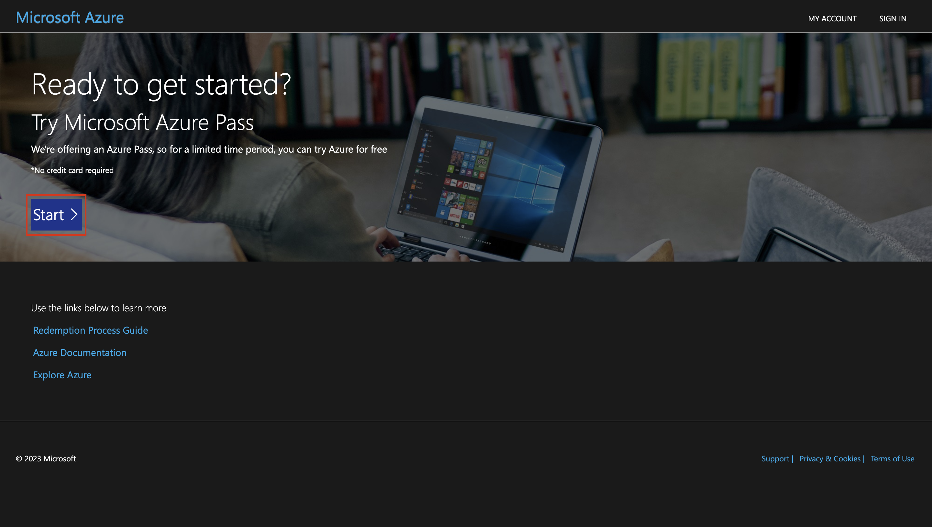

**Note**: Do not use your Company/Work Account to login to redeem the Azure Pass, another Azure Pass will not be issued.

1. Enter the **Office 365 tenant credentials** given on the Resources page of your lab environment and select "**Sign In**".
2. Click "**Confirm Microsoft Account**" if the email address is correct.

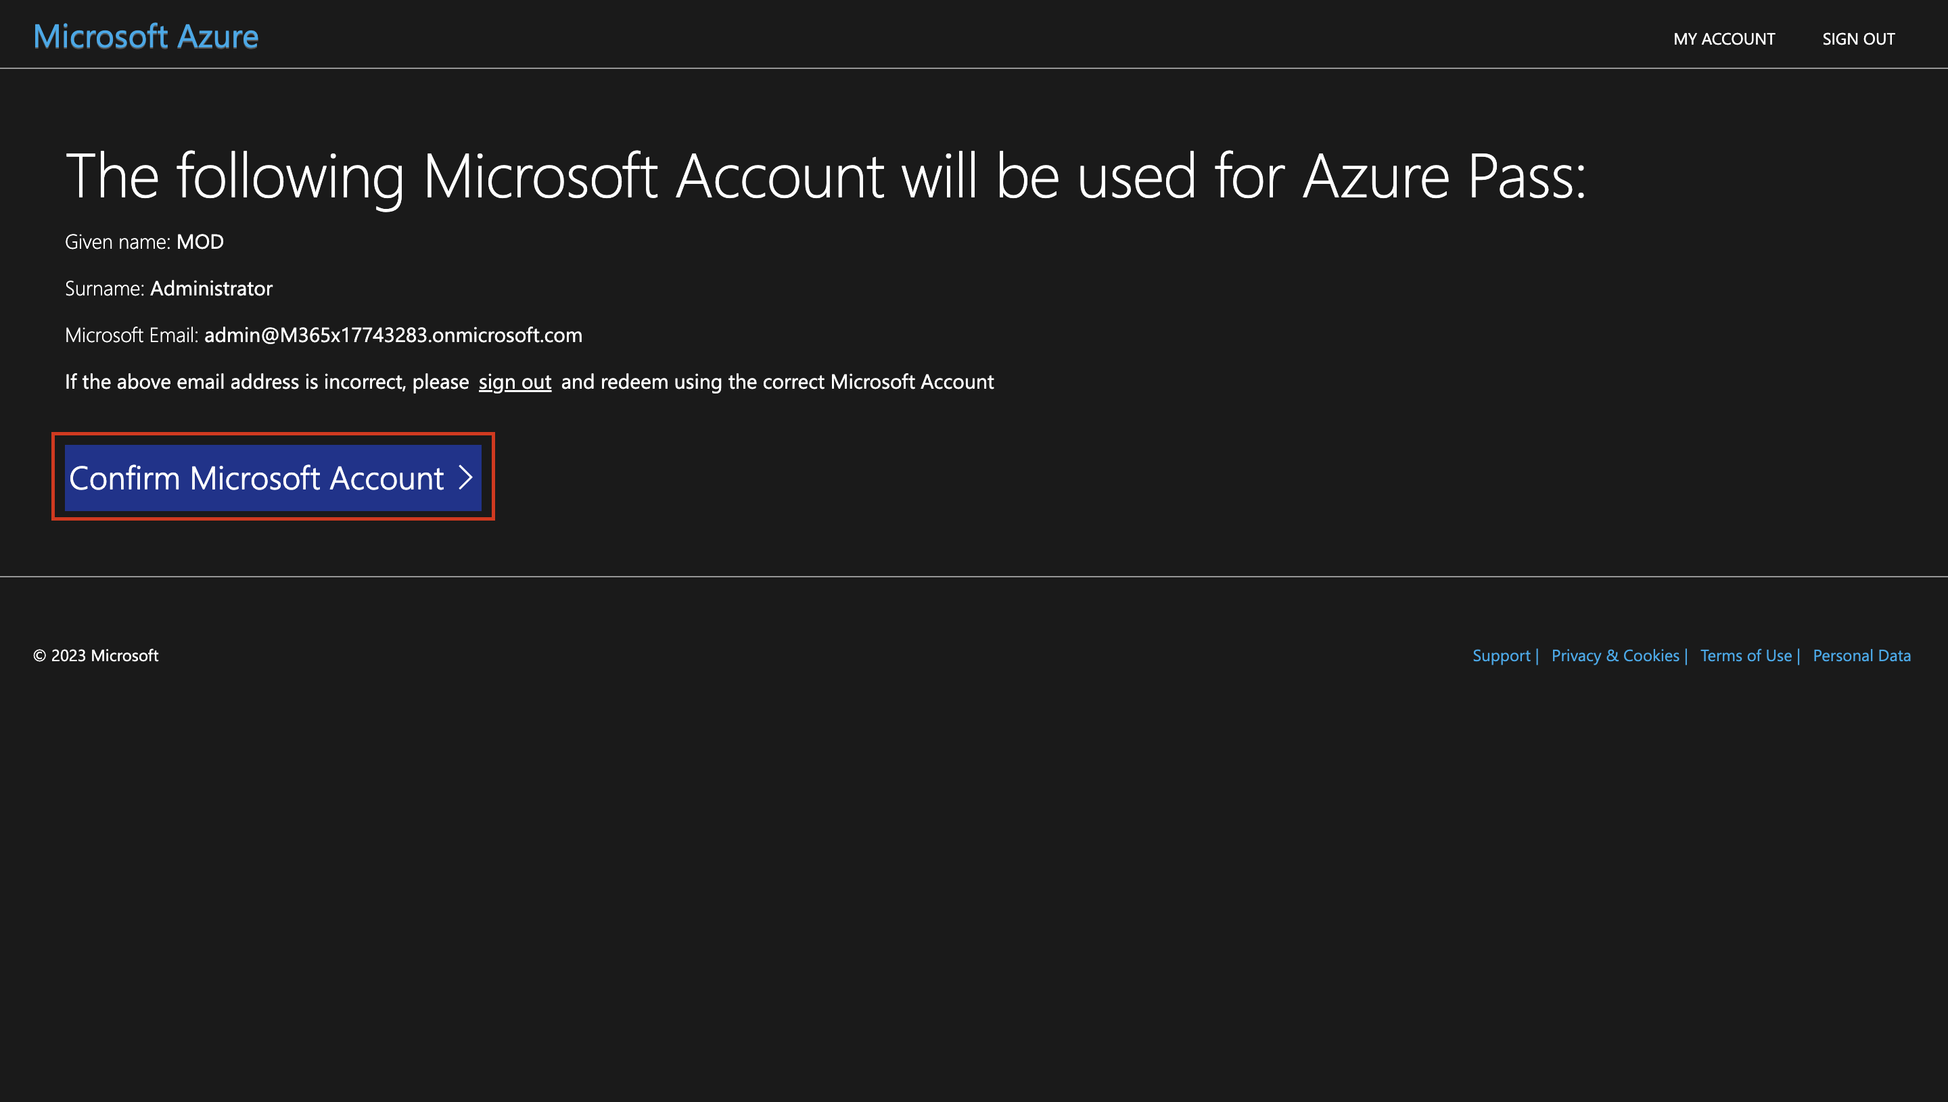

1. Paste the promo code given on the **Resources** page of your lab environment in the **Enter Promo code box,** enter the captcha and select **Submit** button.

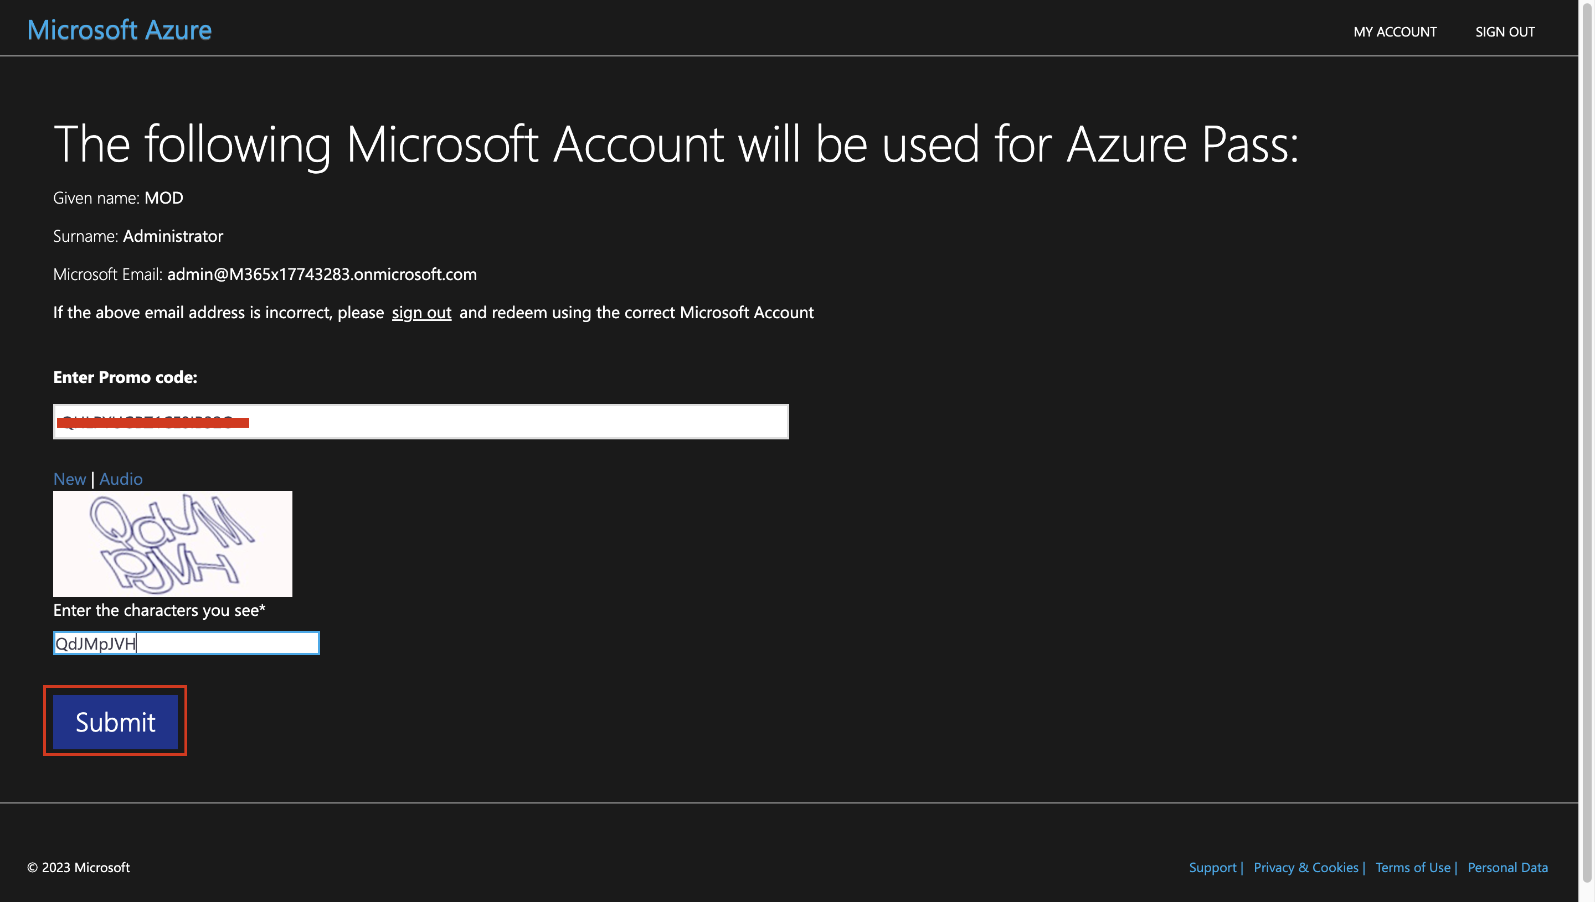

1. If asked login with your tenant credentials again. It may take few seconds to process the redemption.
2. Enter the mandatory profile information. Select the check box – **I agree to the subscription agreement, offer details.**, and then select **Sign up**.

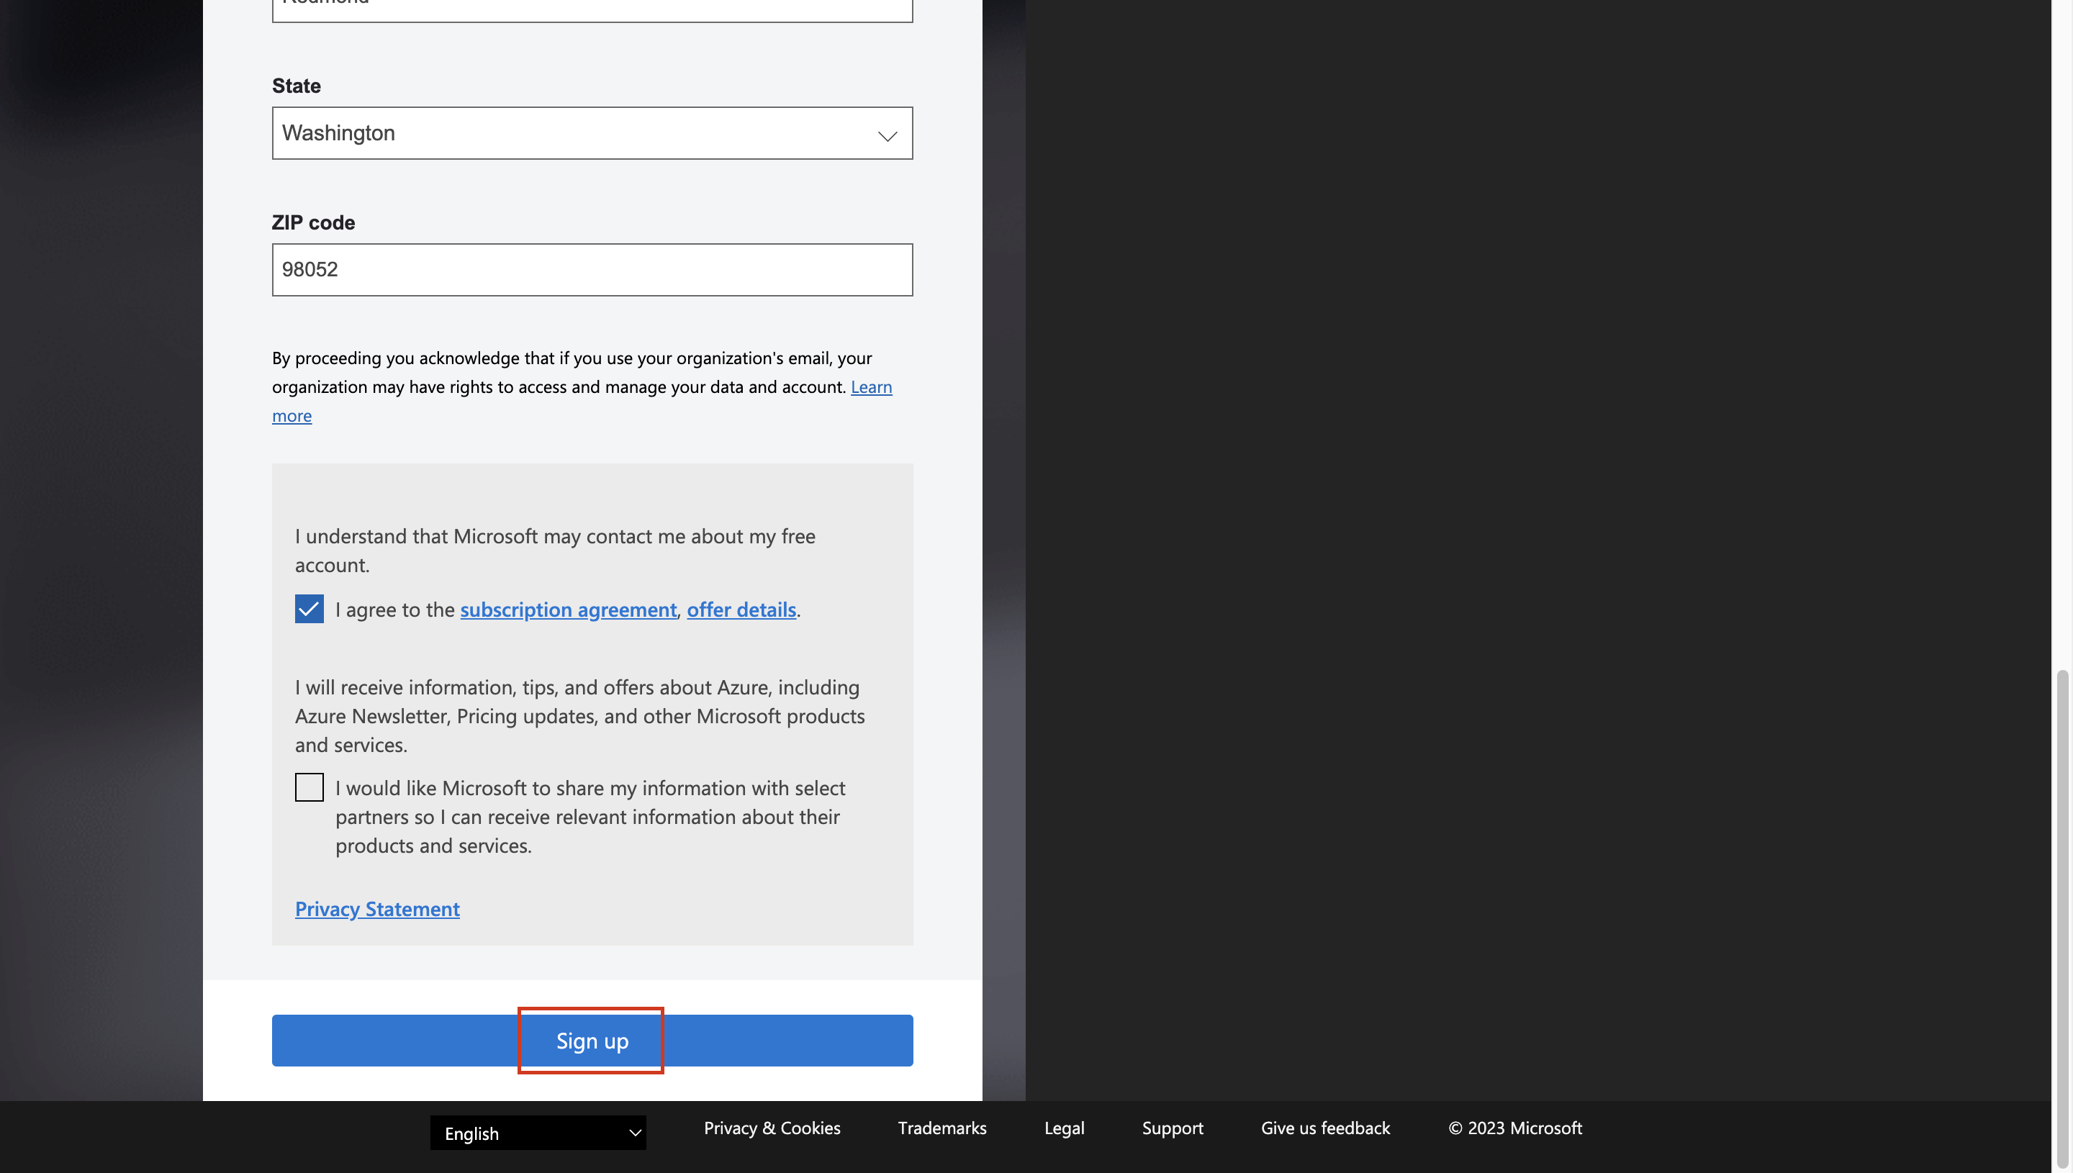

1. On the Protect your account prompt, click on **the** Next button

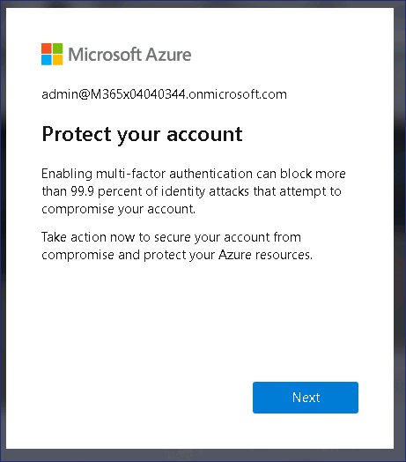

1. Click on the **Next** button on the **More information required** prompt.

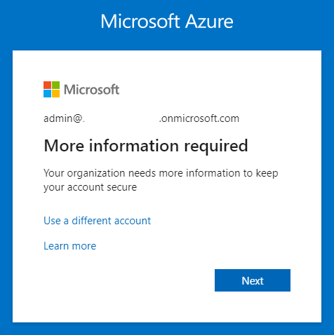

1. 11.Provide the credentials and then complete the MFA sign in

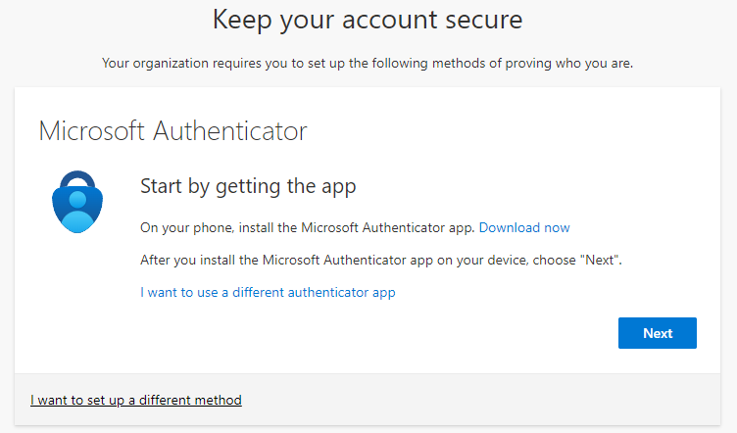

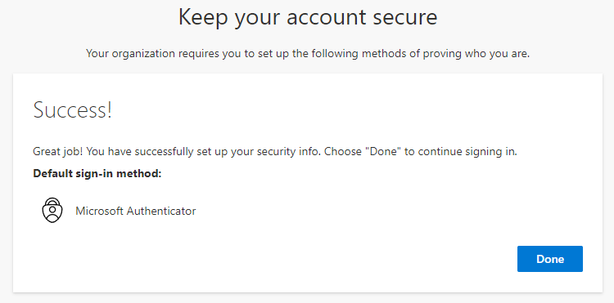

1. Once the authentication is completed you will be redirected to the Azure Pass redemption page.
2. Wait for the account setup to complete and then click on **submit** button.

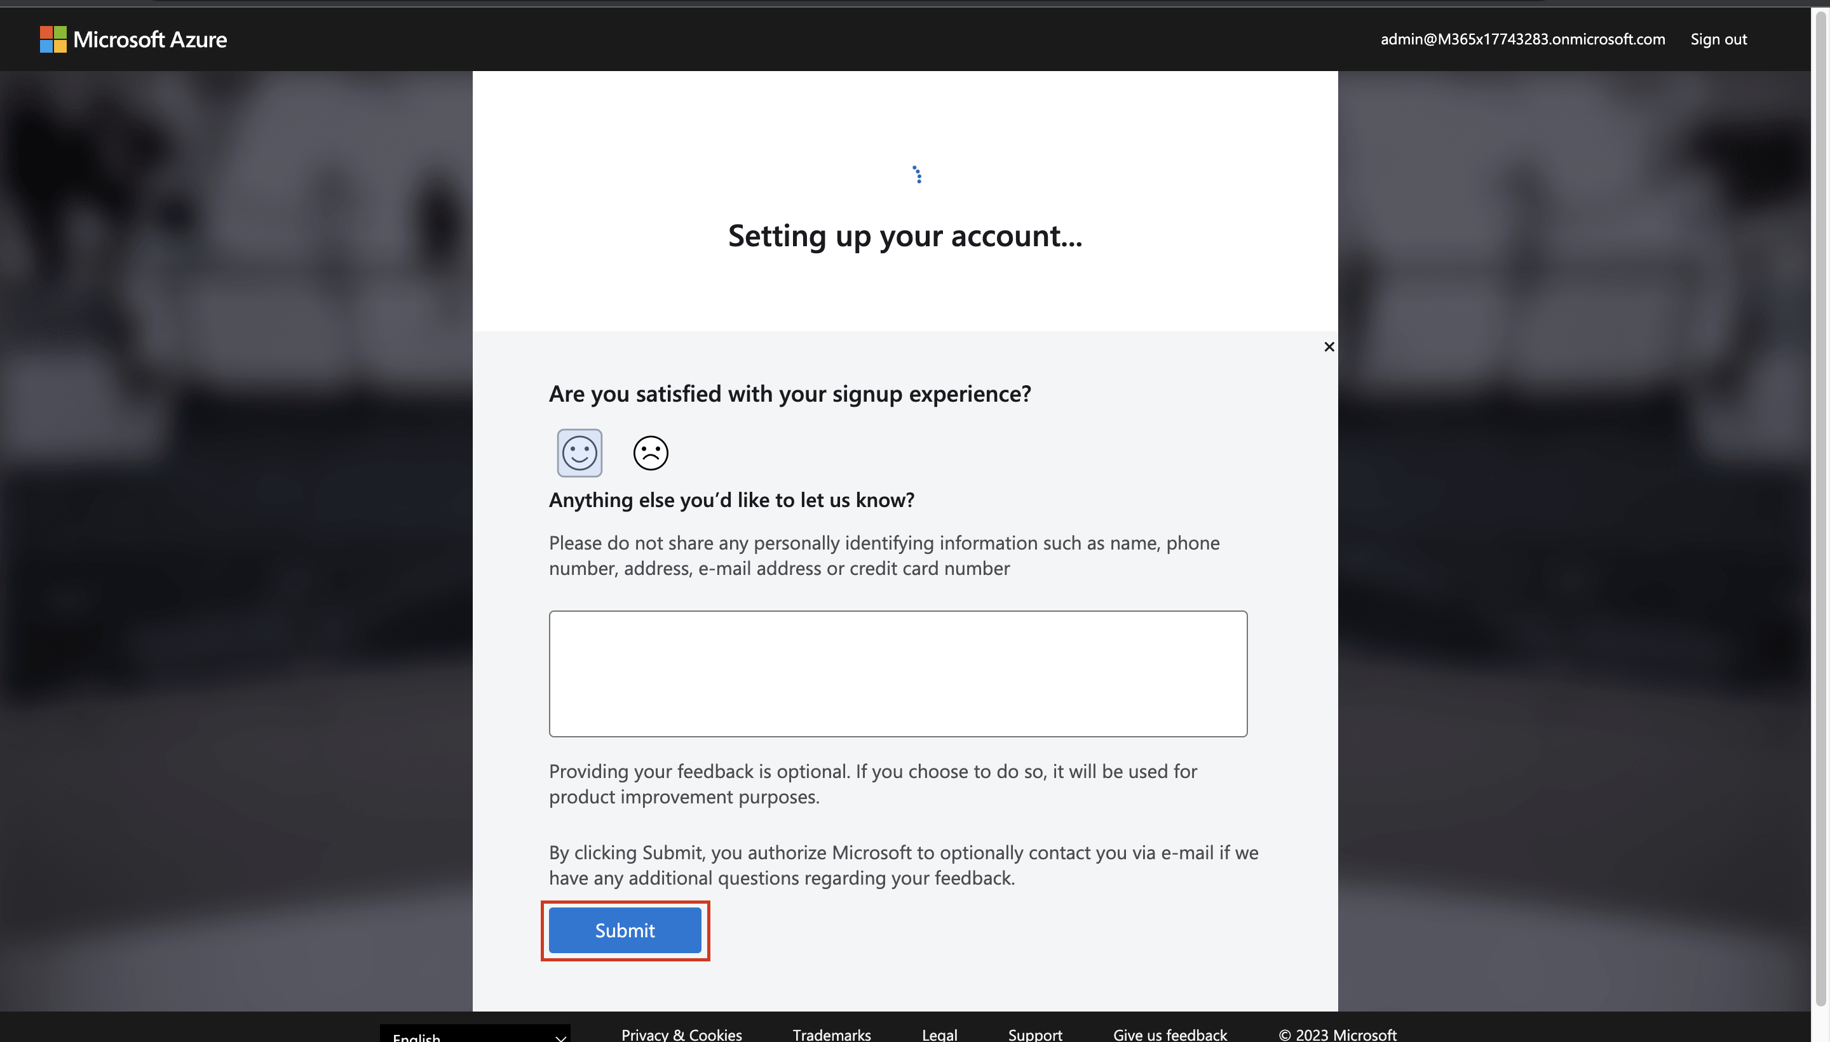

1. It would automatically redirect you to the **Azure Portal** and now you are ready to use Azure services.
2. Click on **Subscriptions** to verify that your new subscription is listed in the list of active subscriptions.

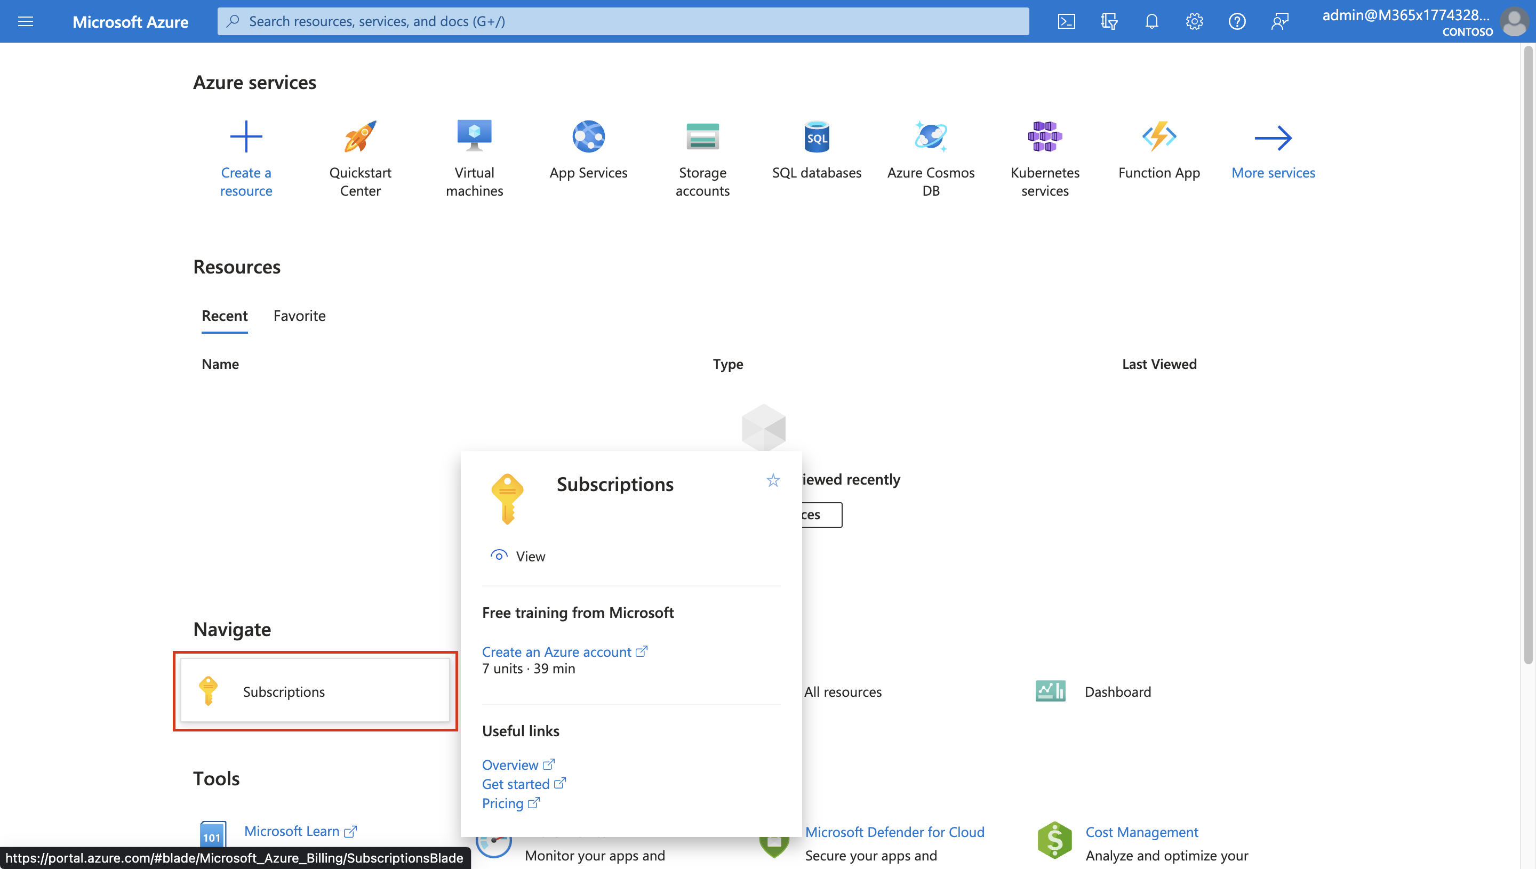

## Exercise 2 – Integrate a single AD forest using Password Hash Sync (PHS)

### Task 1 – Install Azure AD Connect

**Password Hash Sync (PHS)**

Password hash synchronization is one of the sign-in methods used to accomplish hybrid identity. Azure AD Connect synchronizes a hash, of the hash, of a user's password from an on-premises Active Directory instance to a cloud-based Microsoft Entra instance.

Password hash synchronization is an extension to the directory synchronization feature implemented by Azure AD Connect sync. You can use this feature to sign in to Azure AD services like Microsoft 365. You sign in to the service by using the same password you use to sign in to your on-premises Active Directory instance.

Password hash synchronization helps by reducing the number of passwords, your users need to maintain to just one. Password hash synchronization can:

* Improve the productivity of your users.
* Reduce your helpdesk costs.

1. Switch to the **LON-DC1** machine in the lab environment.
2. Sign in with the username and the password given in the Home tab of your environment.
3. Open a browser and navigate to **+++https://entra.microsoft.com/+++** and login using the admin tenant credentials.
4. In the **Microsoft Entra admin center** navigate to **Identity** then expand **Users**, click **All Users** then click on **New User** then click on **Create new user**.

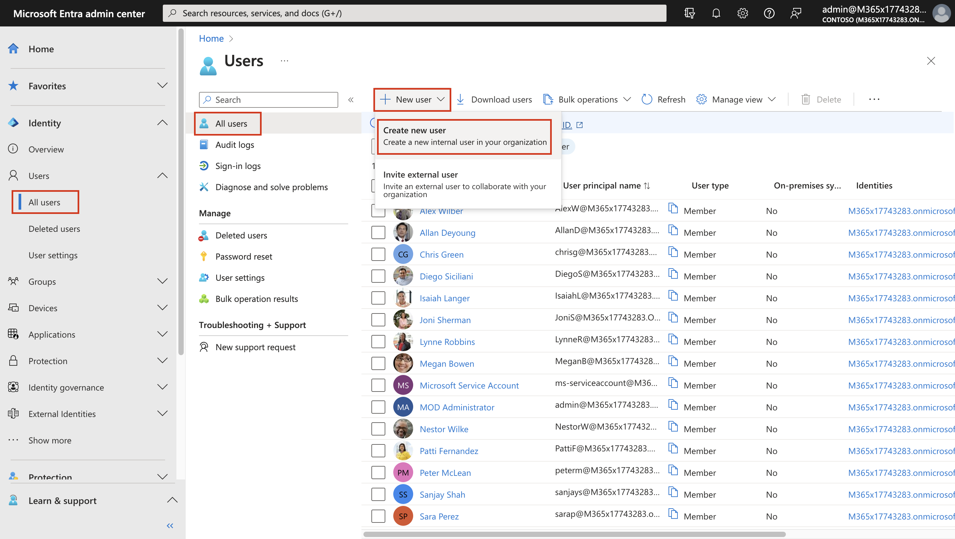

1. Enter the following information under **Basics**:

* **User principal name**: **+++meconnect+++**
* **Display name**: **+++MEConnect+++**
* **First name**: Blank
* **Last name**: Blank
* **Password**: uncheck Auto-generate password and provide **+++Pa$$.w0rd@MS01+++**

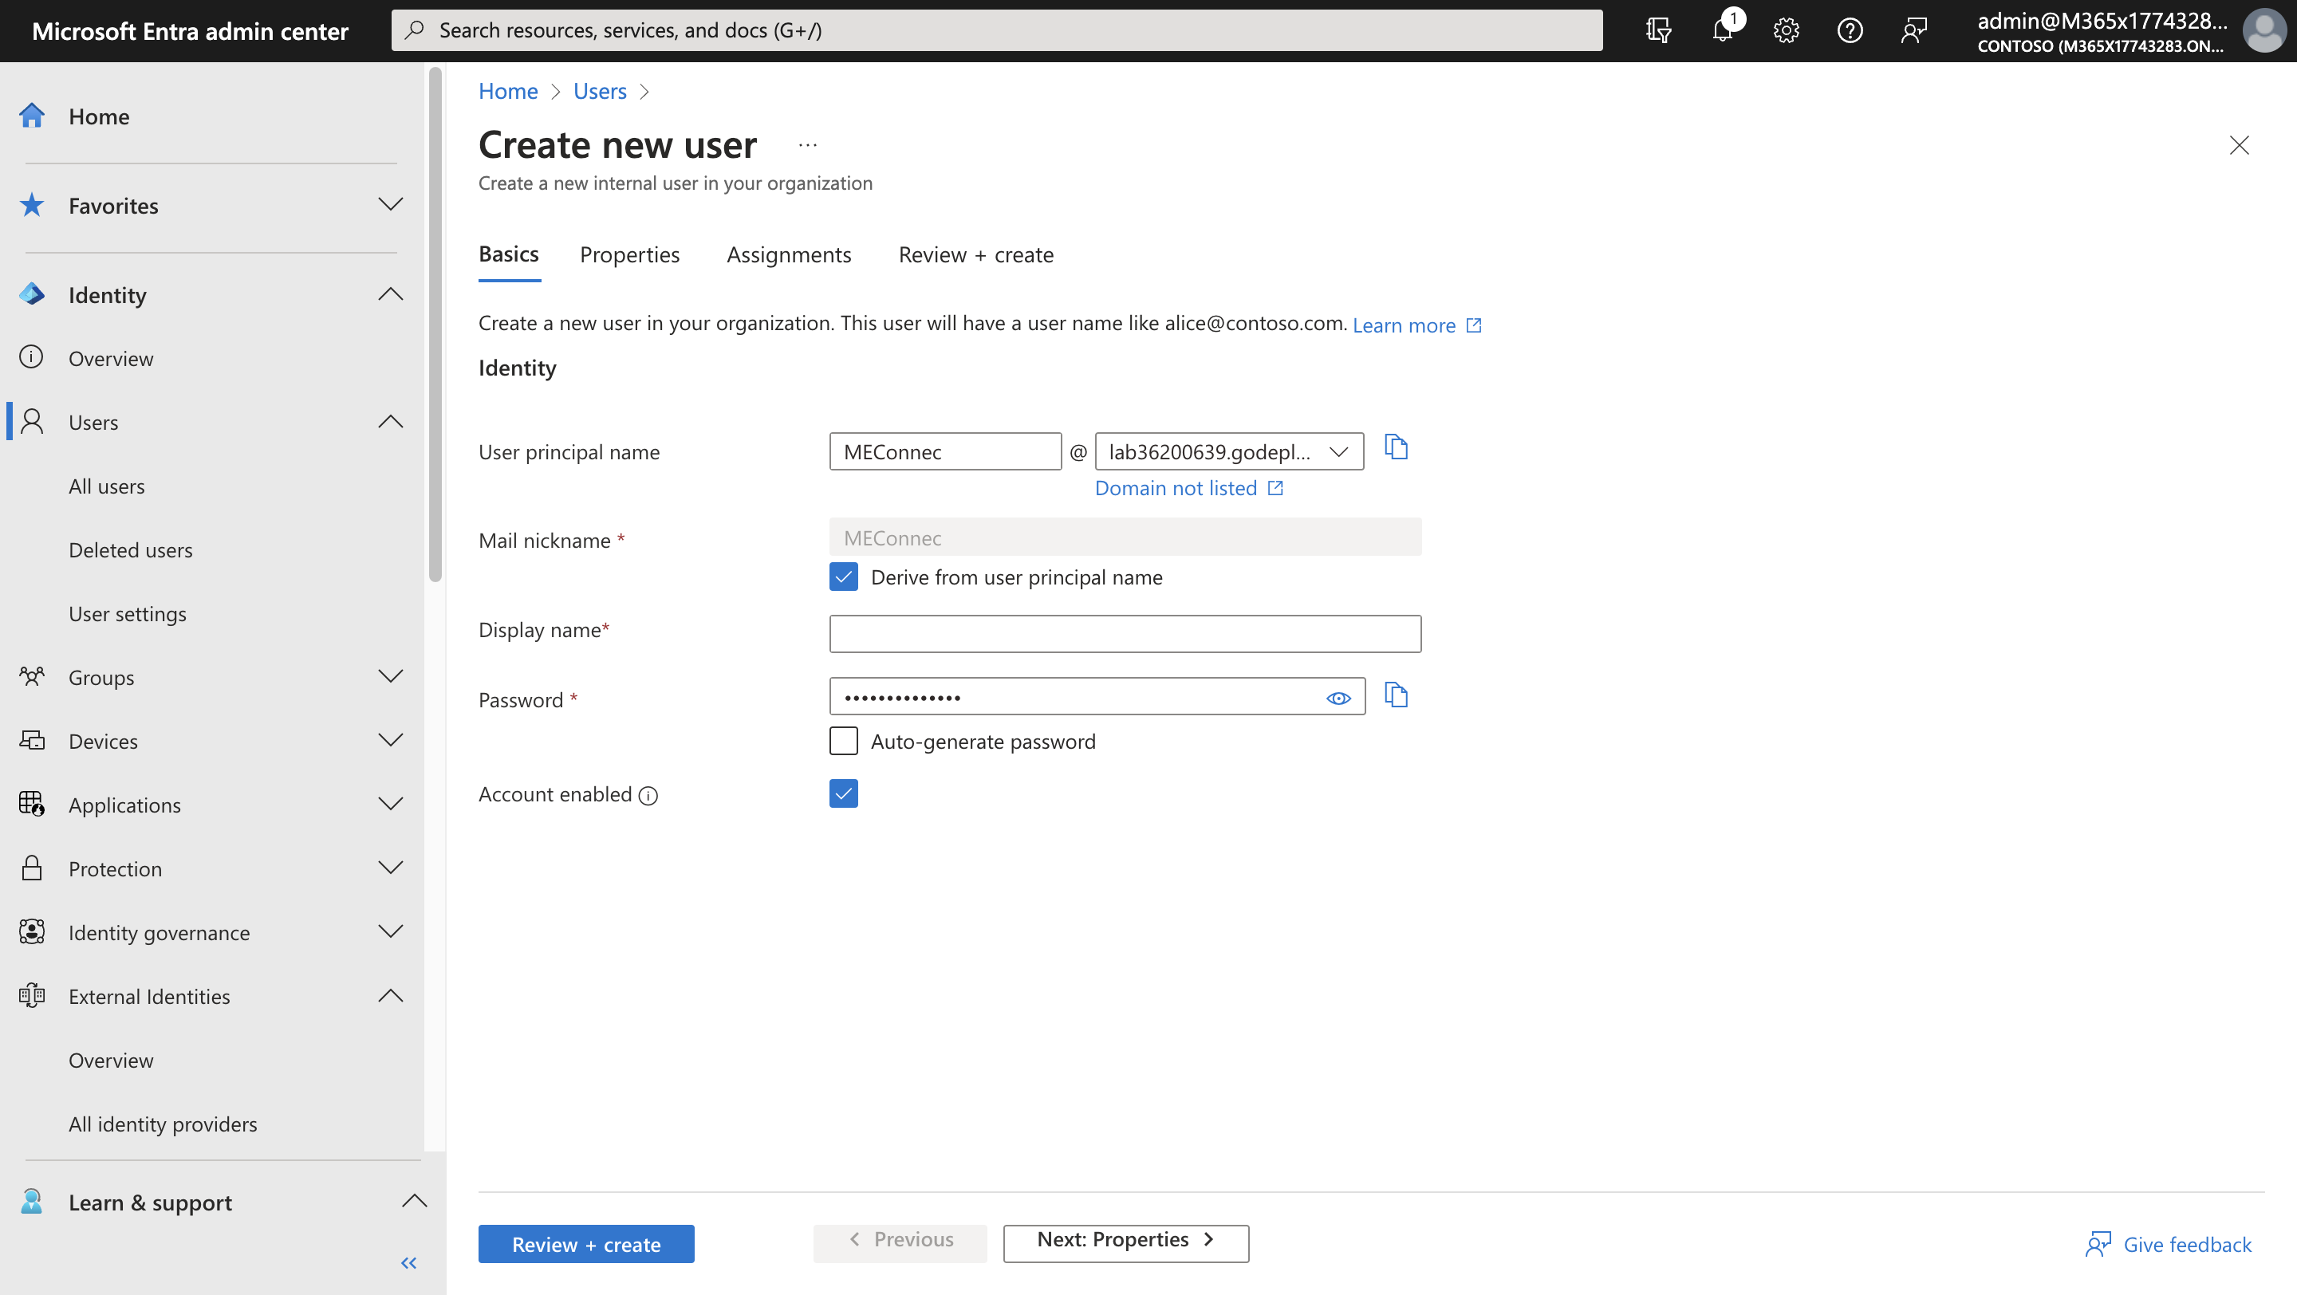

1. Under **Properties**, scroll down and select **United States** as **Usage location**.

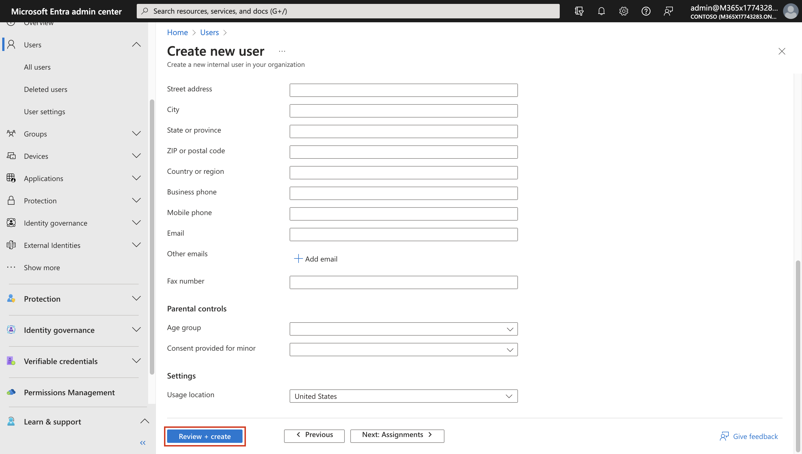

1. Under **Assignment** tab, select **Add role**.

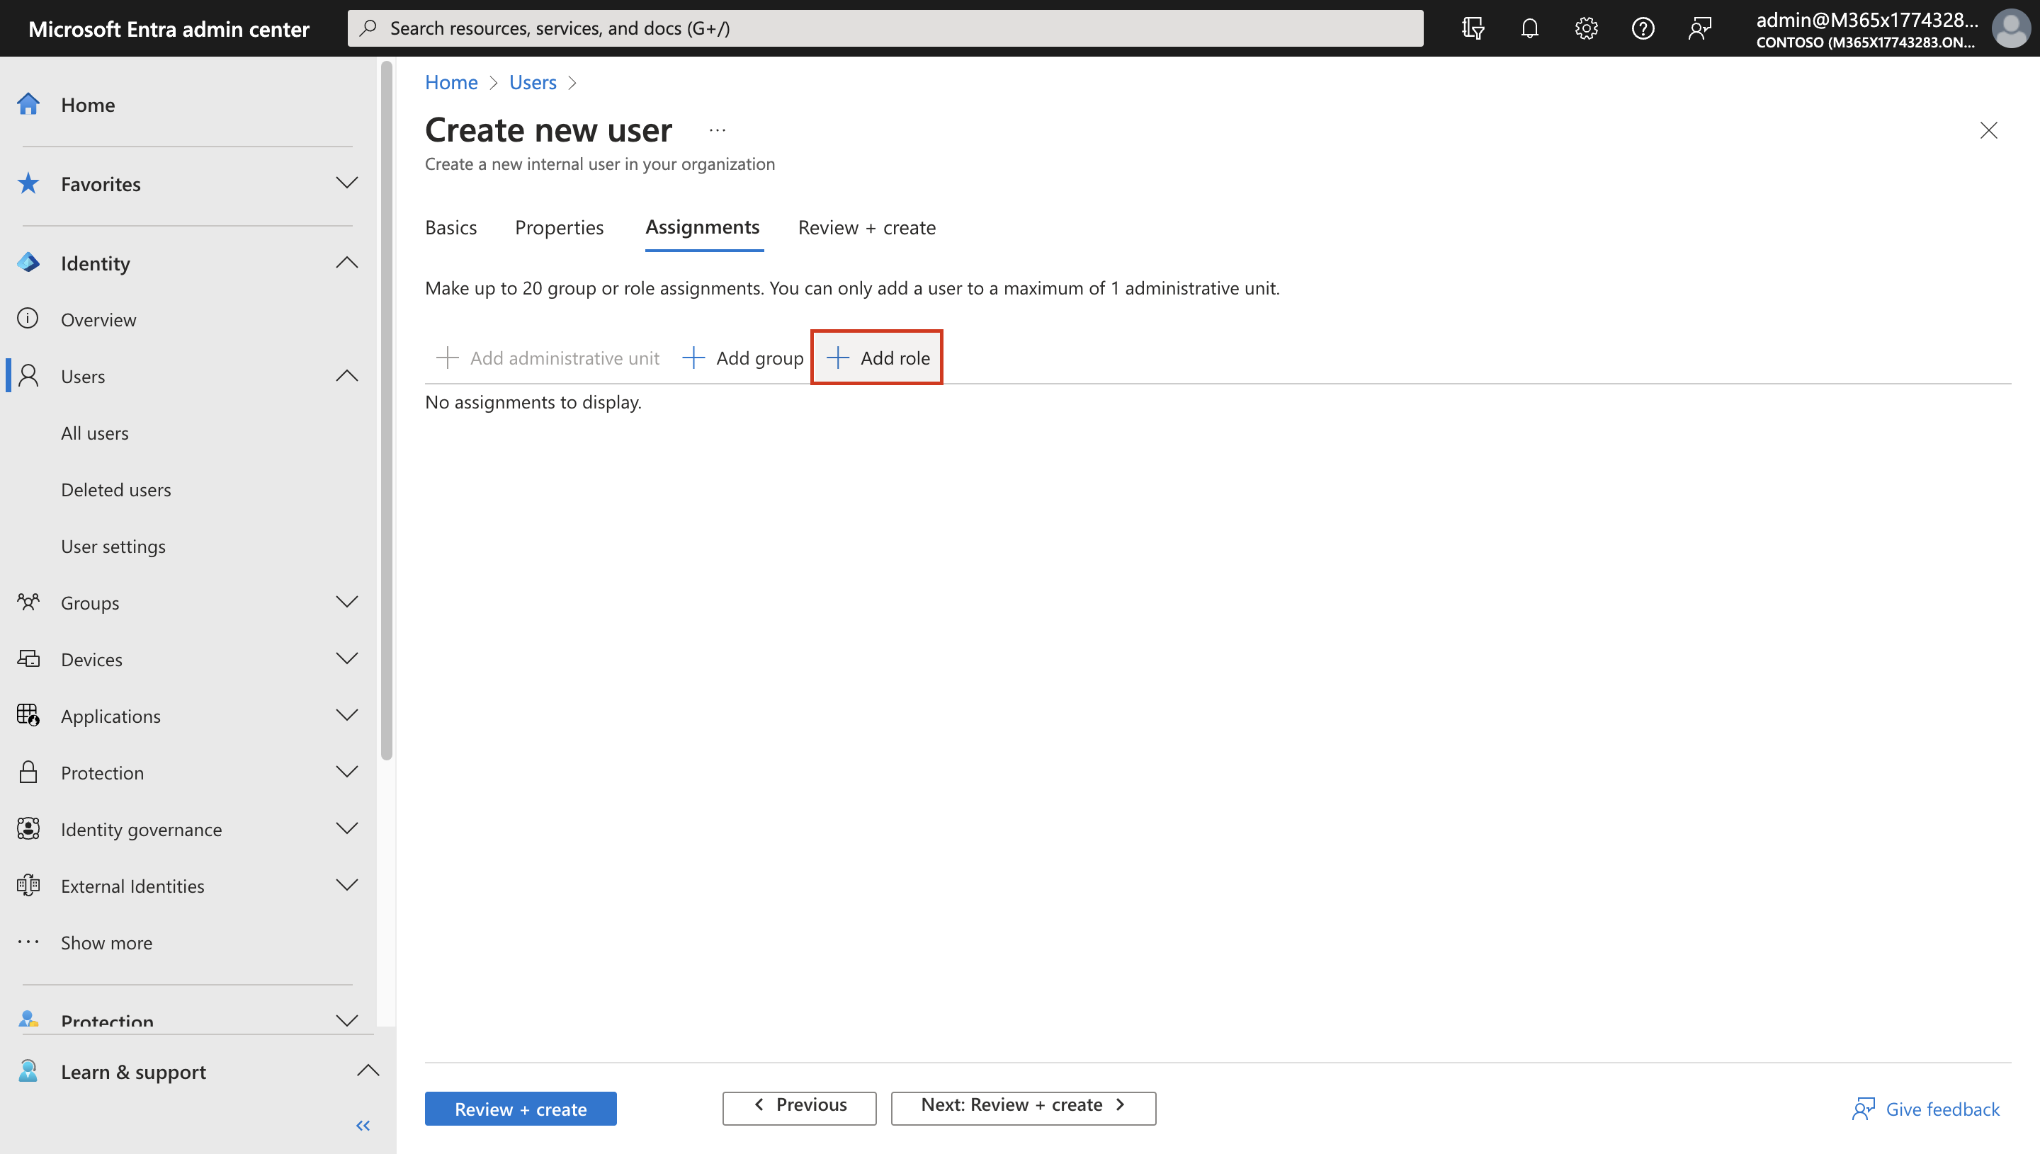

1. Select **Global Administrator** and click **Select**.

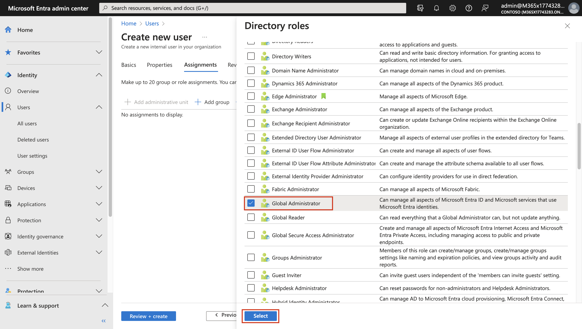

1. Then select **Review + Create**.

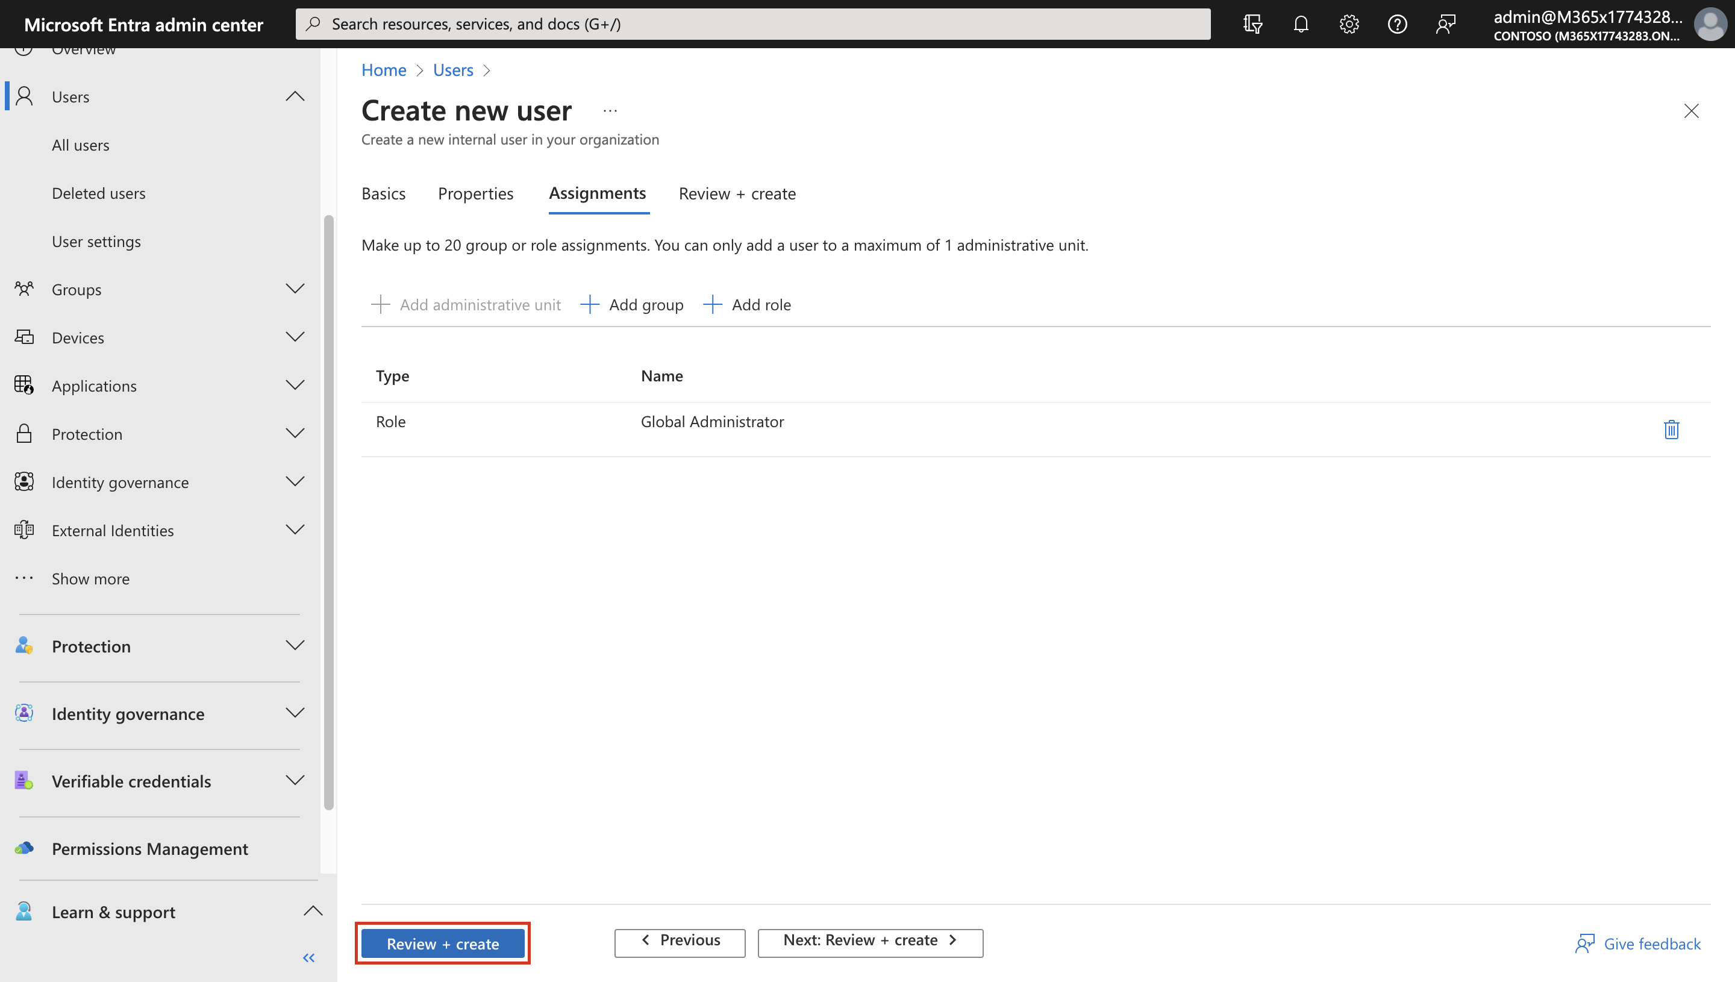

1. Note the **User principal name** and **Password**, and then select **Create**.

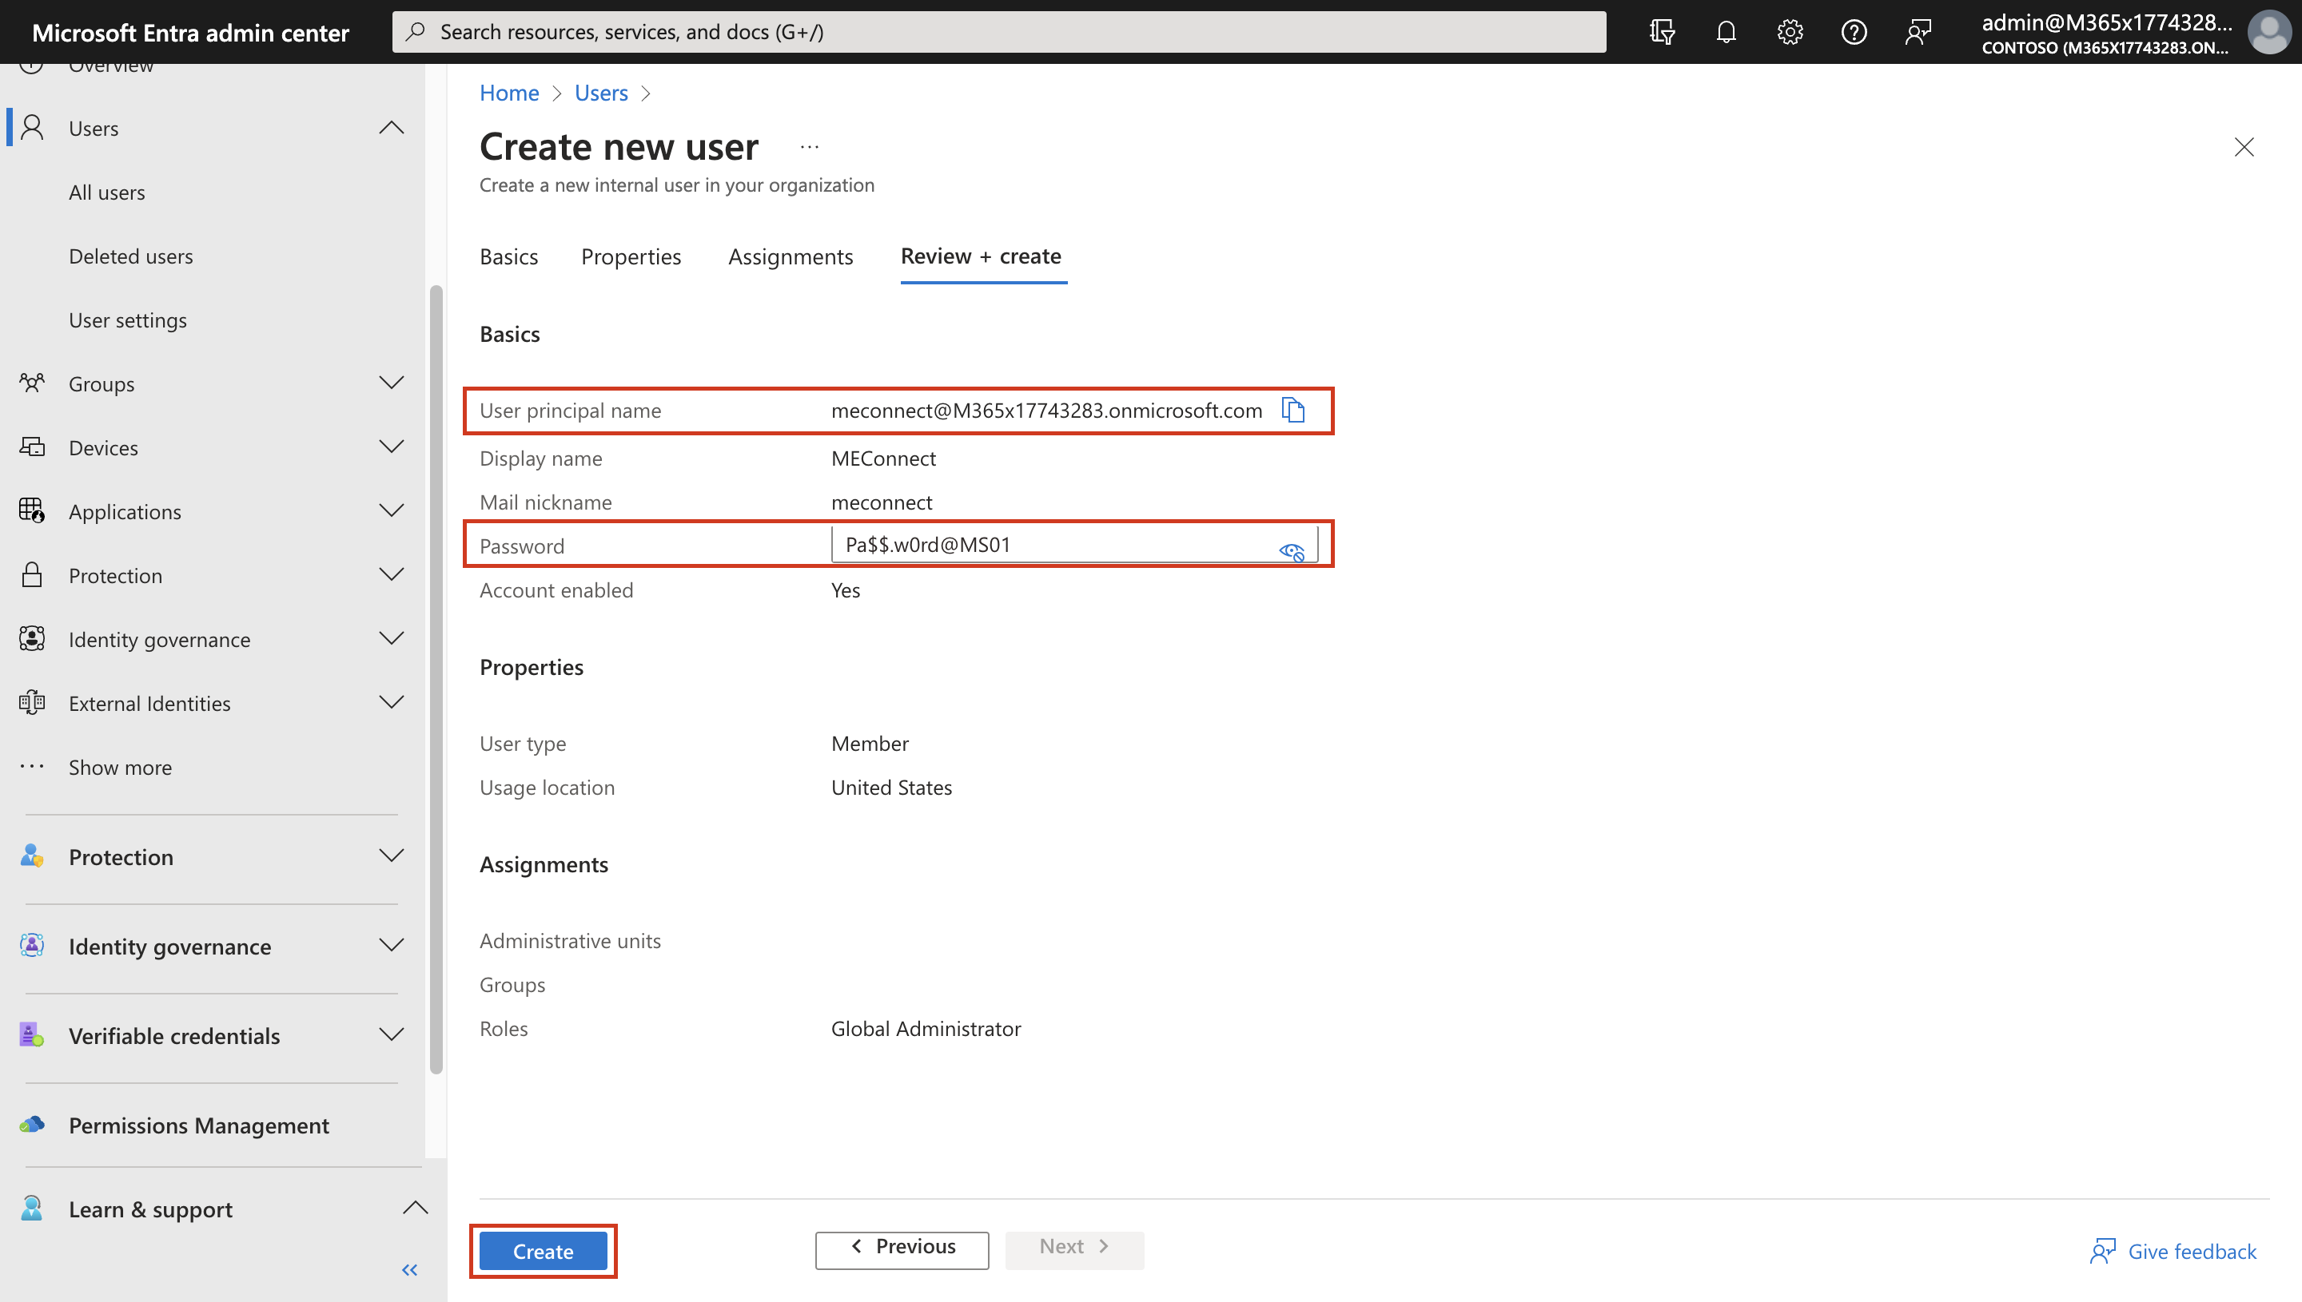

1. Open an In Private / Incognito session in your browser and login to **+++https://entra.microsoft.com/+++** as the user you created i.e. **meconnect** with the password **+++Pa$$.w0rd@MS01+++** that you noted down in the previous step.
2. When prompted, update the password to **+++Pa$$.w0rd@123+++**. Then select **Sign in**.

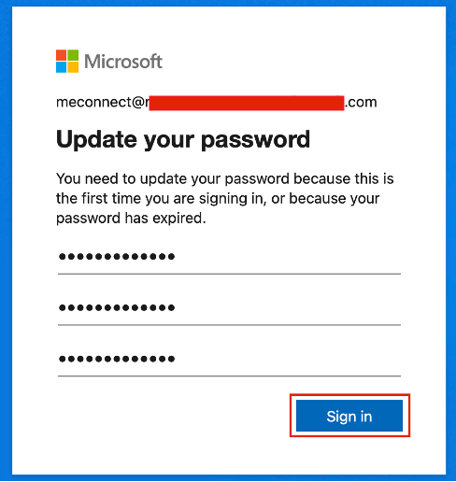

1. Open a browser and navigate to the URL — **+++https://www.microsoft.com/en-us/download/details.aspx?id=47594+++**
2. Click **Download** and then select **Open file**.

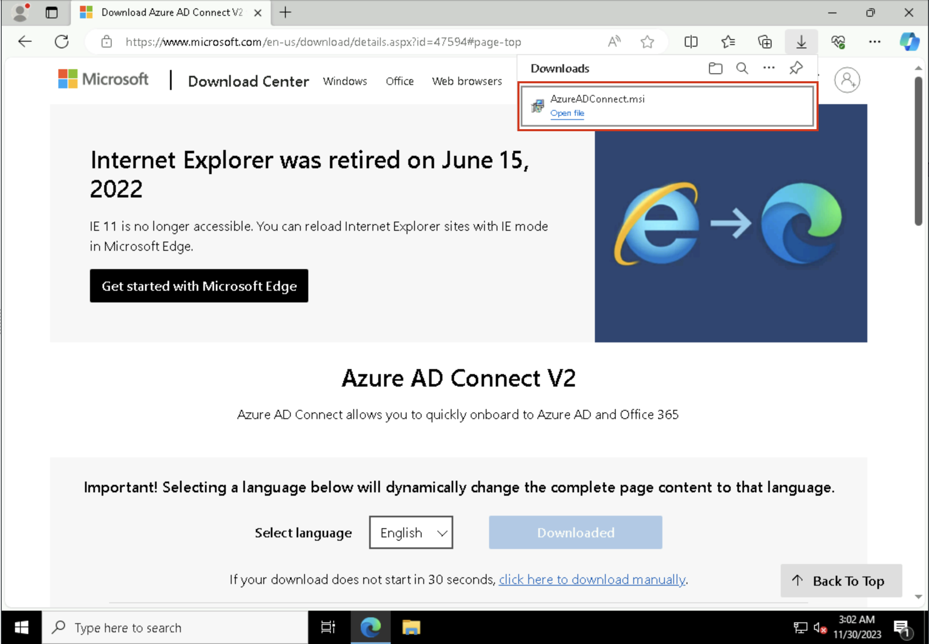

1. Once installed, the **Microsoft Azure AD Connect** configuration will start. select the **Terms & Conditions** check box and click **Continue**.

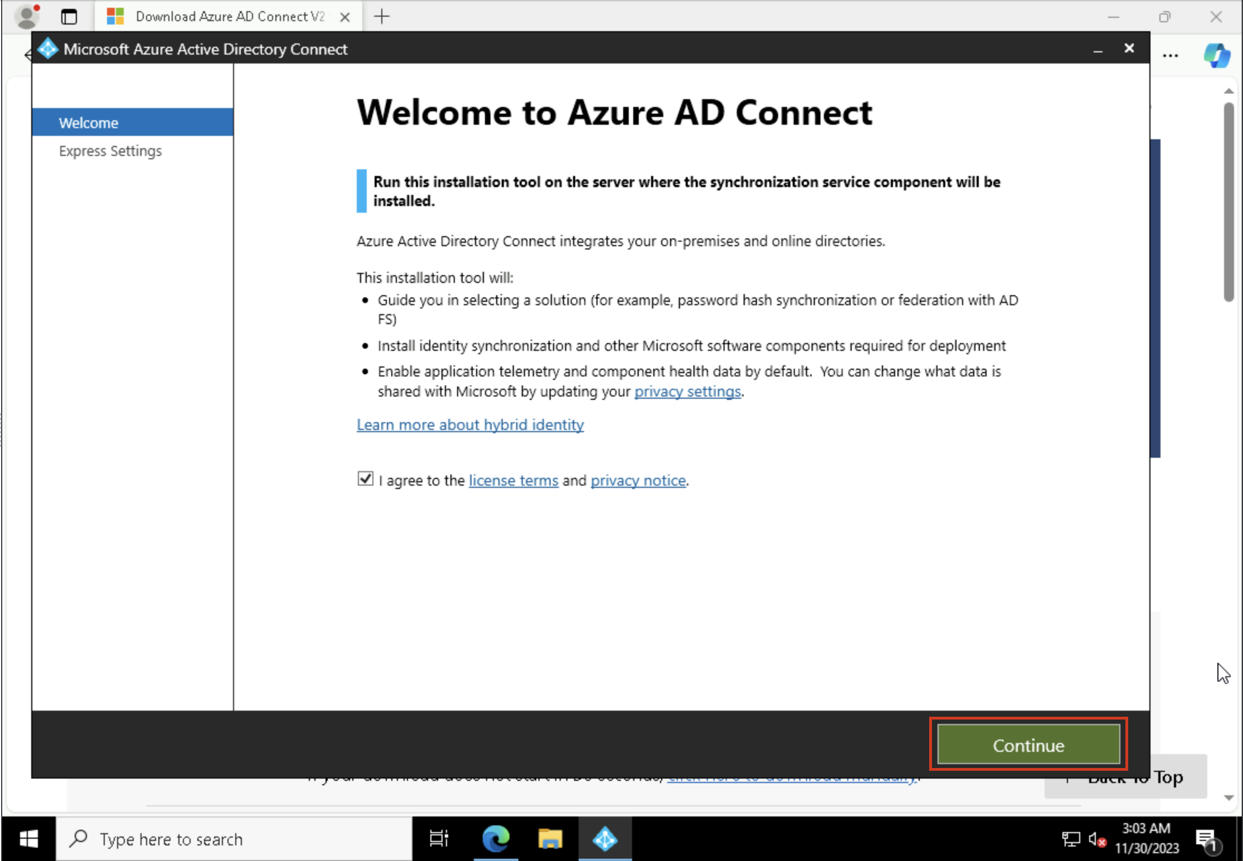

1. On the **Express Settings** page click **Customize**.

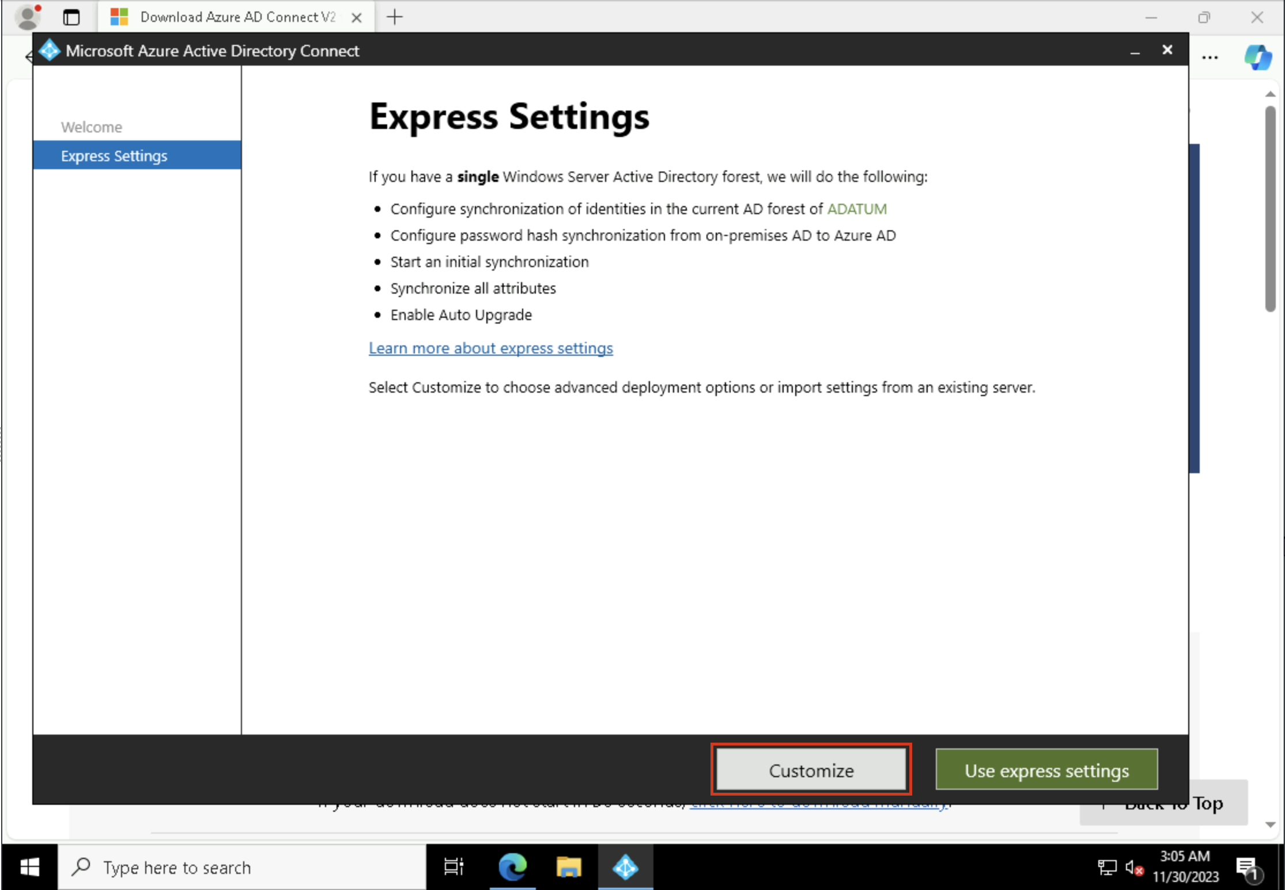

1. On the Install required components page click **Install**.

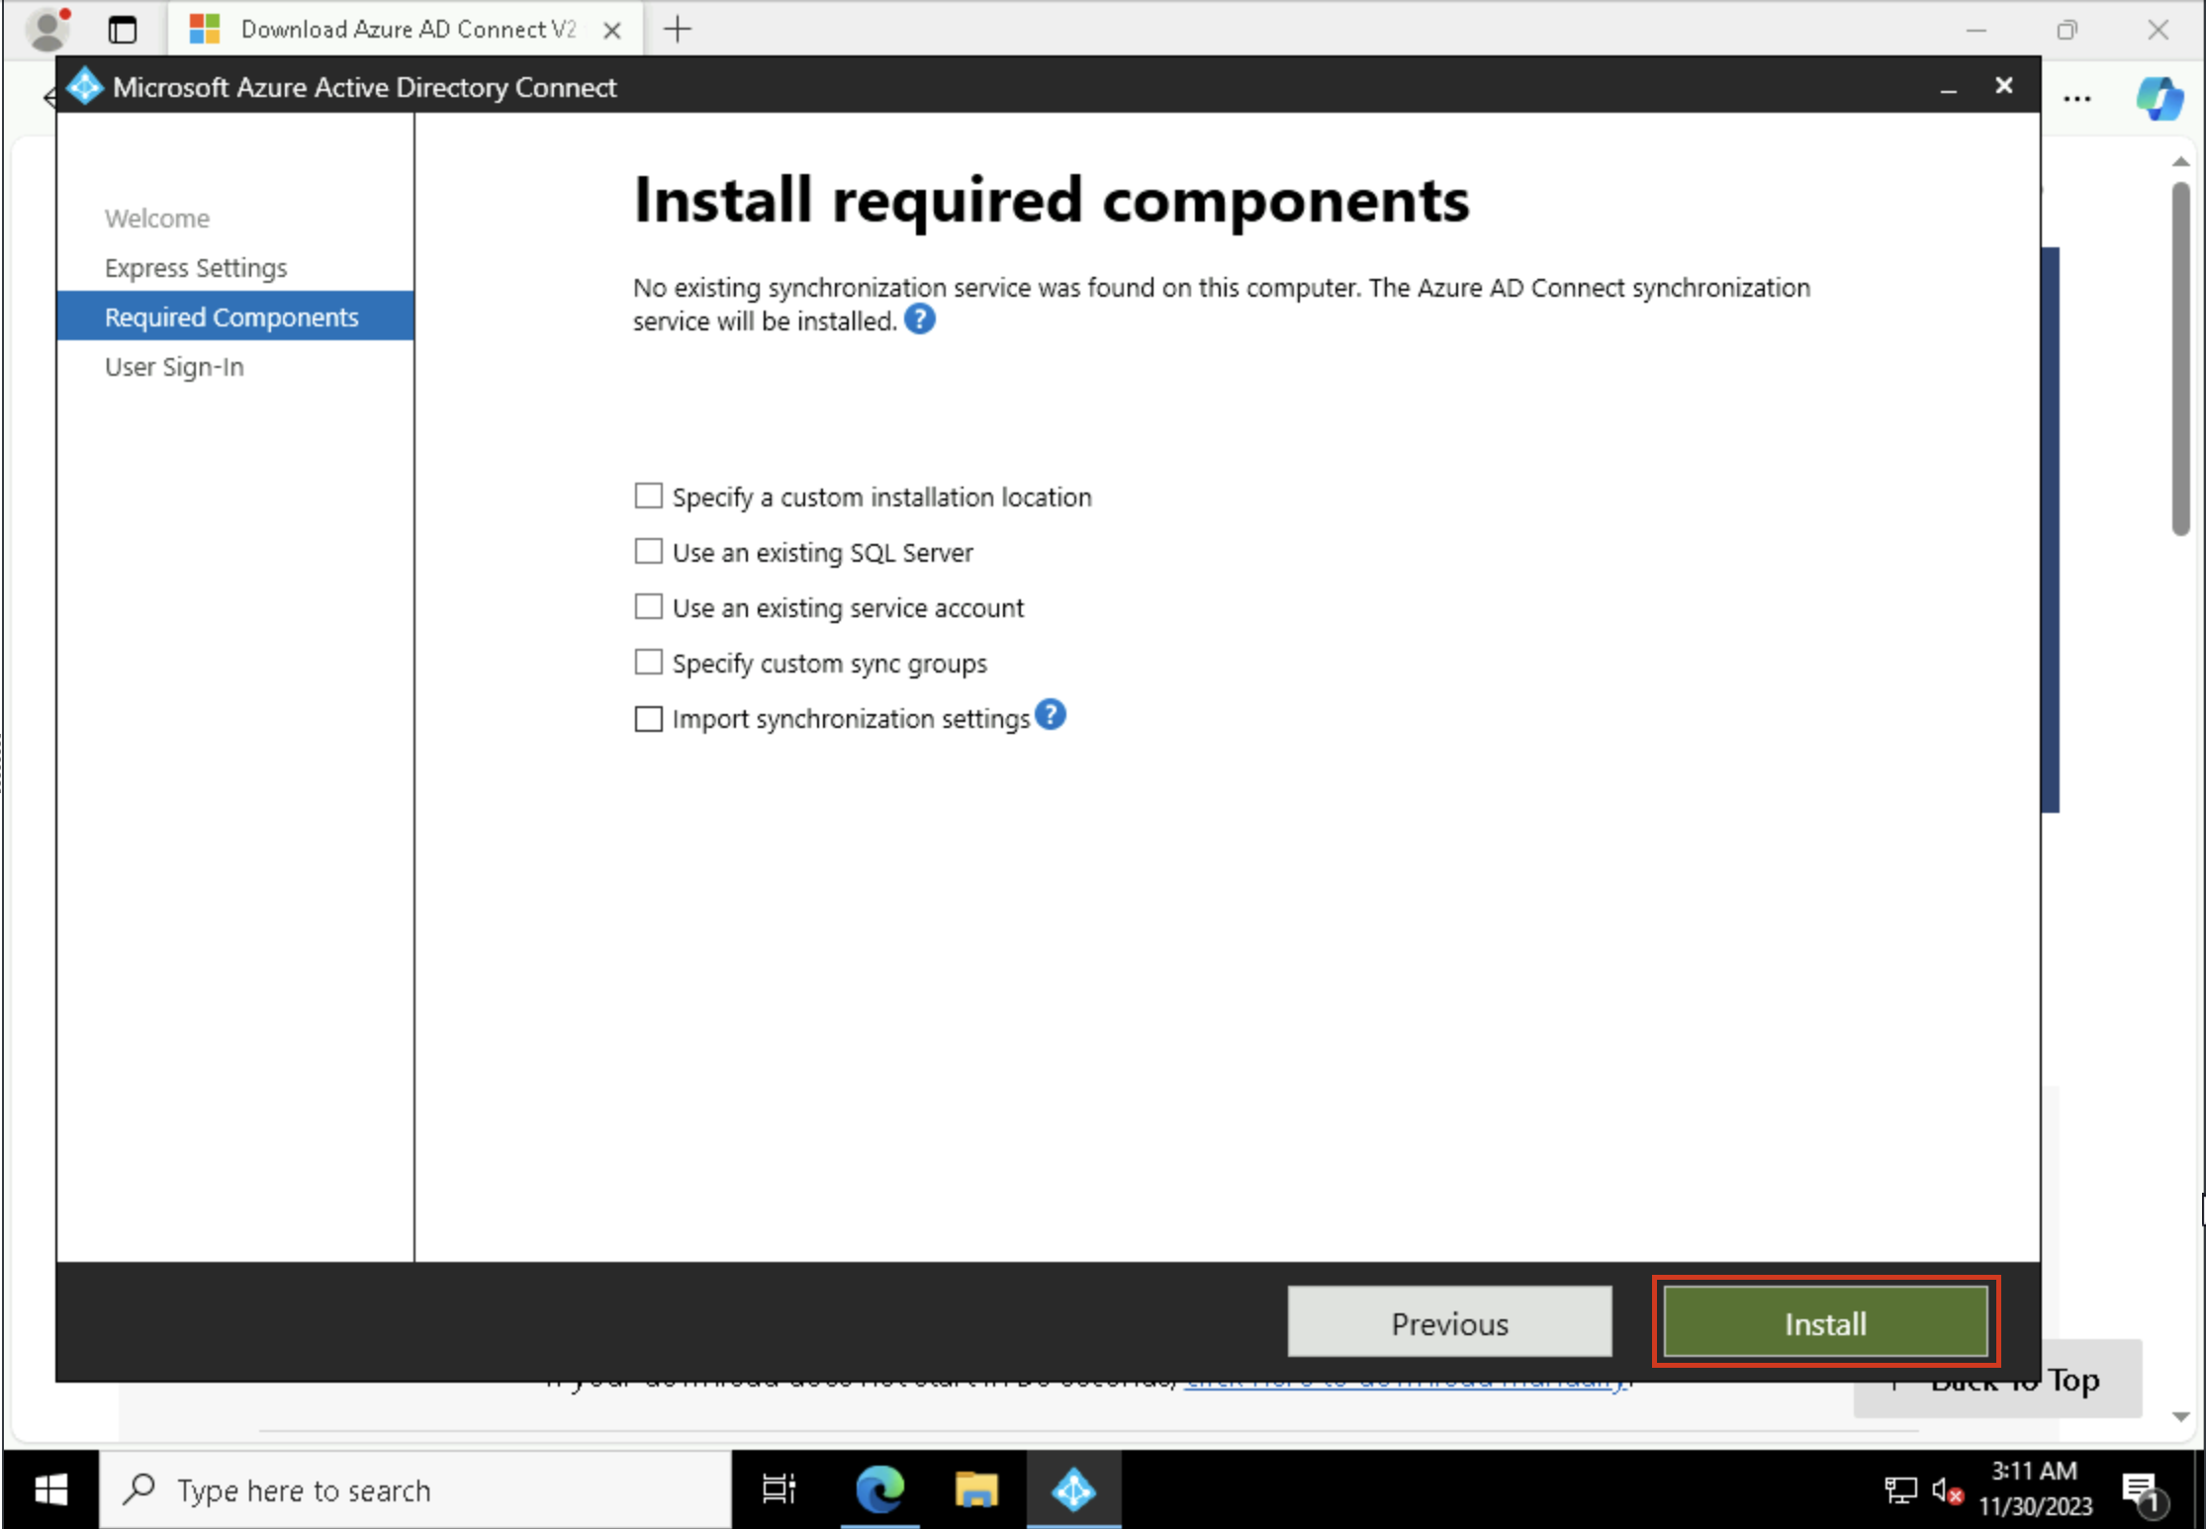

1. At the **User sign-in** page, choose **Password Hash Synchronization** as the **Sign On method** and click **Next**. We will use the MEConnect user we had created in the **Azure portal** to continue the installation process of **ADConnect**.

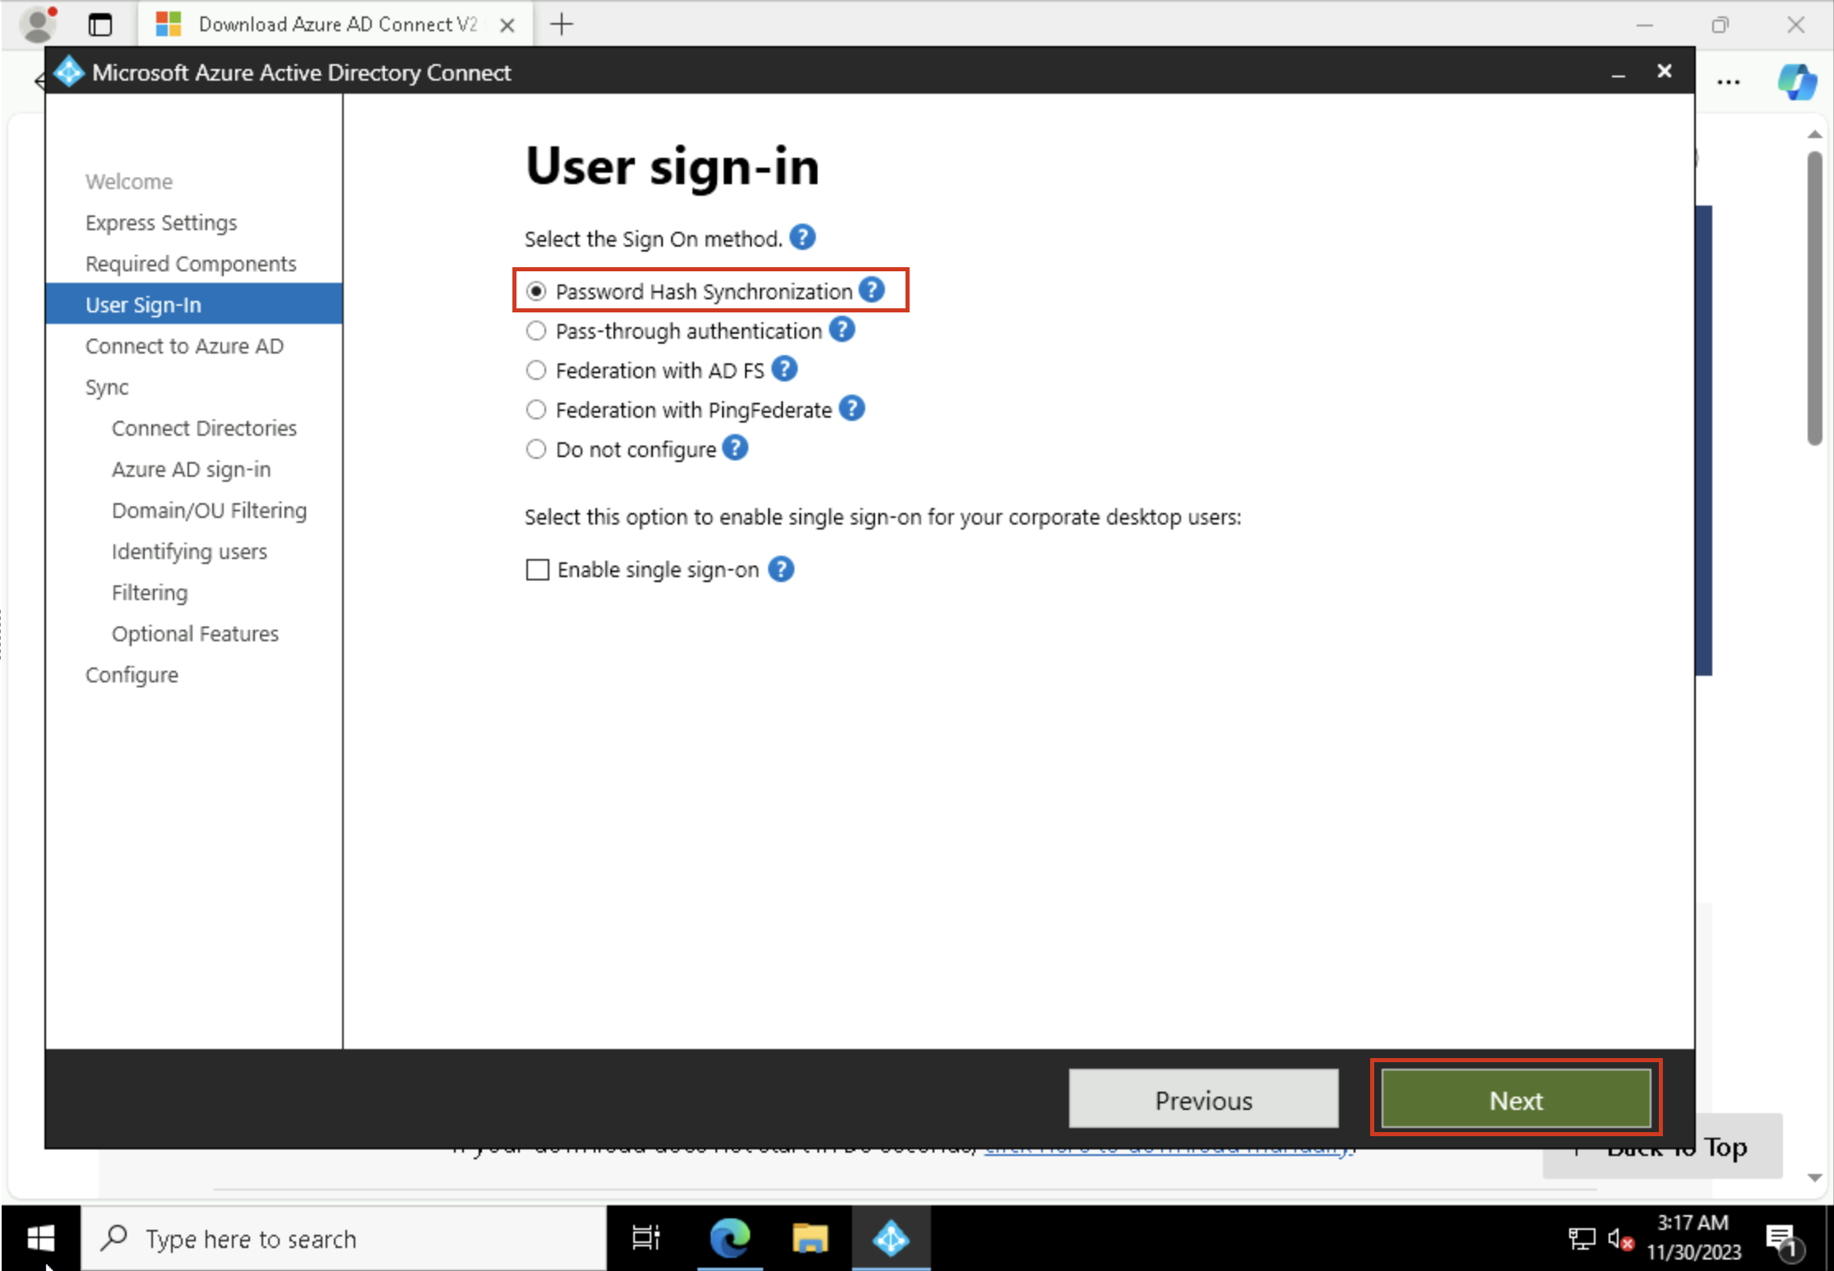

1. In the Username enter **+++meconnect@+++** and paste Tenant name and for the password enter **+++Pa$$.w0rd@123+++**. Then select **Next**.

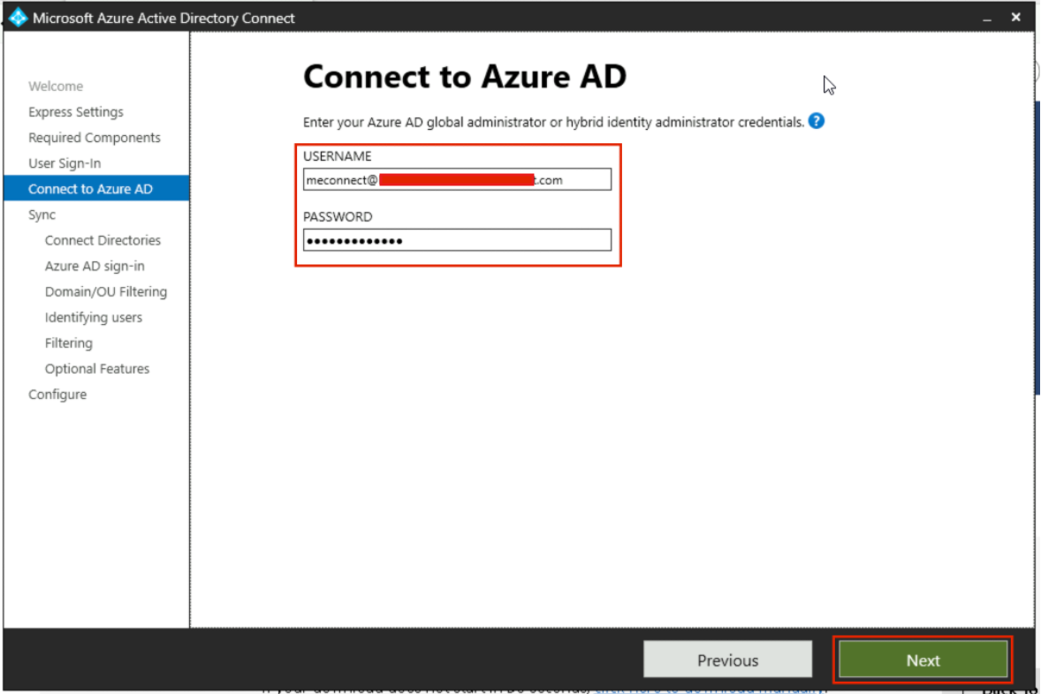

1. If you get a prompt that the content is blocked by Internet Explorer Enhanced Security Configuration, select **Add**.

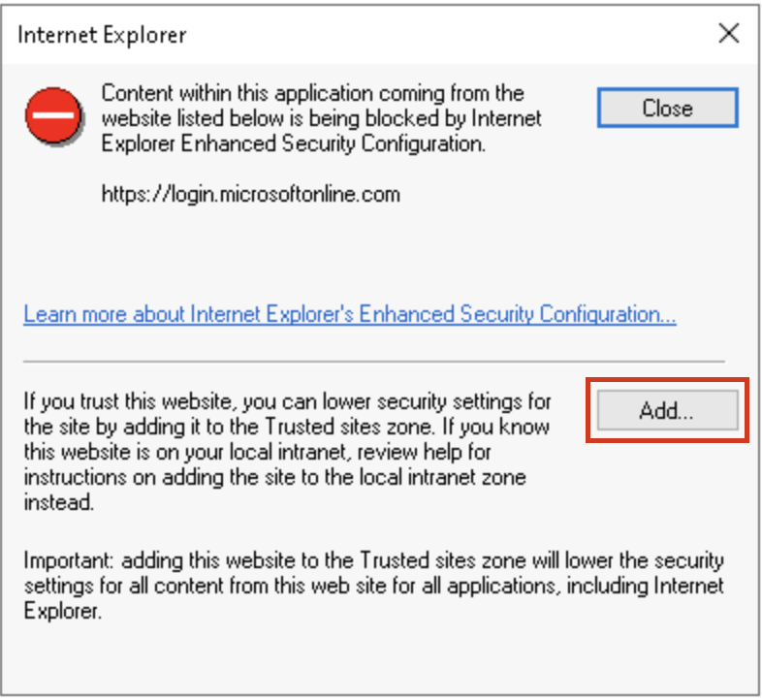

1. On the Trusted sites prompt, again select **Add**  and then **Close**. Do these for all the required sites.

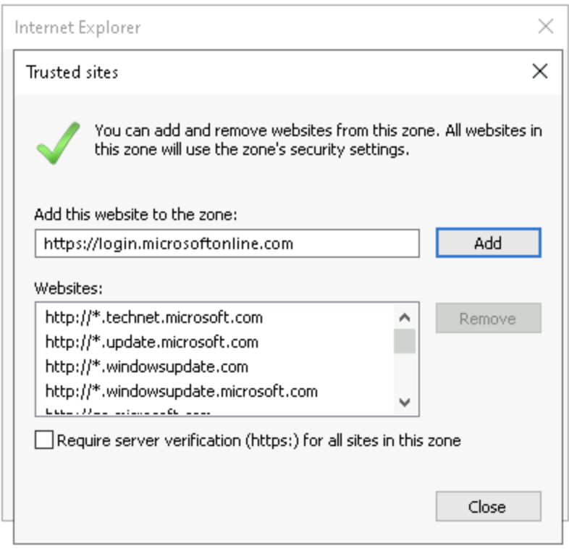

1. If asked, provide the tenant credentials again.
2. 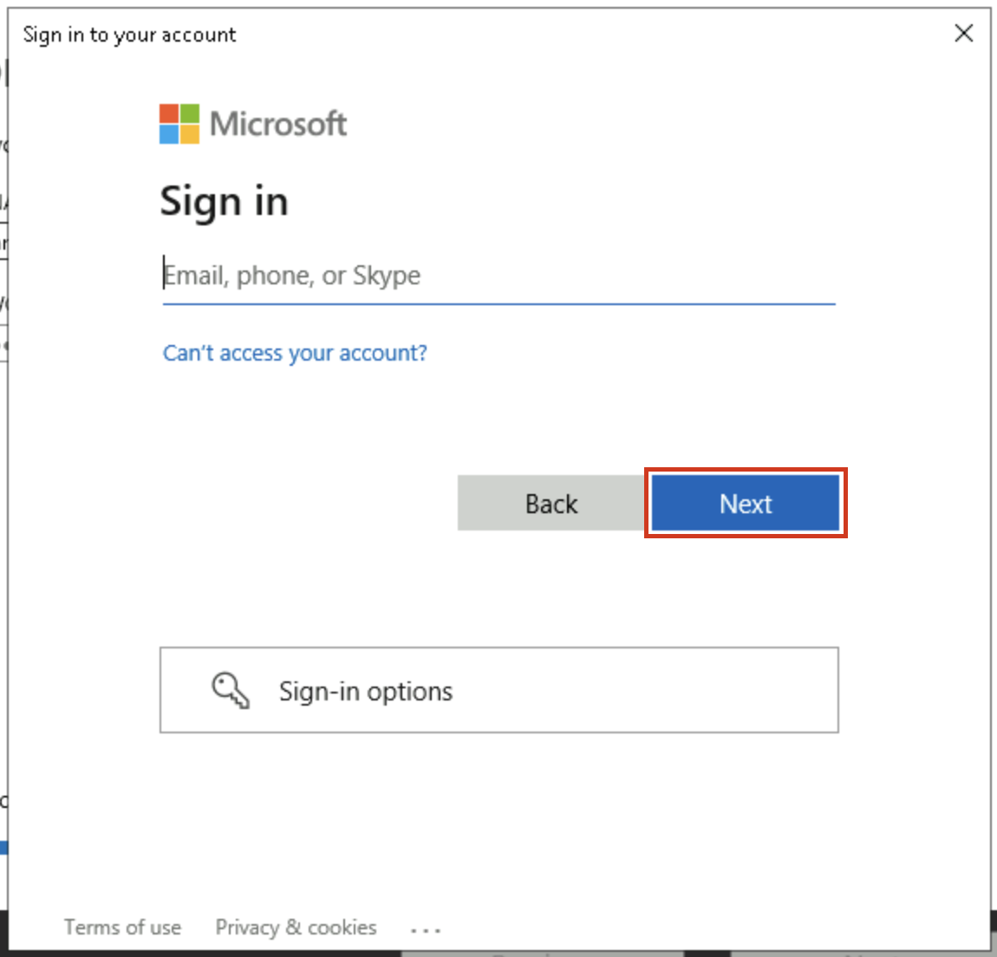

1. On the connect your directories page click **Add directory**.

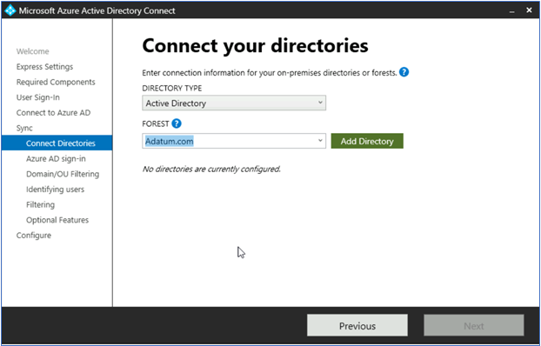

1. On the **AD Forest account** window click **Create new account** and enter the login credentials of your VM, i.e. the domain name and the password and select **Next**.

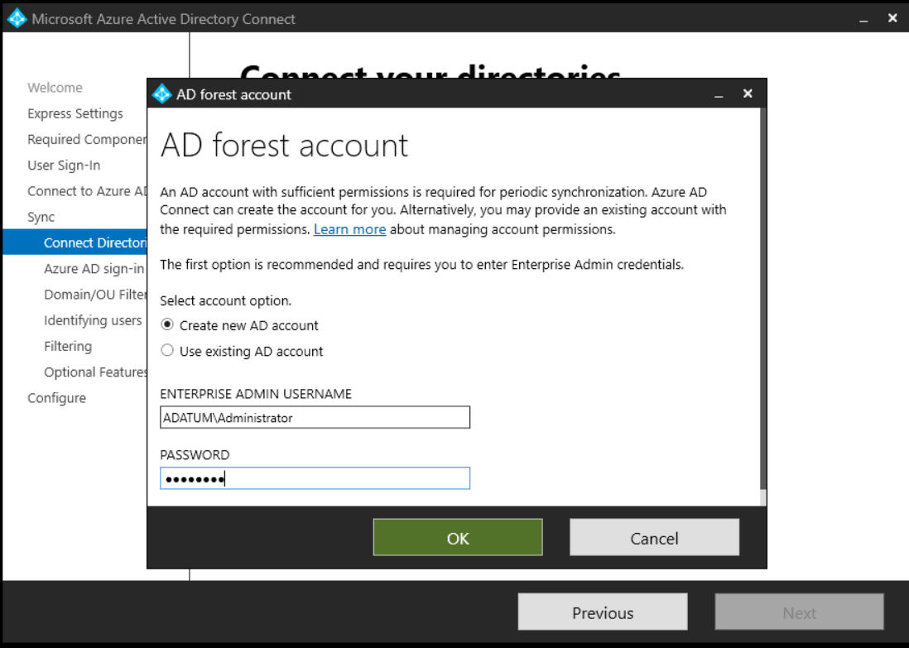

1. Back on the **Connect your directories** page click on **Next.**

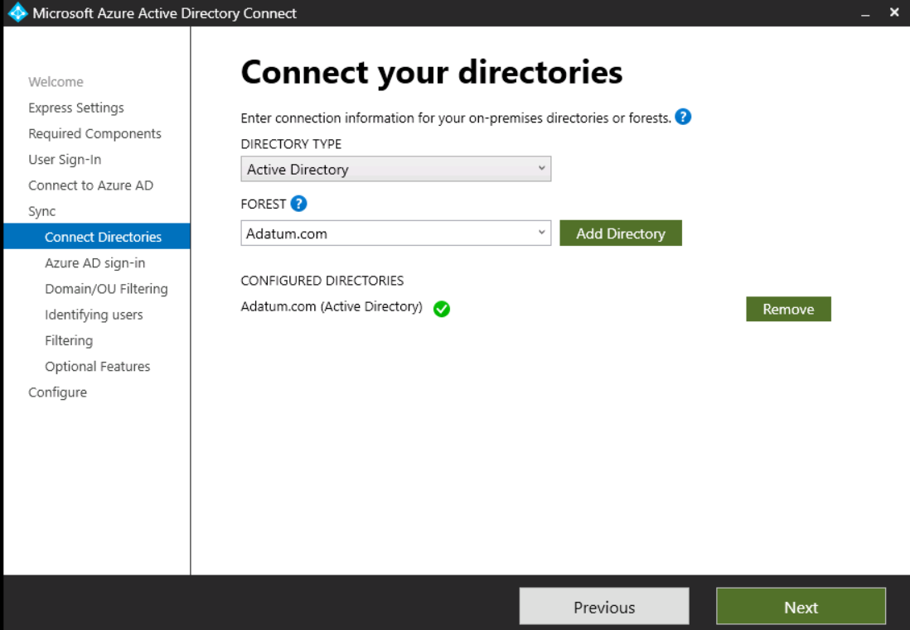

1. On the Azure AD sign in configuration page select the check box for **Continue without matching all UPN suffixes to verified domains** check box and click **Next**.

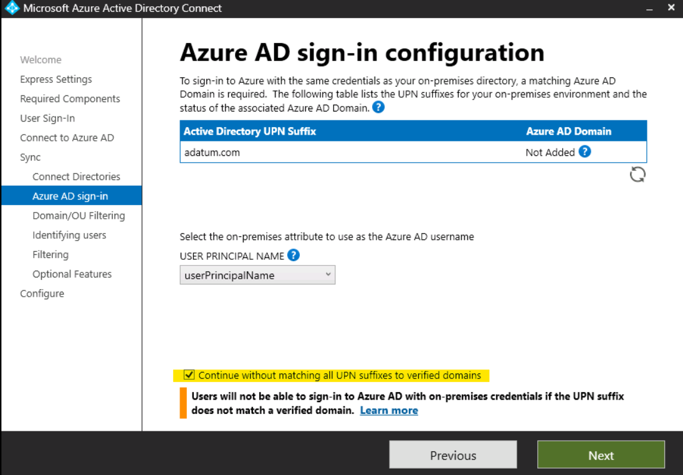

1. On the **Domain and OU filtering** page select the Sync **selected domains and OUs** radio button and only select the **IT** OU and then click on **Next**

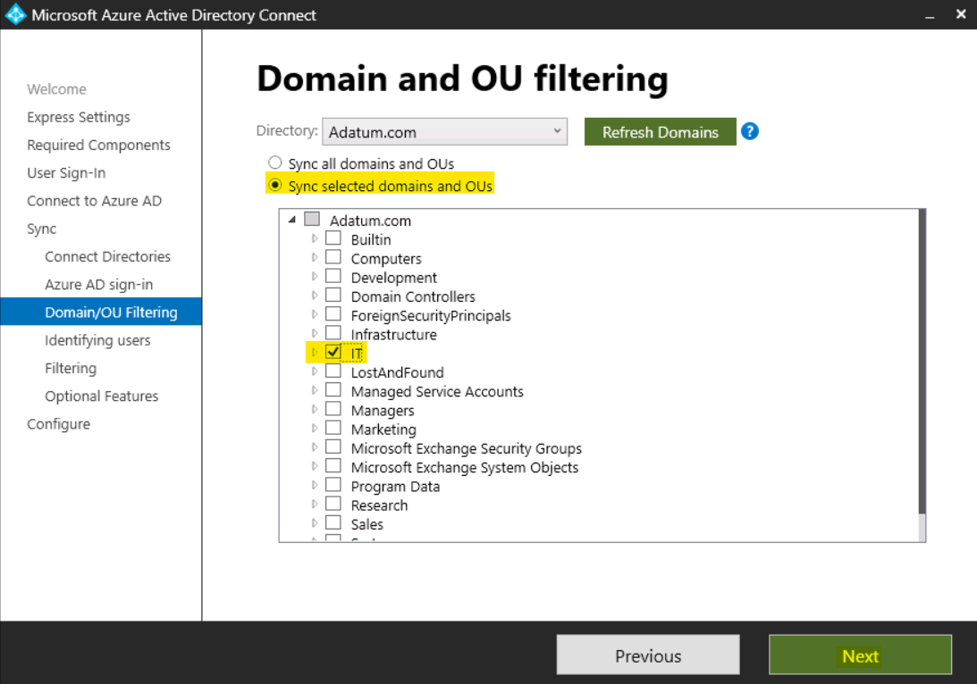

1. On the **Uniquely identify your users**, leave the default values and click on **Next**.
2. On the **Filter users and devices**, leave the default values and click on **Next**.
3. On the **Optional features**, leave the default values and click on **Next**.
4. On the **Ready to configure** page, click on the **Install** button.

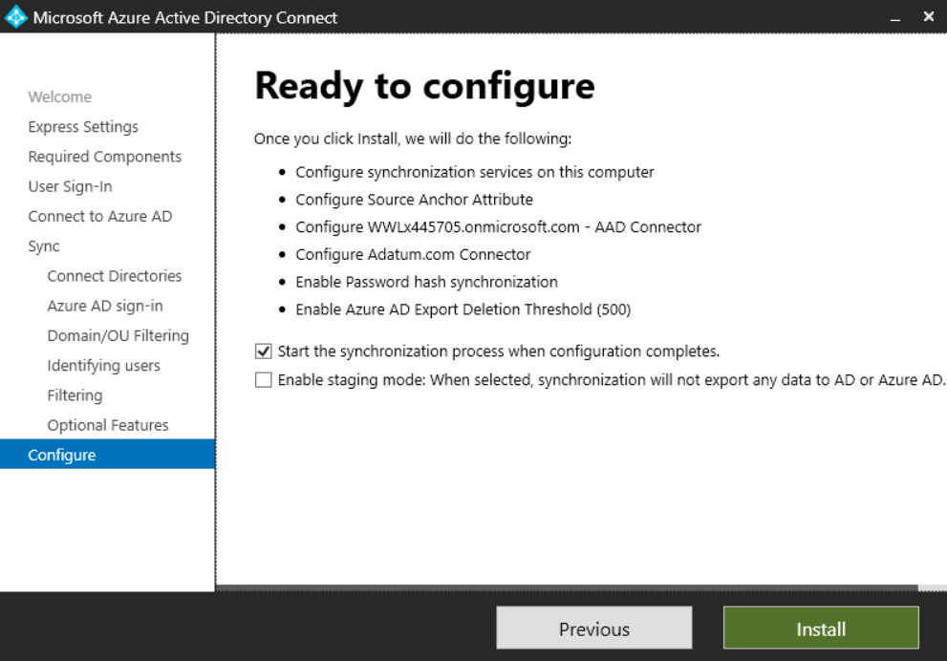

1. Once the installation is complete, select **Exit**.

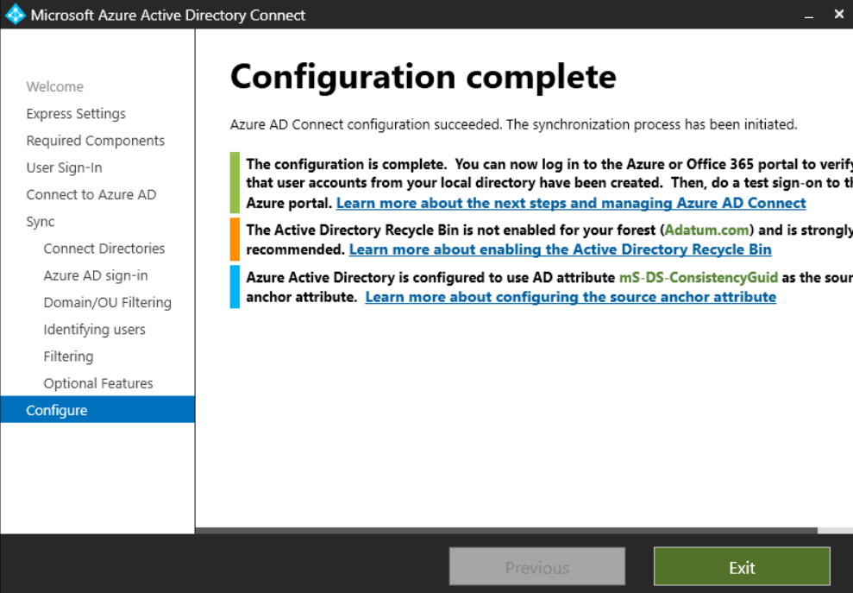

### Task 2 – Verify users are created and synchronization is occurring with Microsoft Entra ID

We will now verify that the users that we had in our on-premises directory have been synchronized and now exist in Microsoft Entra ID tenant. To verify users are synchronized do the following.

1. Switch back to the browser with the **Microsoft Entra admin center** opened, then select **Identity**, expand **Users**, select **All users**.

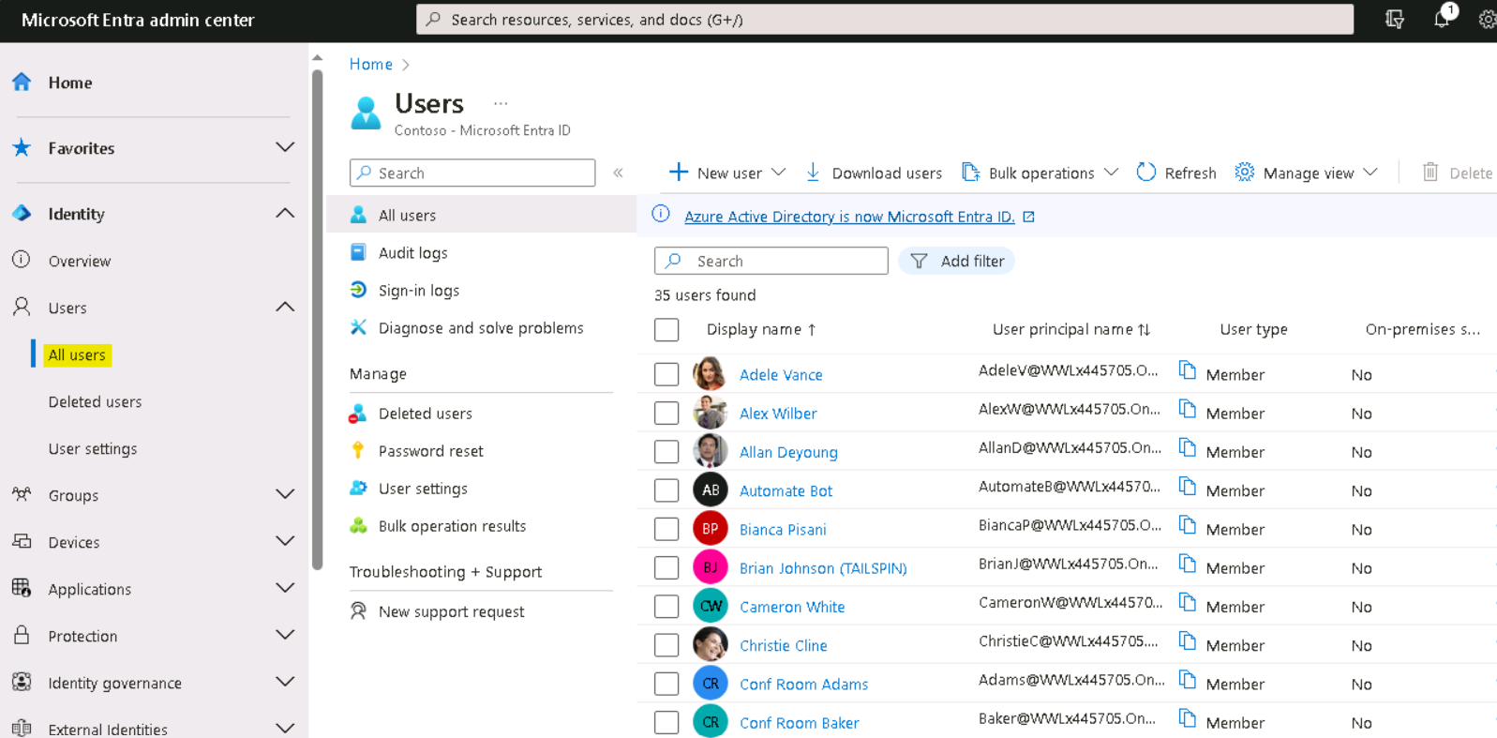

1. If required click on the Refresh button and verify that you see the new users in our tenant, the **On-premises synced** enabled.

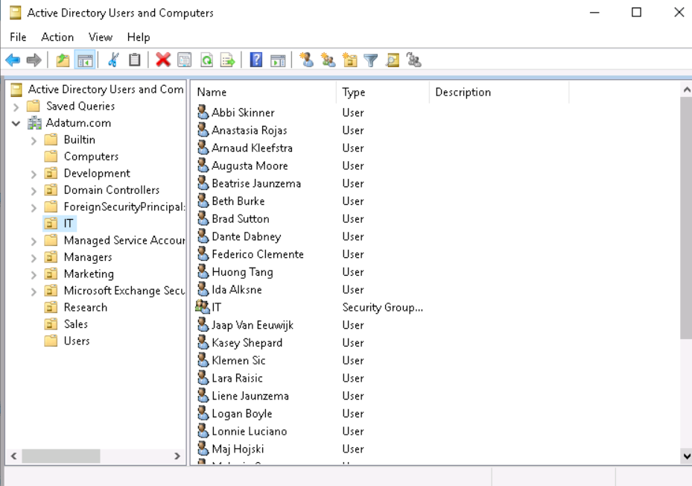

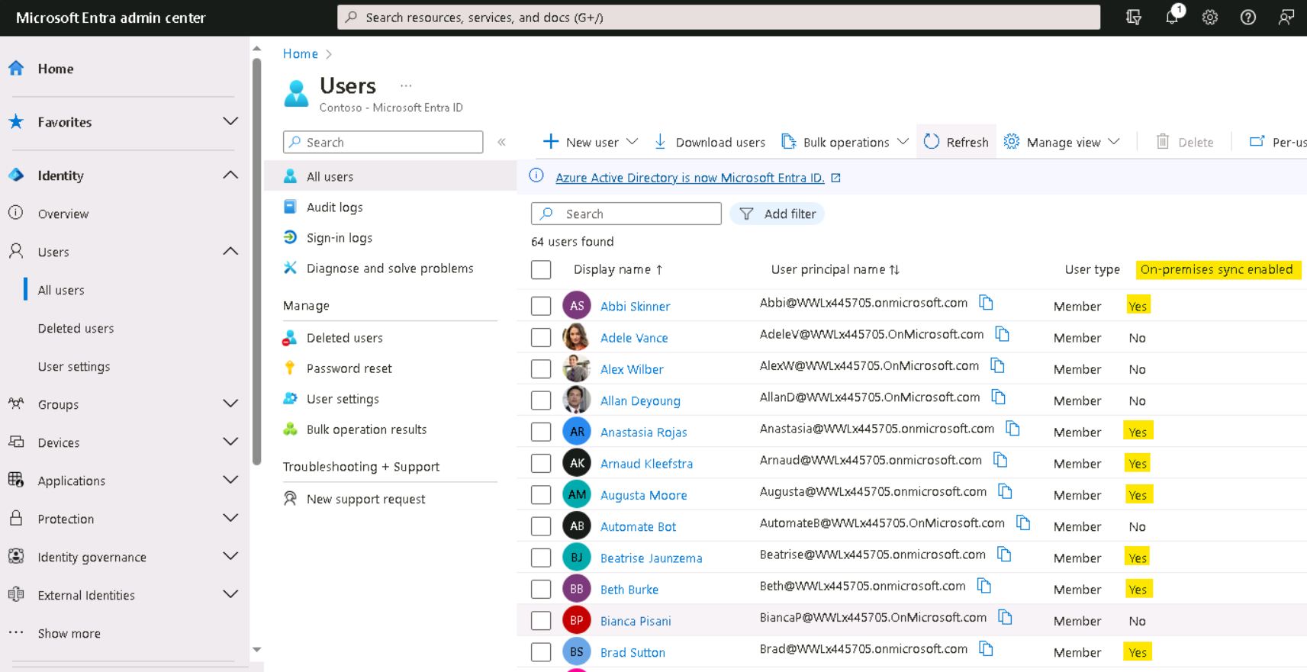

1. From the list of users, select the user **Abbi Skinner**, then click on **Edit properties**

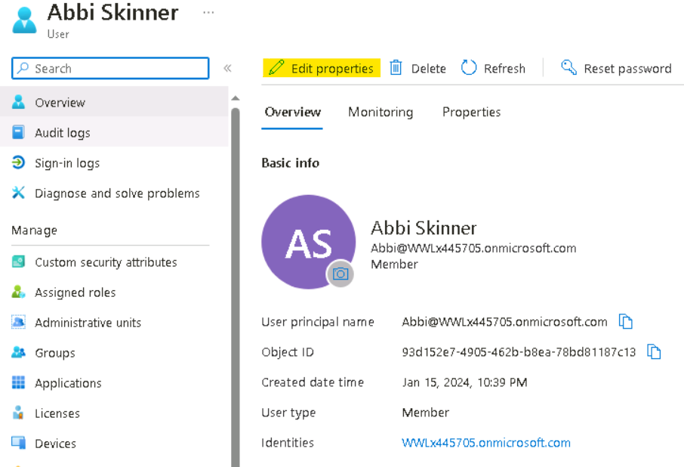

1. Select the **Settings** tab, then from the drop-down choose **United states** for Usage location and then click on the **Save** button.

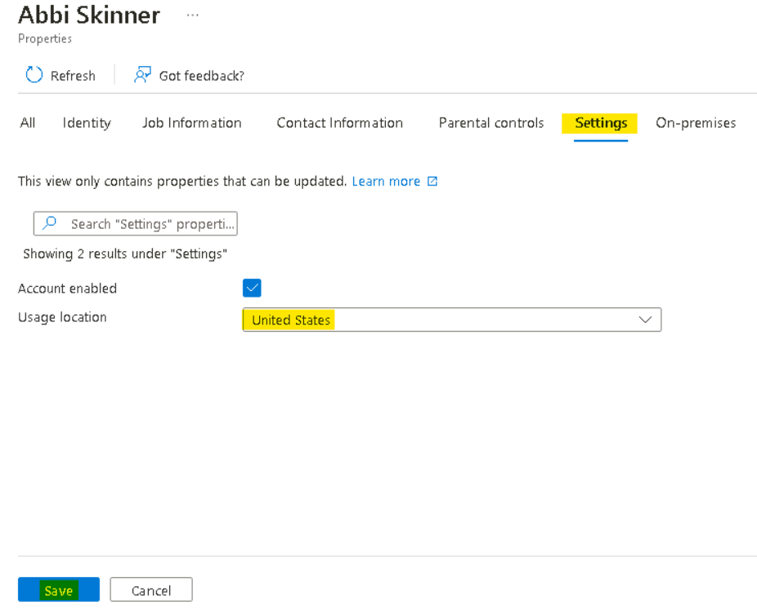

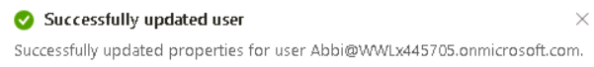

1. Repeat the same steps to verify the Usage location for the below users.
   * Beth Burke
   * Huong Tang
   * Logan Boyle

**Note** - Usage location is necessary while assigning a License, the License assignment will fail for a user who does not have a Usage location.

## Exercise 3 – Create Groups and assign Licenses from Microsoft Entra admin center.

### Task 1 - Create Groups and assign Licenses

1. Open the Edge browser and login to the **Microsoft Entra admin center +++https://entra.microsoft.com+++**.
2. If prompted for credentials enter your **Office365 Tenant Credentials** provided on the **Home tab** of the lab Interface as show in the Image.
3. Select **Identity** expand the **Groups**, select **All groups** then click on **New group**.

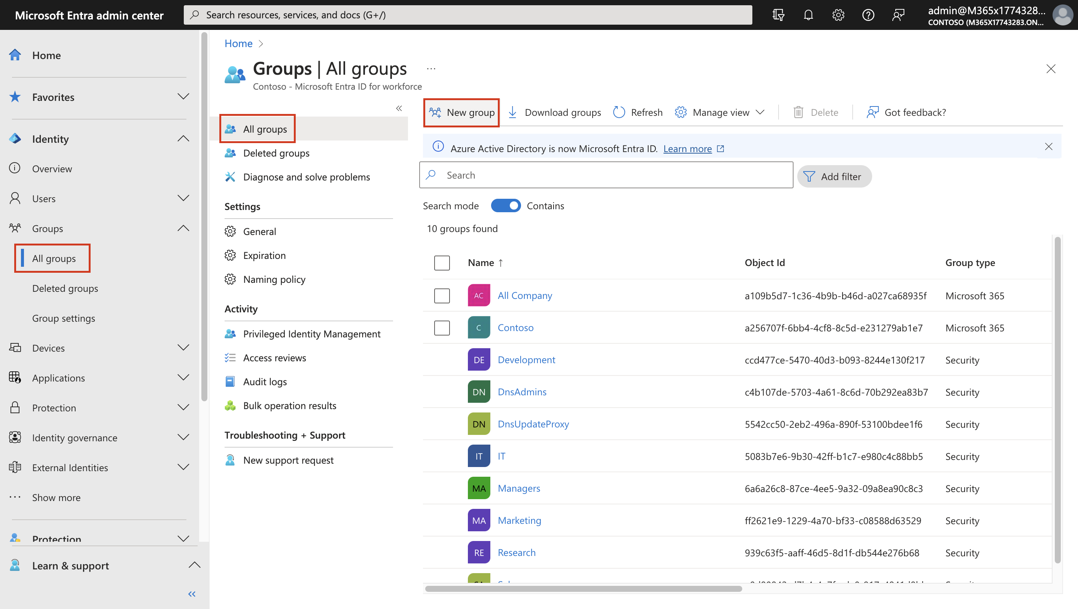

1. The **New Group** pane will appear, provide the below details.
   * Group type – **Microsoft 365**
   * Group name – **+++Sales101+++**
   * Group email address – **+++Sales+++**
   * Group Description – **+++Group for users in Sales department+++**
   * Microsoft Entra roles can be assigned to the group – **Yes**
   * Scroll down and click on link – **No members selected**

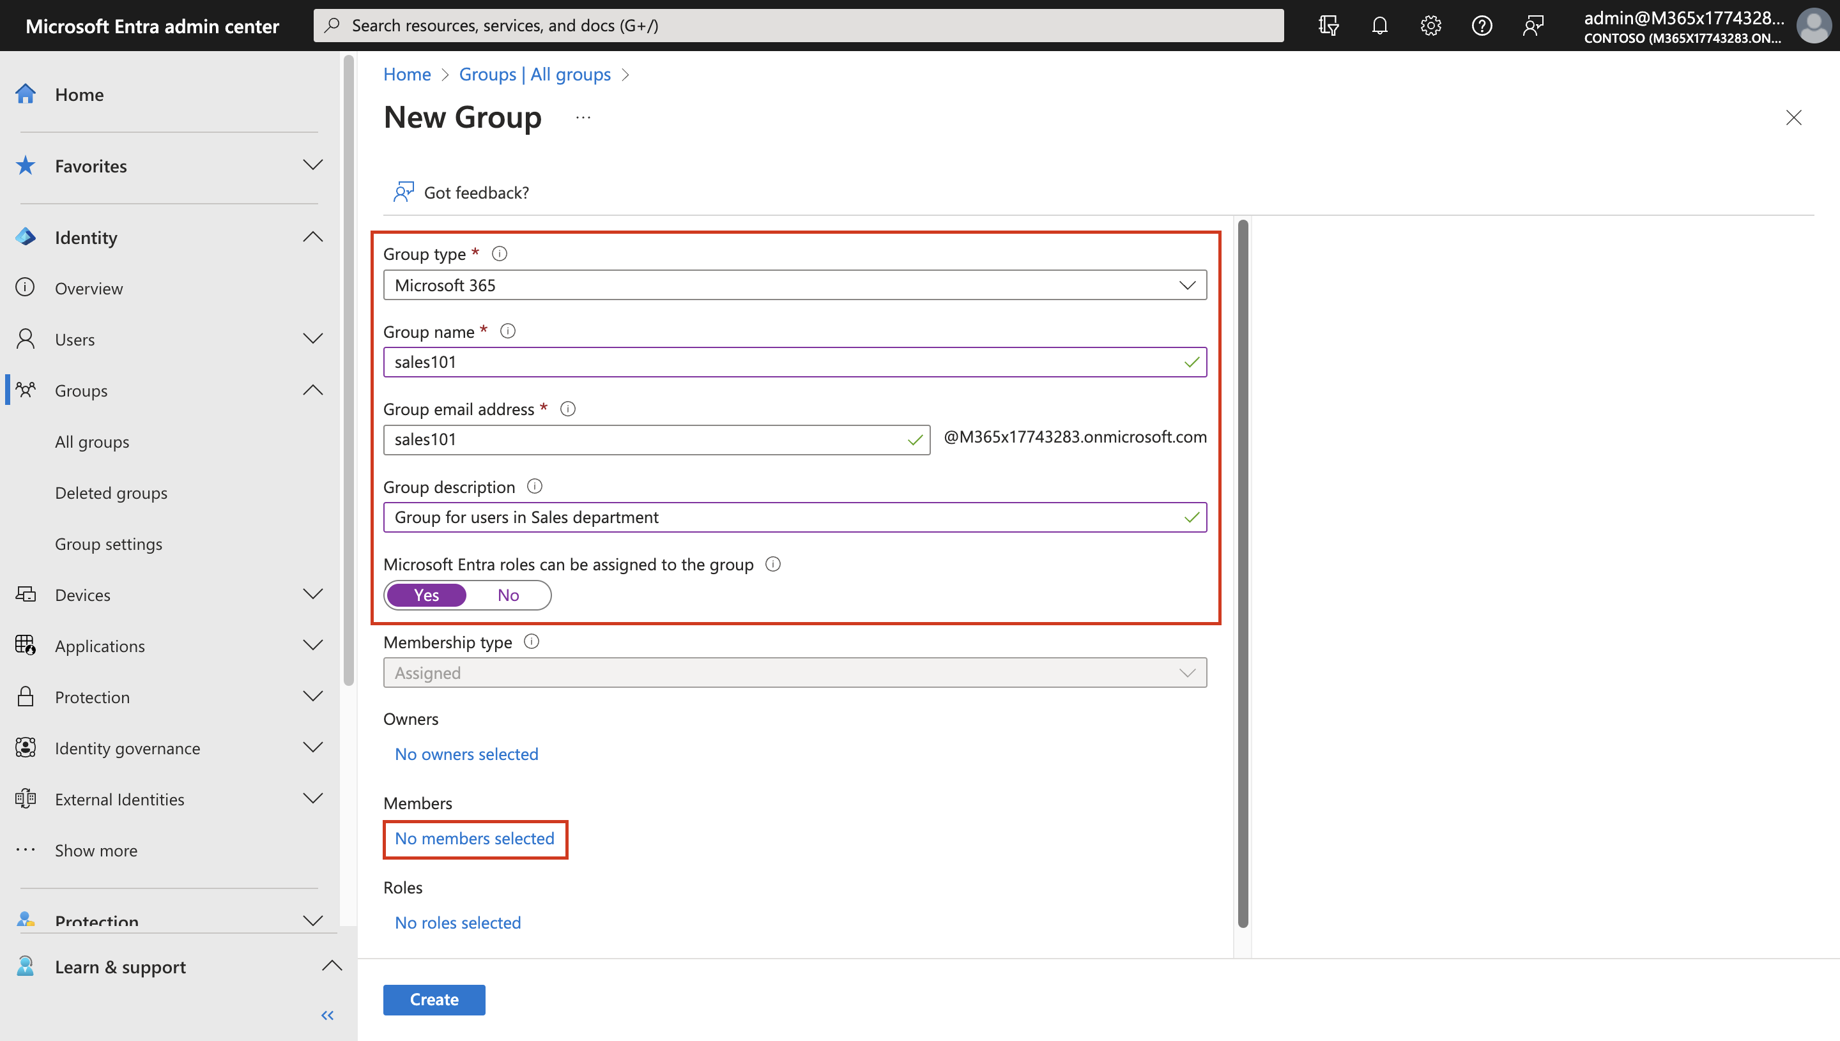

* + On the Add members tab, add **Abbi Skinner** and **Huong Tang** and click on **Select**.

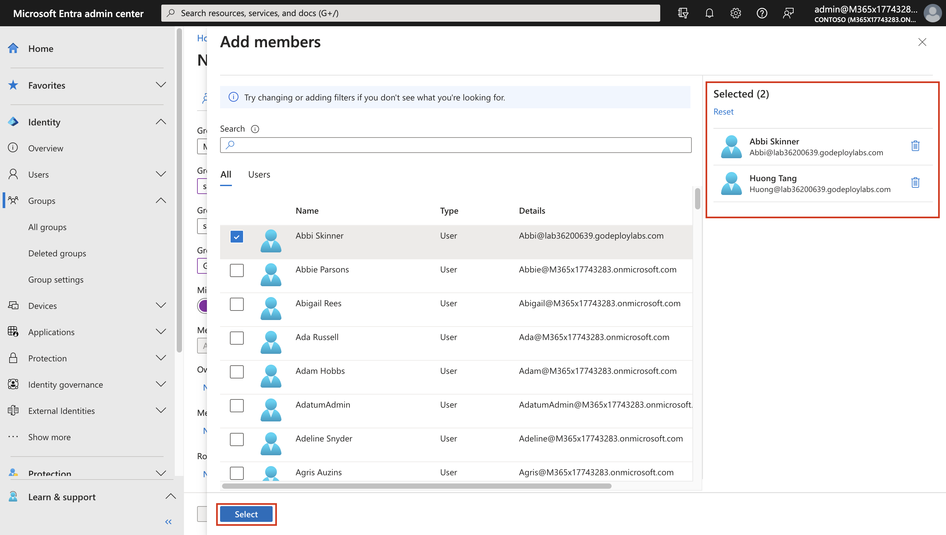

* Click on **Create**.

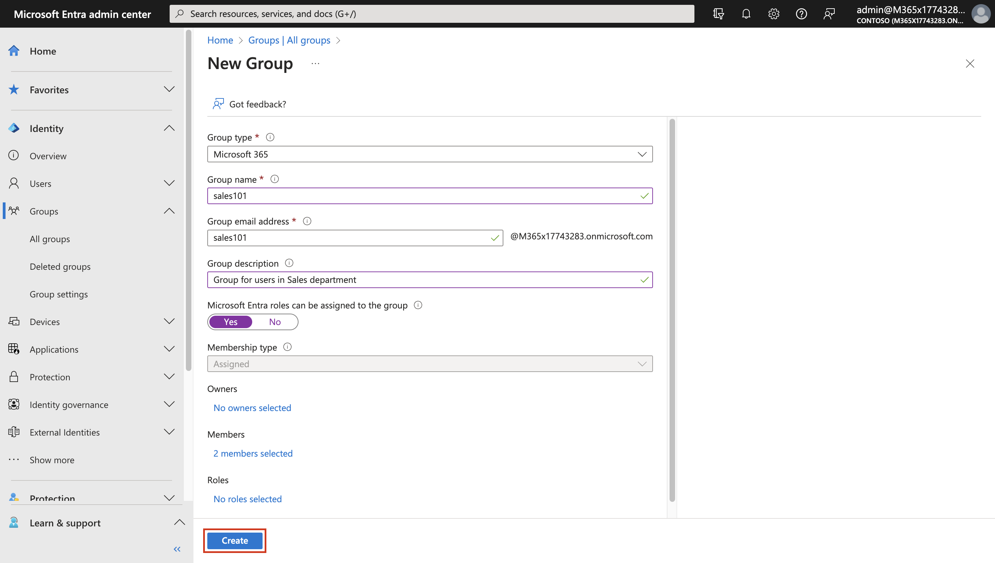

1. You will get a prompt as shown in below image, click **Yes**.

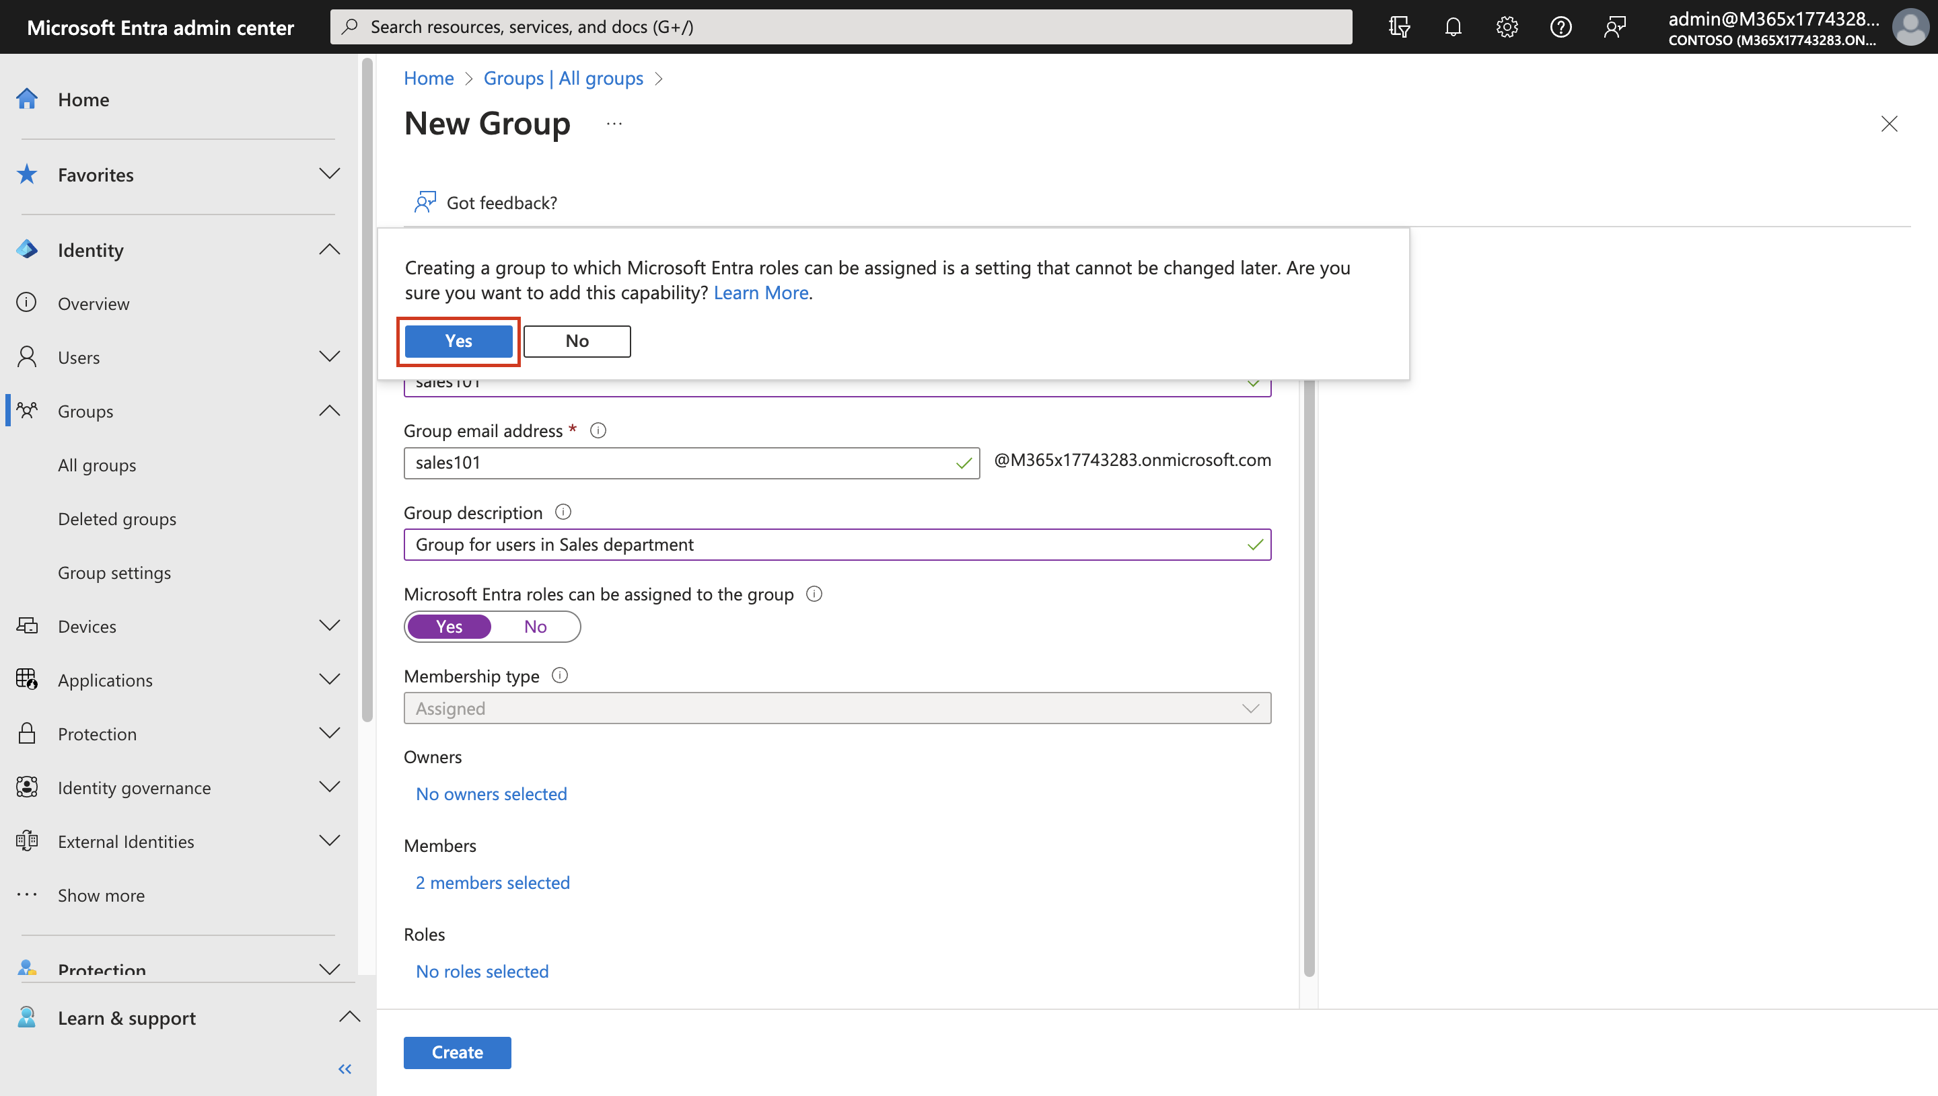

1. Your group is created, and you will get a successful notification.

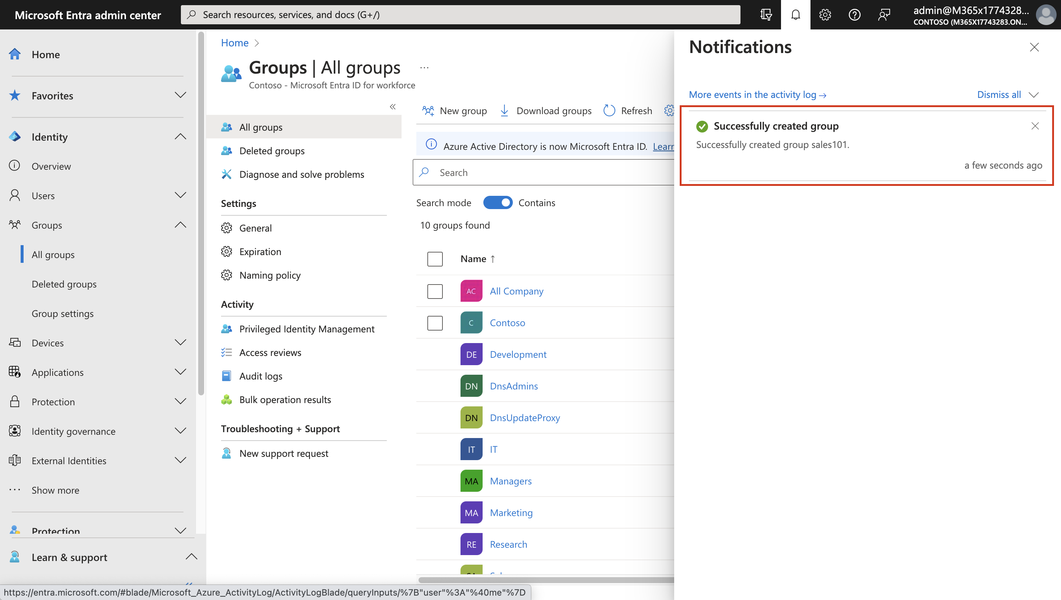

1. Repeat the steps 3-5 to create another group with below details

* Group type – **Microsoft 365**
* Group name – **+++Research101+++**
* Group email address – **+++Research101+++**
* Group Description – **+++Group for users in Research department+++**
* Microsoft Entra roles can be assigned to the group – **Yes**
* Members – **Beth Burke** and **Logan Boyle**

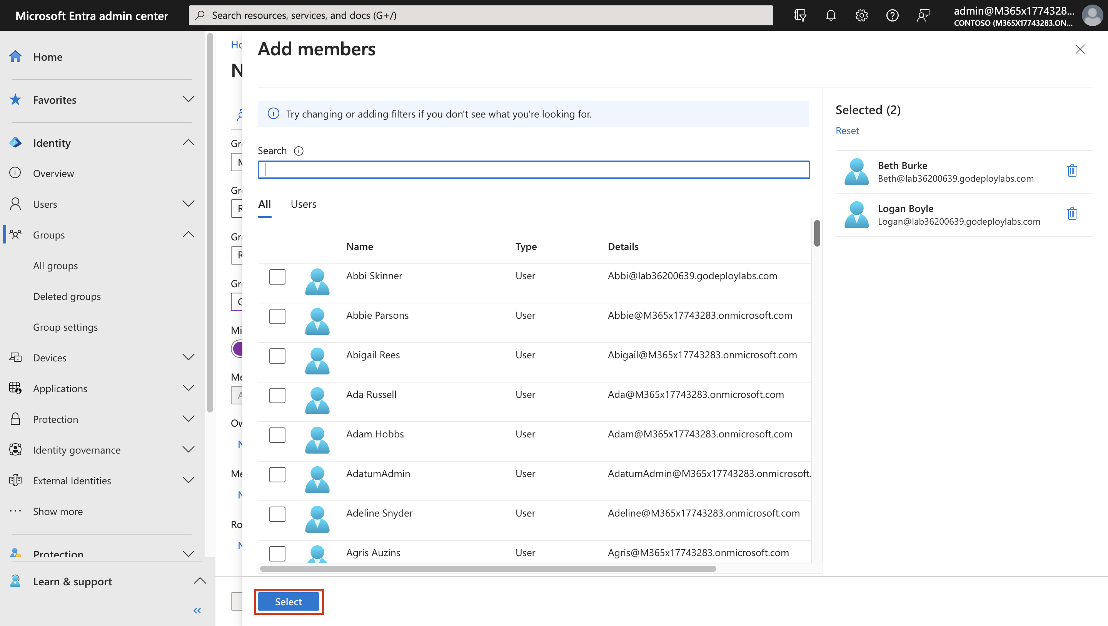

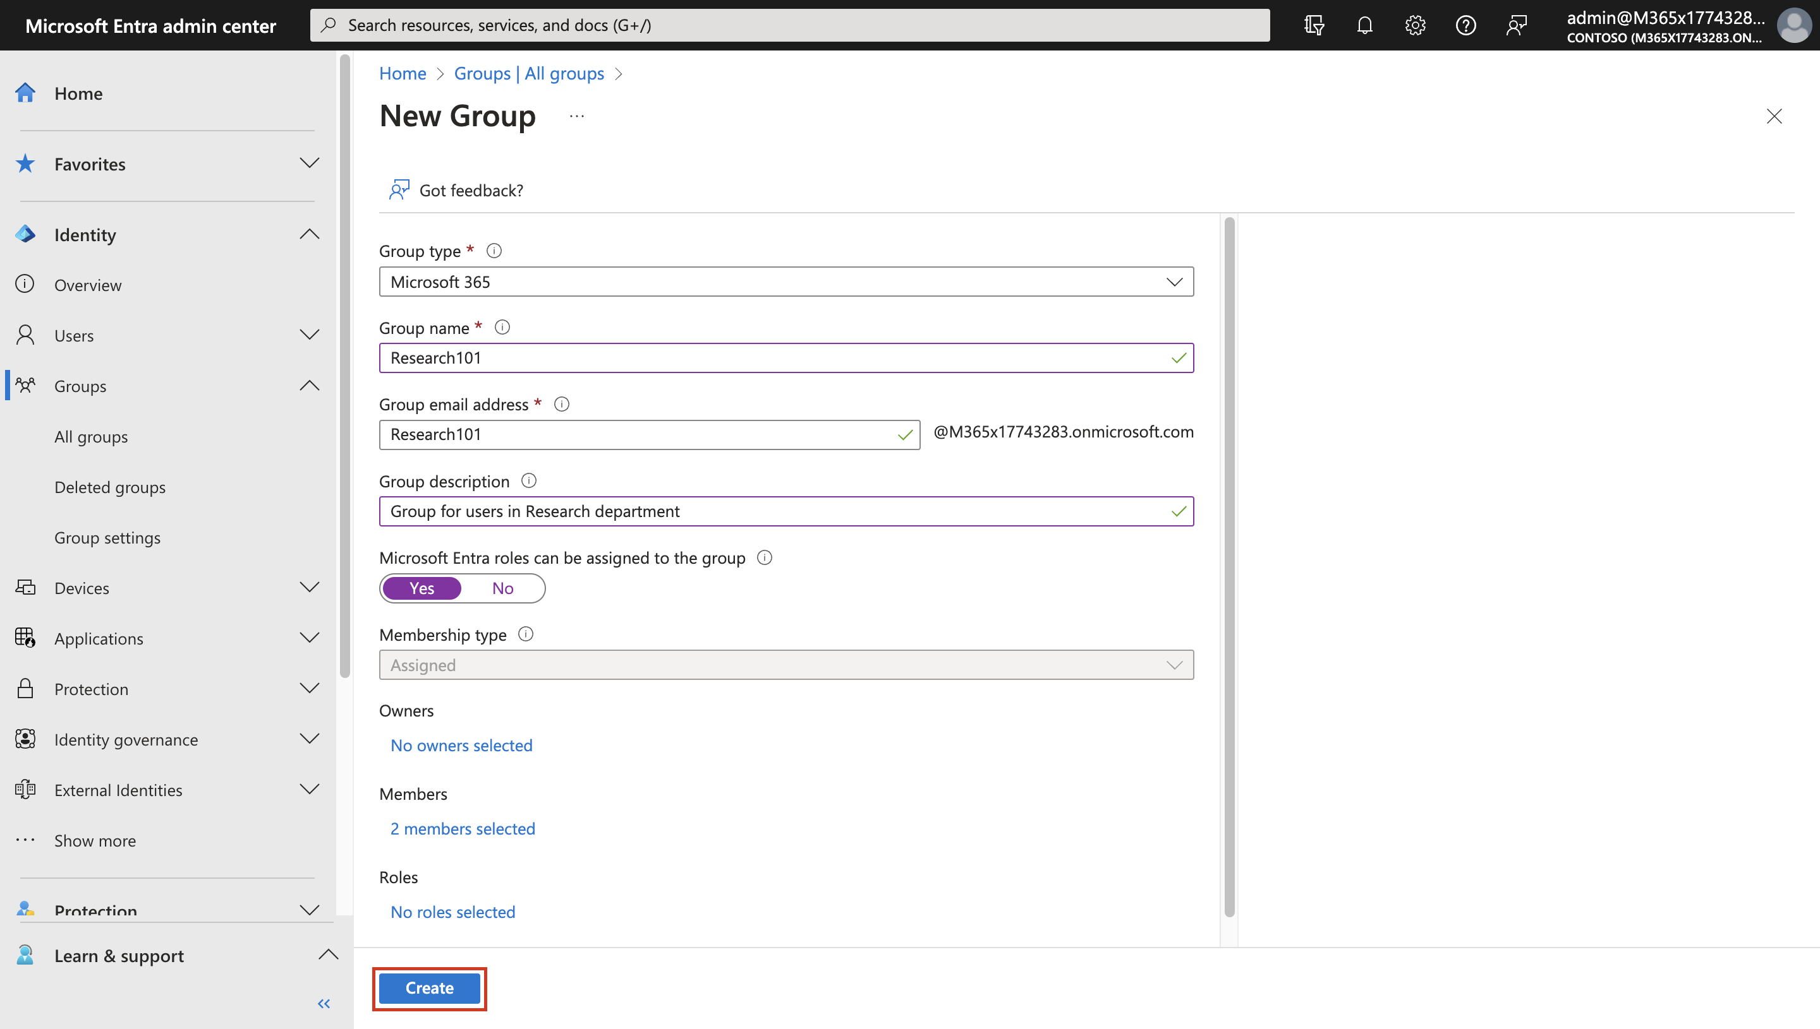

1. Once both the **Groups** have been created, click on the **Refresh** button and the Group list should appear as shown in the below image.

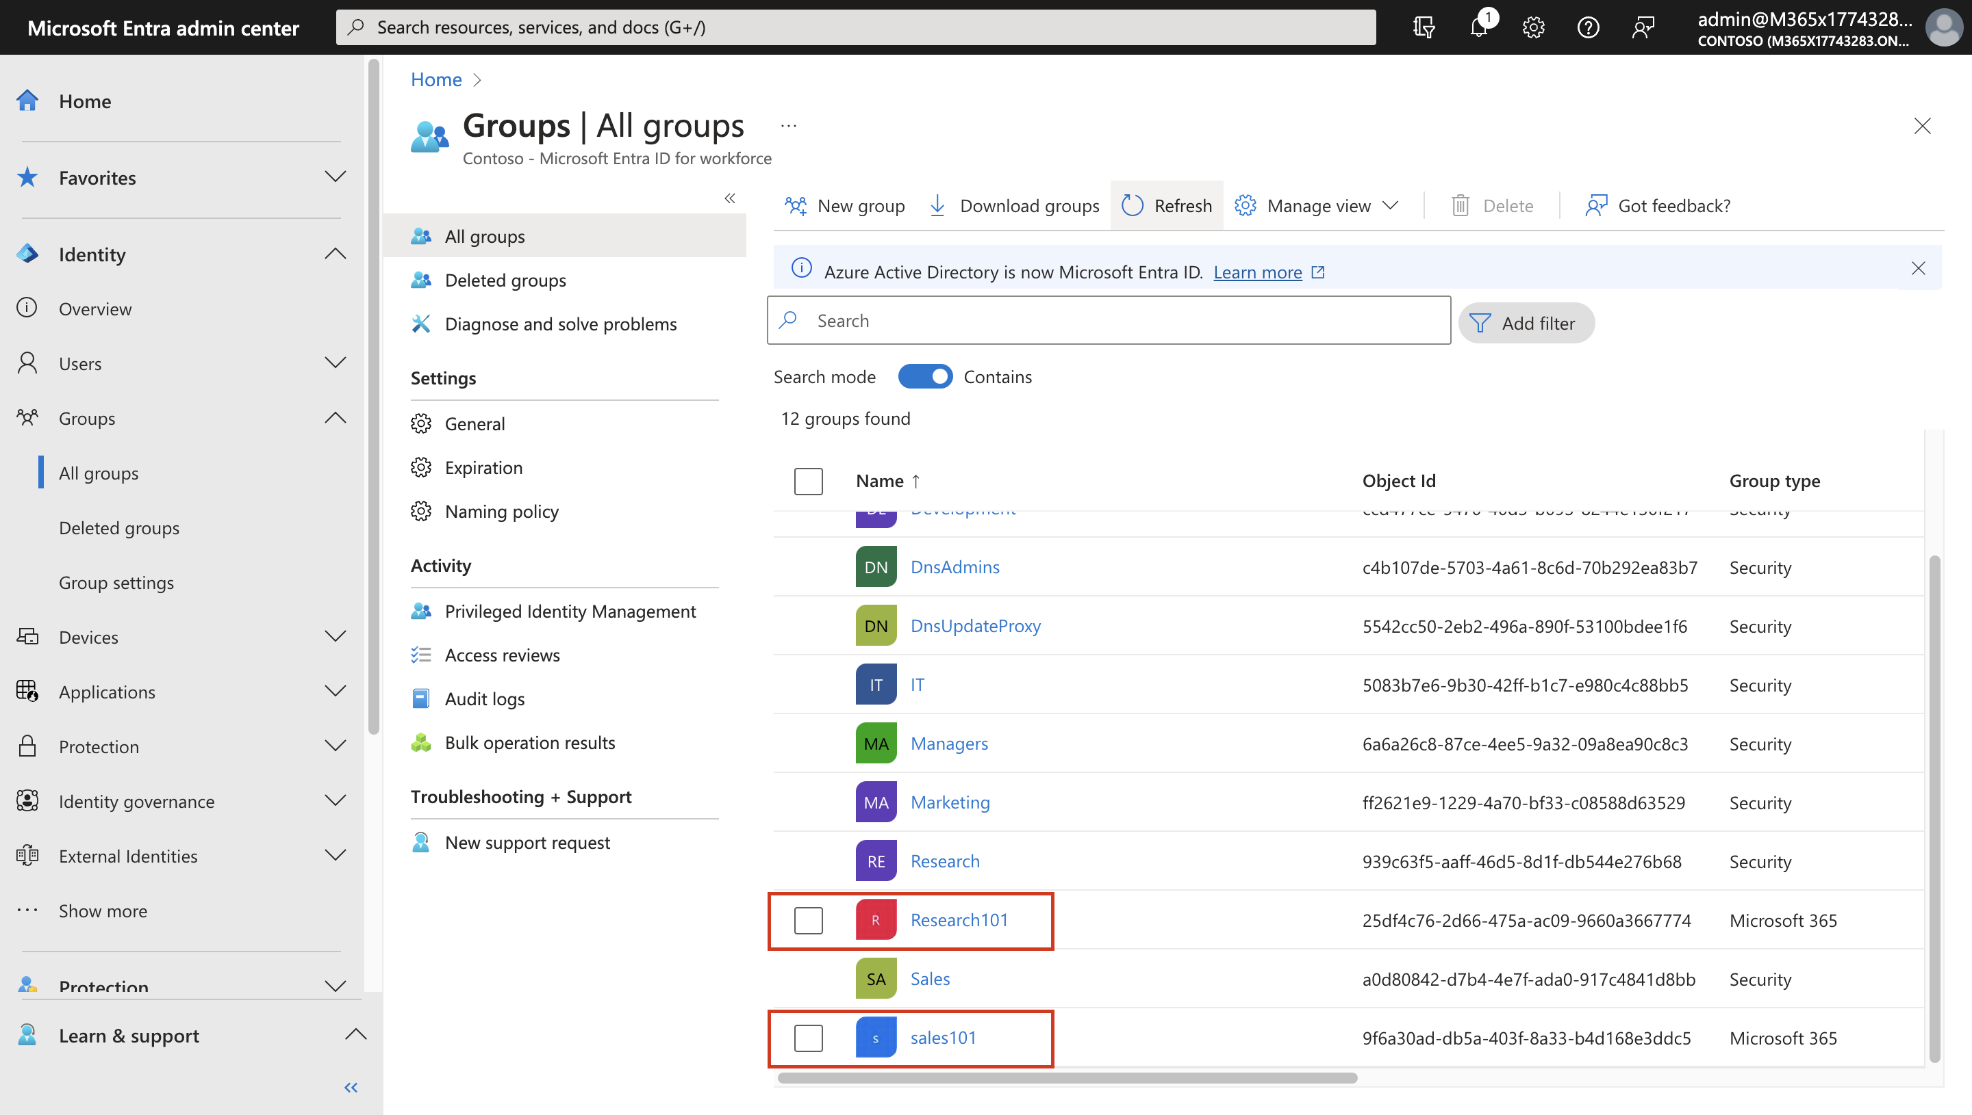

1. While in the **Microsoft Entra admin center**, click on **… Show more**.

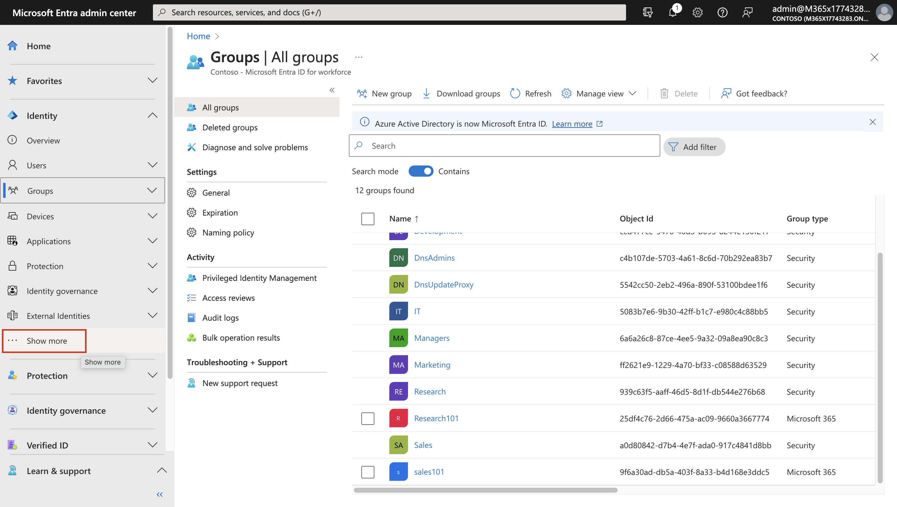

1. Expand **Billing** then click on **Licenses**, then select **All Products**.

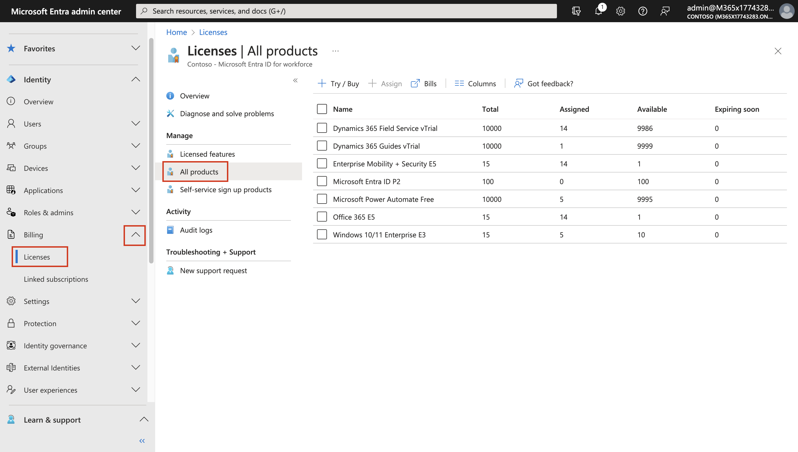

1. Click on the **Microsoft 365 E5** license, you will notice that **20/20** licenses have been assigned, we will release few licenses to be used for the upcoming steps.

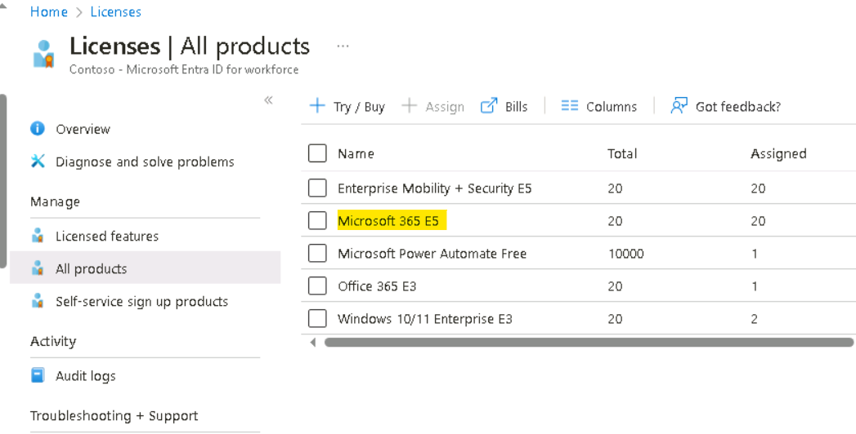

1. From the list of users select the below users and then click on Remove license
   * 1. Lee Gu
     2. Nestor Wilke
     3. Patti Fernandez
     4. Pradeep Gupta

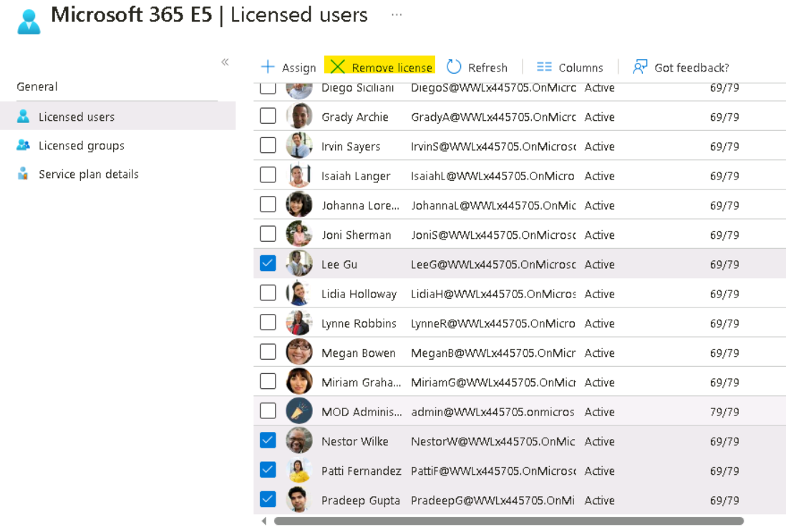

1. When prompted to Remove license click on the **Yes** button.

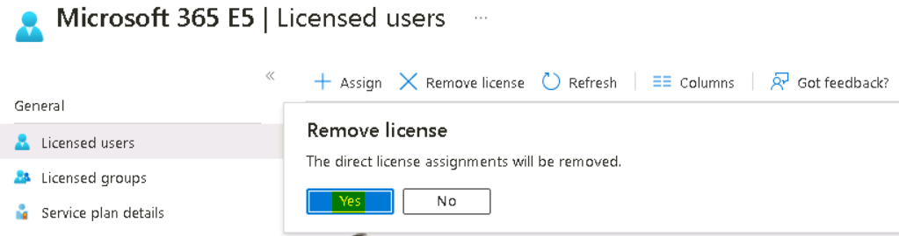

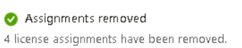

1. Close the **Microsoft 365 E5** blade and then refresh the page, now the available number should be **4.**

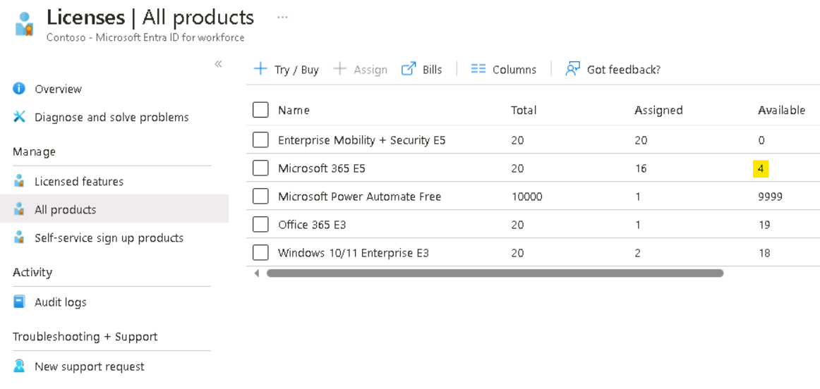

1. Select **Microsoft 365 E5** and **Office 365 E5** licenses and then click on **+ Assign**.

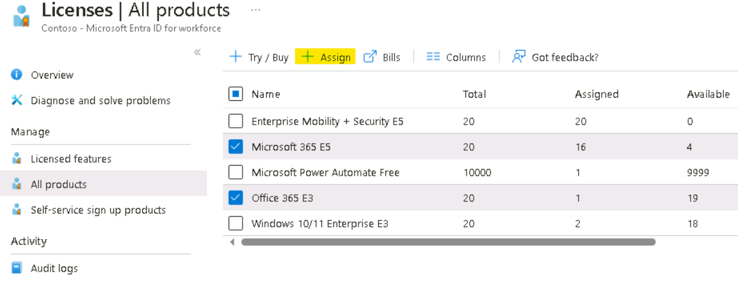

1. On the **Assign license** window, on the **Users and groups** tab, select on **Add users and groups**.

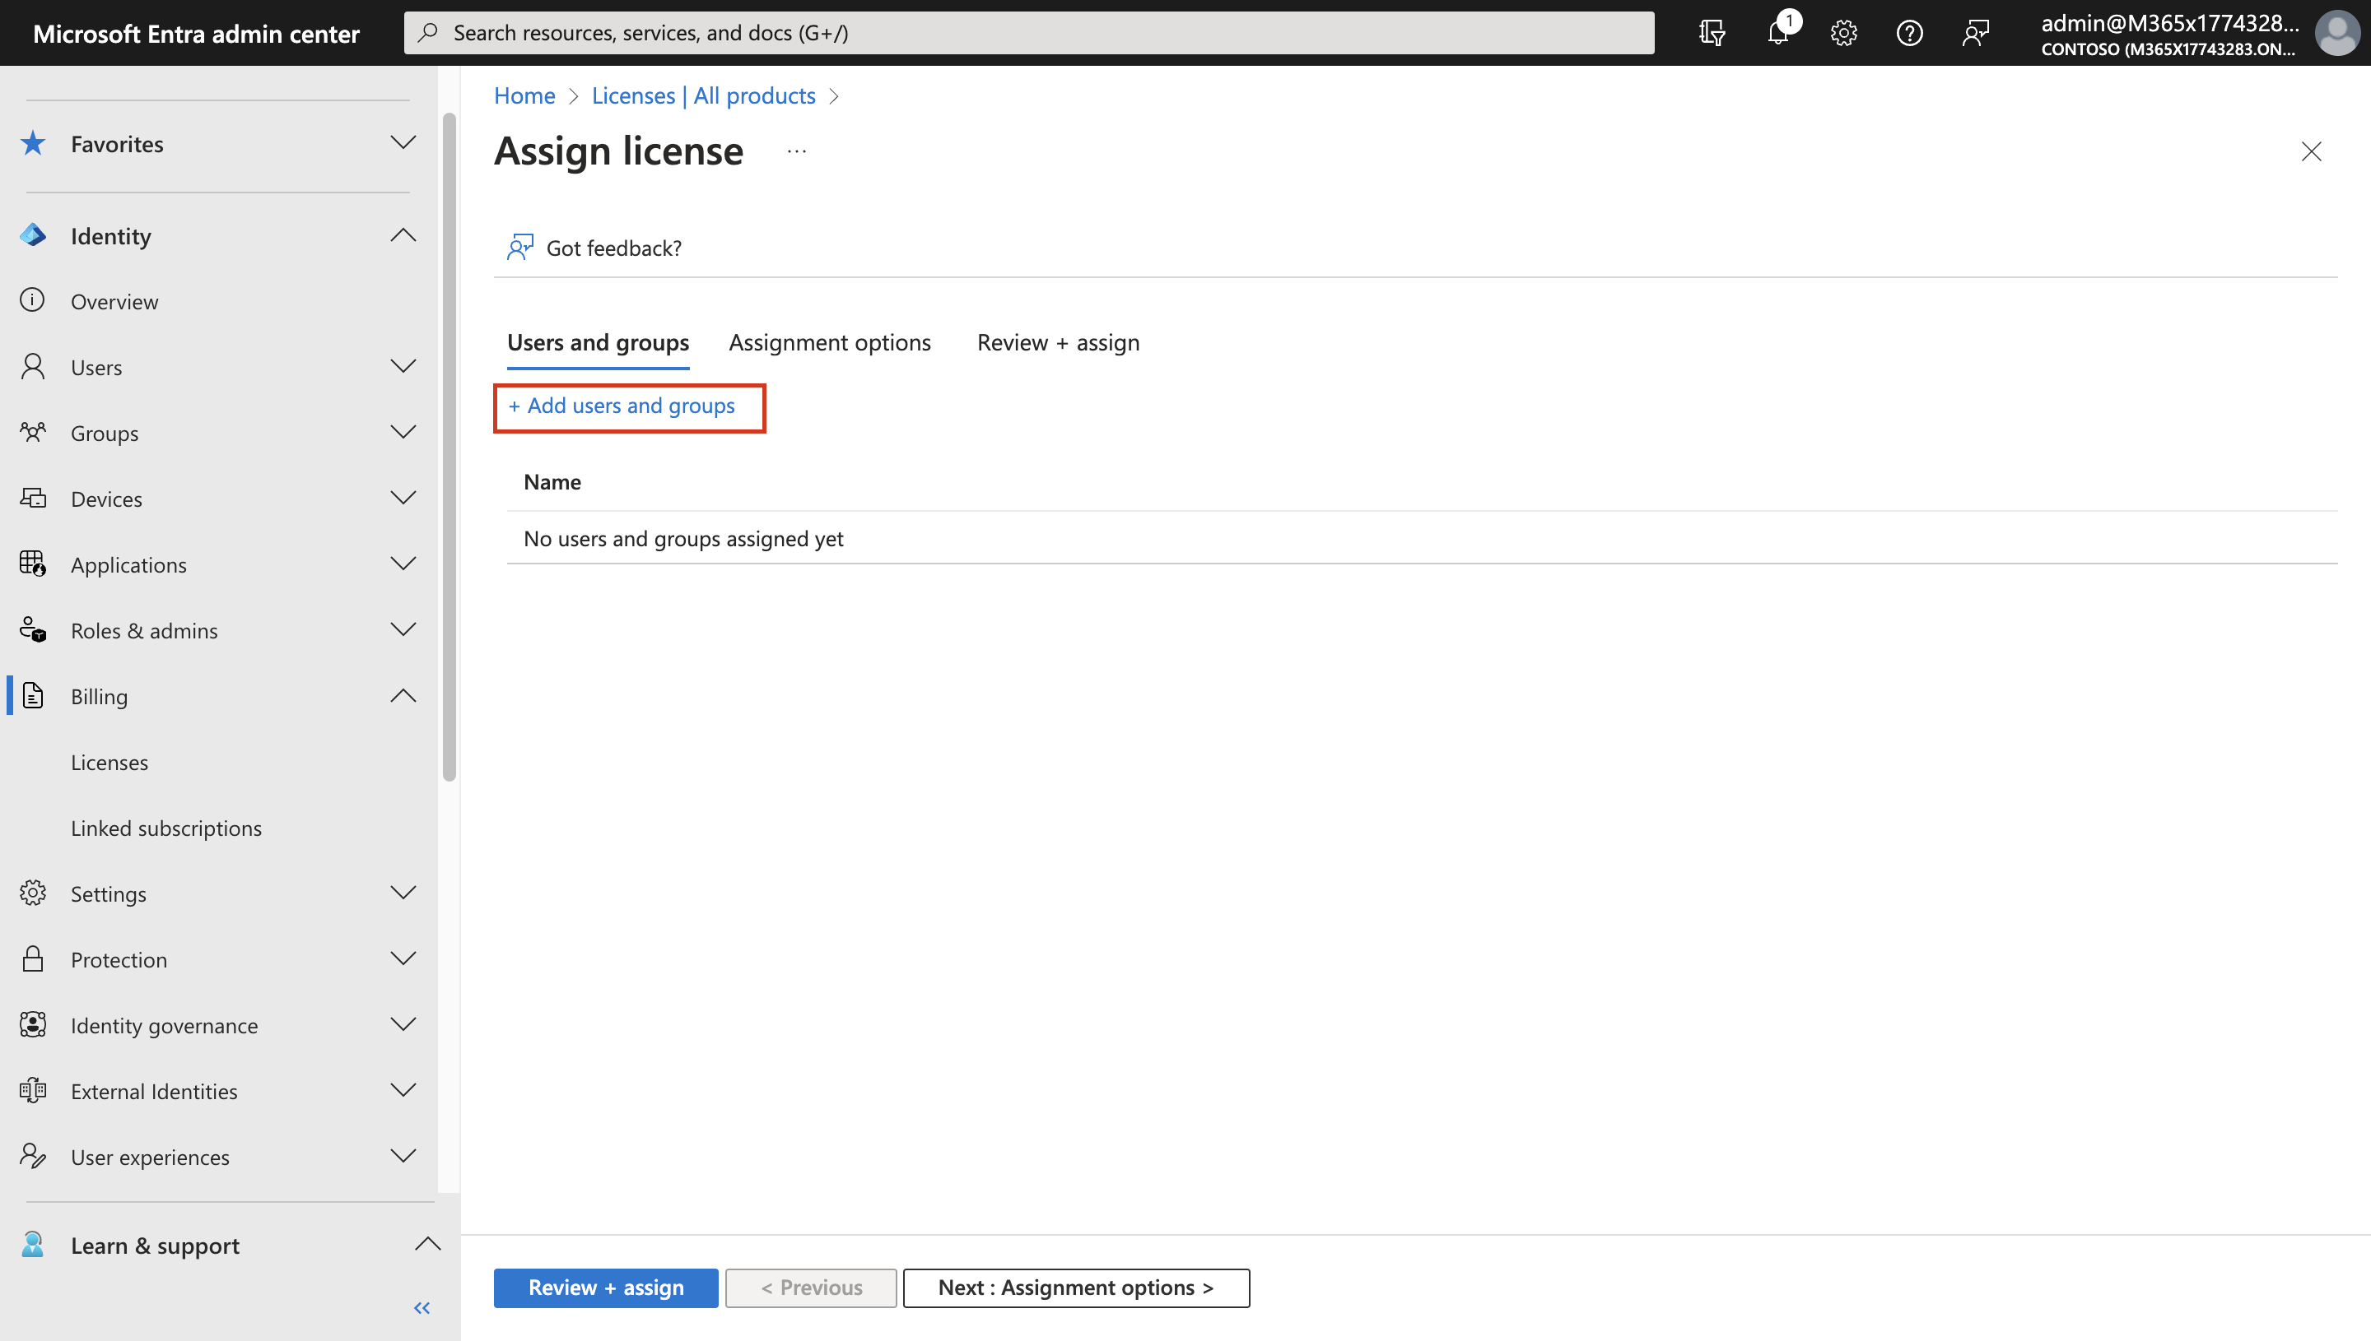

1. Under Groups tab, select the groups **Sales101** and **Research101**, then click on **Select**.

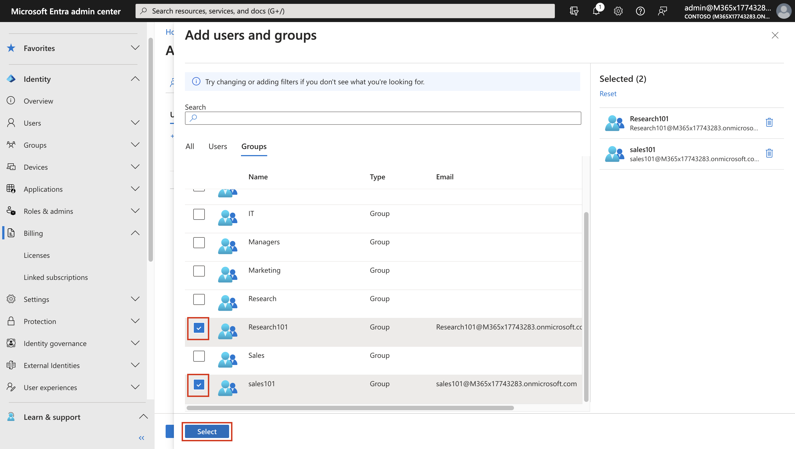

1. Click on **Review + assign**.

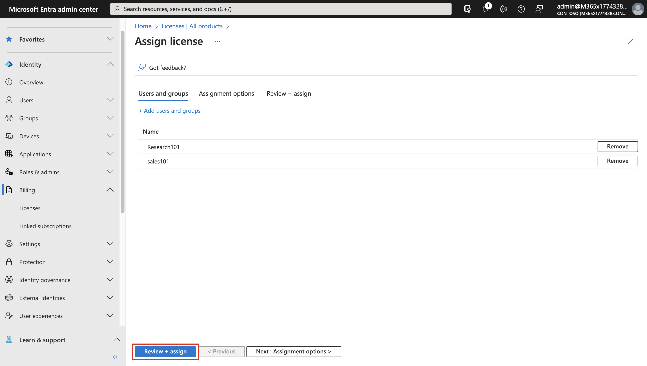

1. Click on **Assign**.

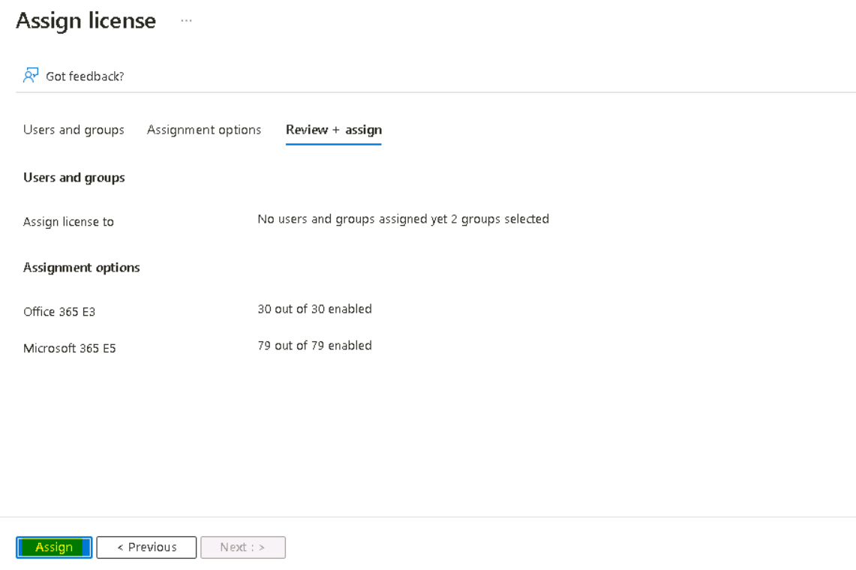

1. You should get the notification as shown in below image.

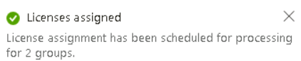

1. Both the Groups have the license assigned.

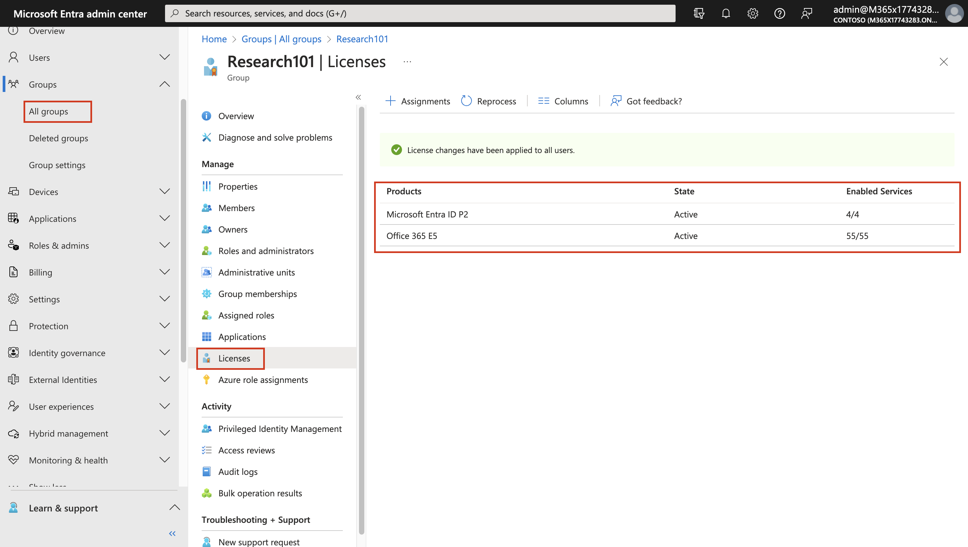

### Task 2 – Add a Guest account and create an External Collaborators group.

1. Open the Edge browser and login to the **Microsoft Entra admin center +++https://entra.microsoft.com+++**.
2. If prompted for credentials enter your **Office365 Tenant Credentials** provided on the **Home tab** of the lab Interface as show in the Image.
3. Select **Identity** expand **Users**, select **All Users**, the from the **New user** drop-down menu select **Invite external user**.

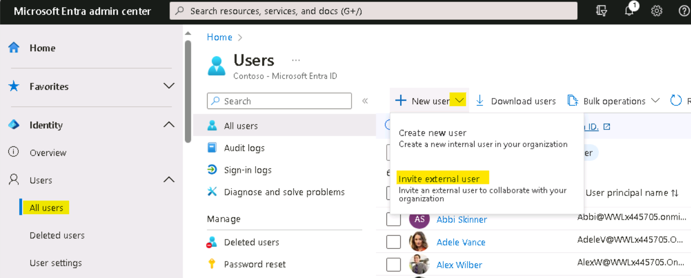

1. On the Invite external user page, provide the below details
   * Email – your personal outlook email address or create a new outlook email for testing.
   * Display name – **+++External User+++**
   * Message – **+++Invite to my Org+++**
2. Click on **Next: Properties >**

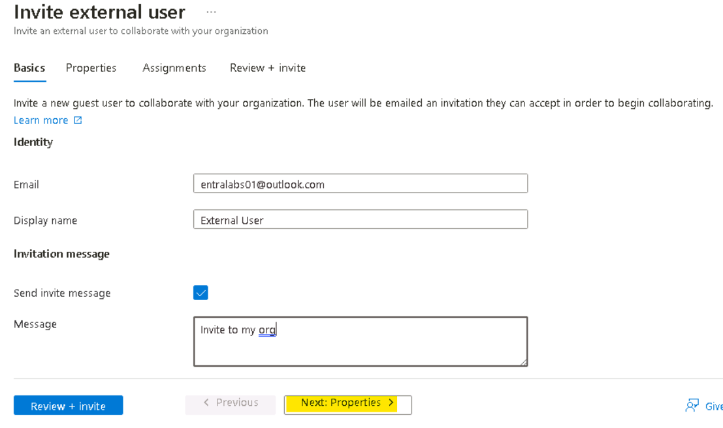

1. On the **Properties** tab, set the Usage location to **United States** and then click on **Review + invite** button.

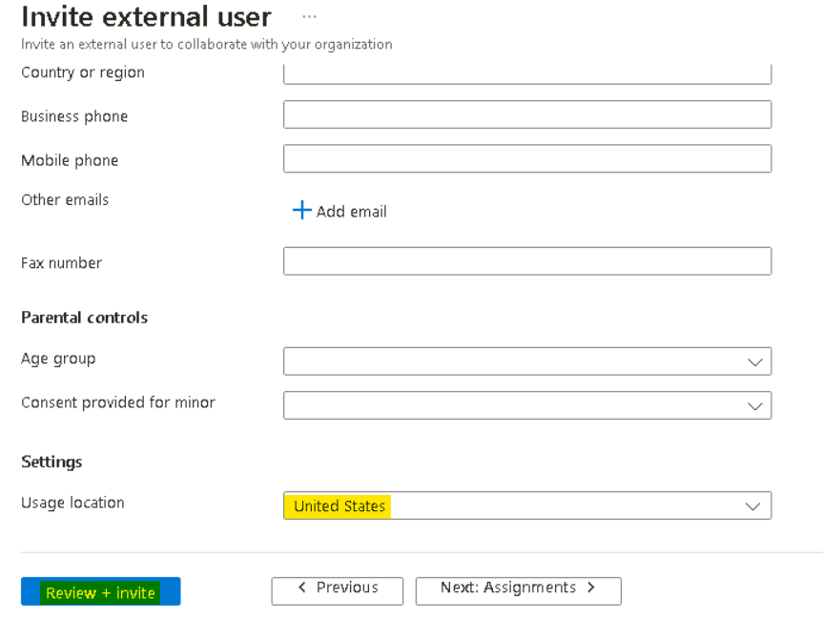

1. On the **Review + invite** tab, click on the **Invite** button.

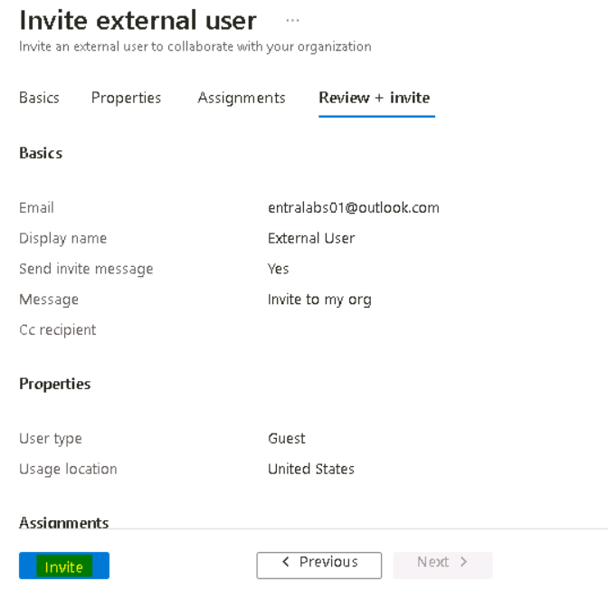

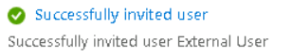

1. Open an InPrivate window and open the Outlook for the external account on which the invite was sent.

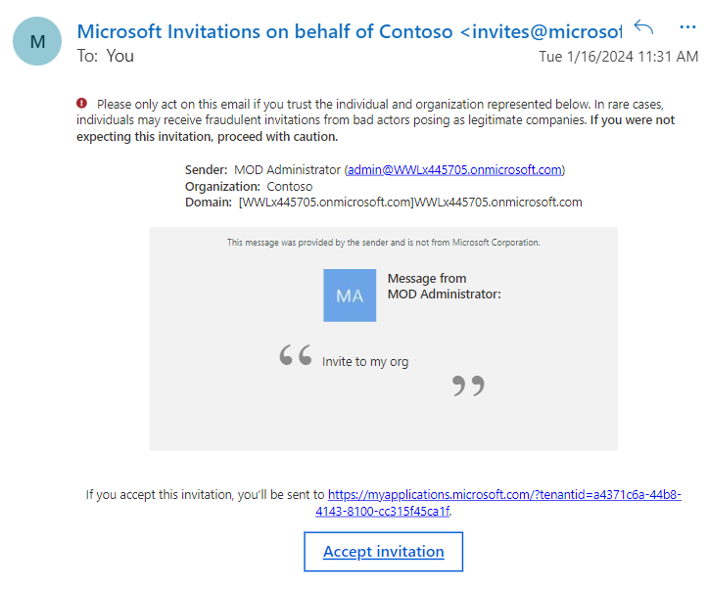

1. Click on the **Accept invitation** link.
2. Click on the **Accept** button to grant permission.

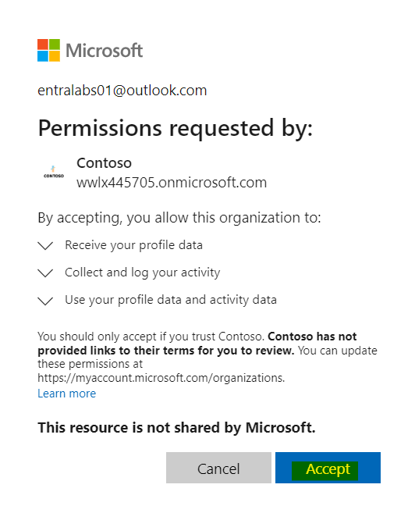

1. You should successfully be logged into My Apps portal for the Microsoft Entra Tenant.

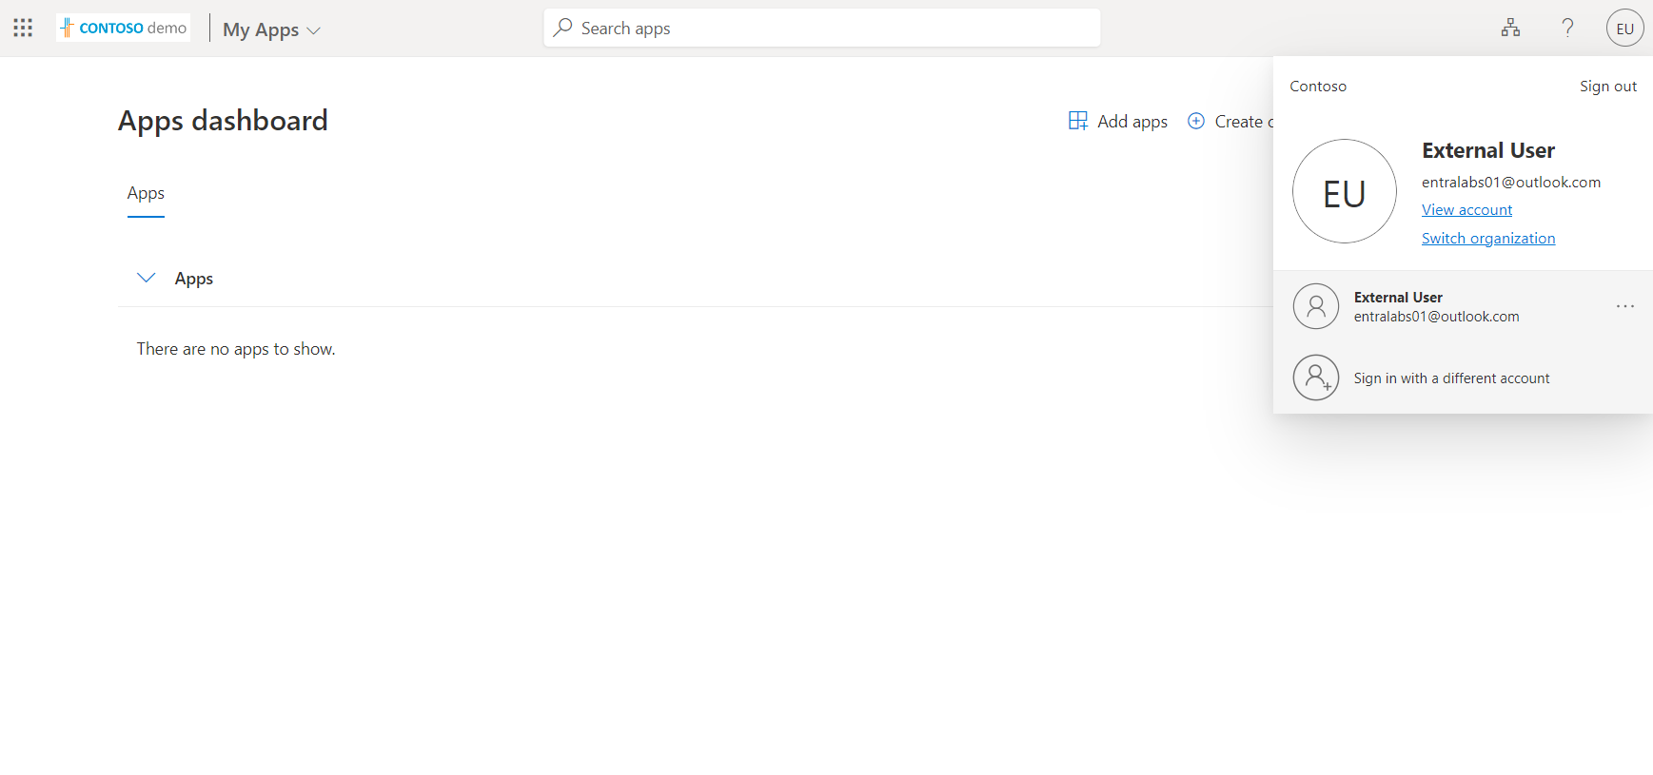

1. Switch back to the tab with **Microsoft Entra admin center** portal logged with Tenant admin.
2. Select **Identity** expand the **Groups**, select **All groups** then click on **New group**.



1. Create the group with below details.

* Group type – **Security**
* Group name – **+++External Collaborators+++**
* Group Description – **+++Group of External Users+++**
* Microsoft Entra roles can be assigned to the group – **Yes**

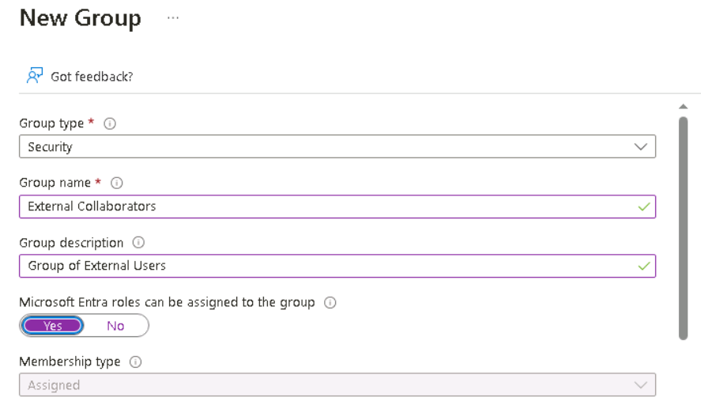

* Scroll down and add the Invited user account – External User and then click on **Select** button.

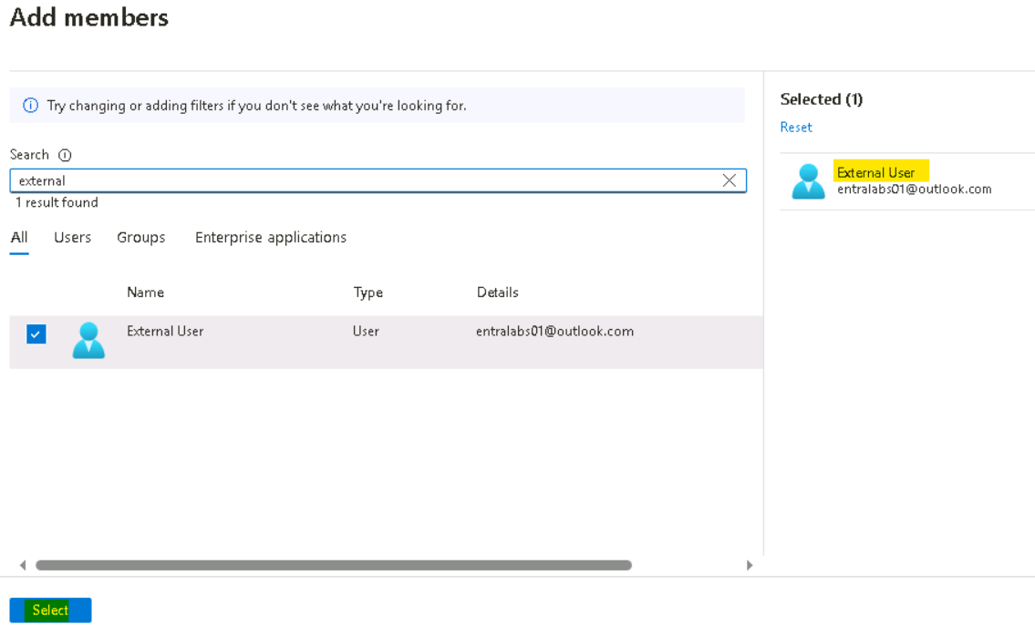

1. Click on **Create** button

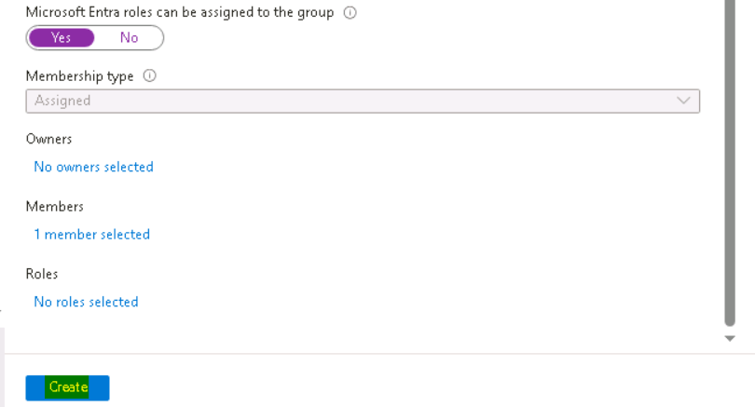

1. Click on the Yes button when prompted.

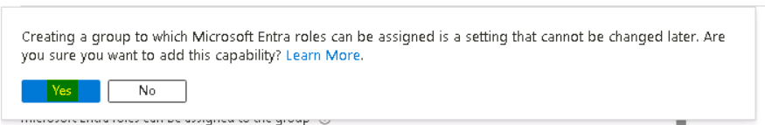

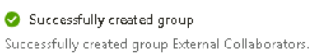

## Exercise 4 – Enabling Microsoft Entra ID per-user Multifactor Authentication

To secure user sign-in events in **Microsoft Entra ID**, you can require multi-factor authentication (MFA). We can enable each account for per-user Multi-Factor Authentication. When users are enabled individually, they perform multi-factor authentication each time they sign in (with some exceptions, such as when they sign in from trusted IP addresses or when the remember MFA on trusted devices feature is turned on).

1. Open the Edge browser and login to the Microsoft Entra admin center **+++https://entra.microsoft.com+++**.
2. If prompted for credentials enter your **Office365 Tenant Credentials** provided on the **Home tab** of the lab Interface as show in the Image.
3. In the **Microsoft Entra admin center** navigate to **Identity** then expand Users, click **All** **Users** then click on the ellipses **…** then select **Per-user MFA**.

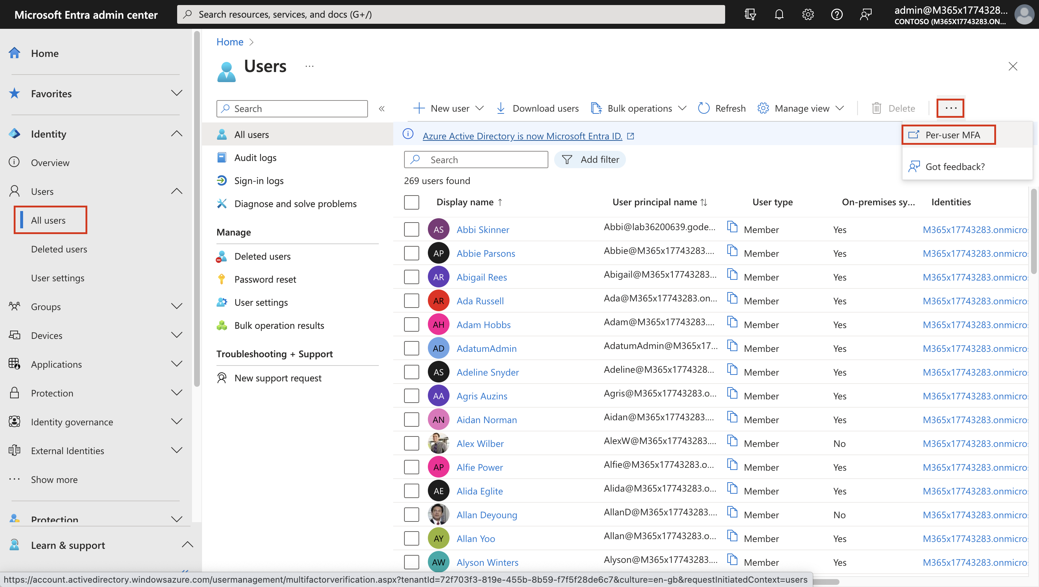

1. Select the users **Abbi Skinner** and **Beth Burke** and click on **Enable**.

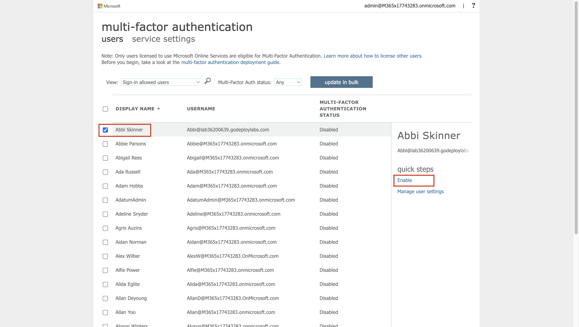

1. On the Message About enabling multi-factor auth, click on **enable multi-factor auth**.

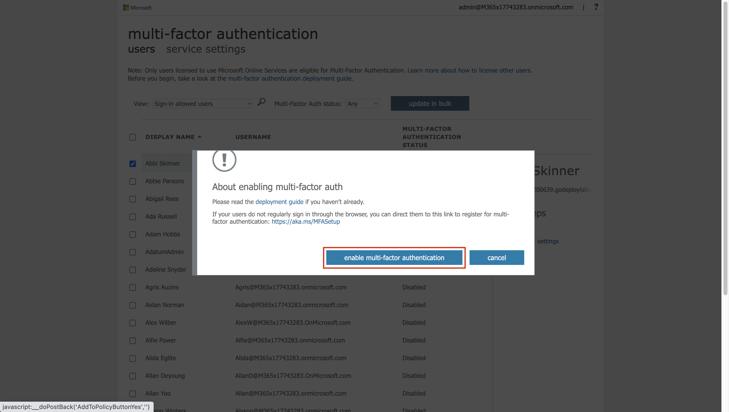

1. Click on the **Close** button on the confirmation message.

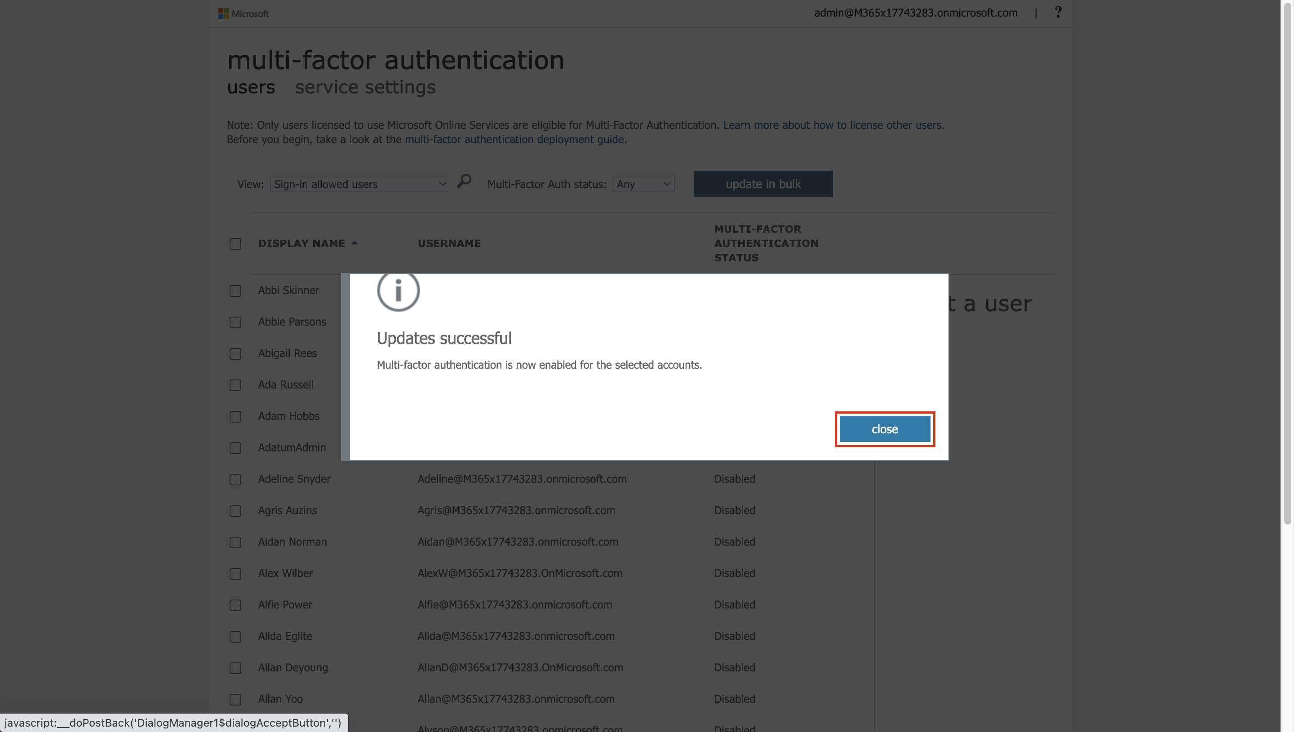

1. Open a browser in InPrivate/incognito mode and login to **My Apps portal** **+++https://myapps.microsoft.com+++**.
2. Enter the credentials for **Beth Burke** account

* Username – **+++Beth@+++** paste the **Tenant name** from the Home tab.
* Password – **+++Pa55w.rd+++**

1. You will be prompted to More information is required, click on **Next**

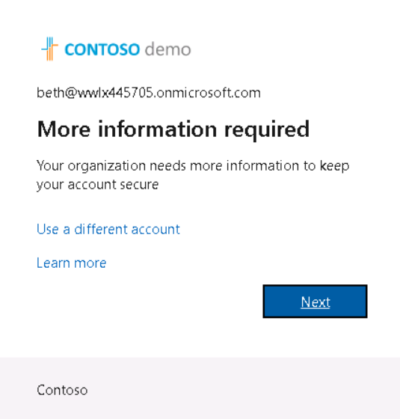.

1. On the **Start by getting the app** page, click on **Next**

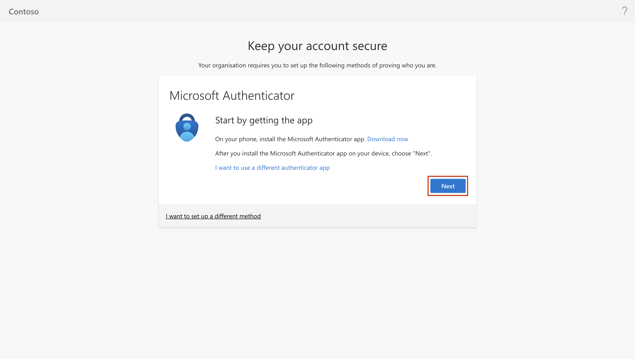

1. Install the **Microsoft Authenticator App** on your phone from the play store or app store as appropriate.
2. On the **Set up your account page**, select **Next.**

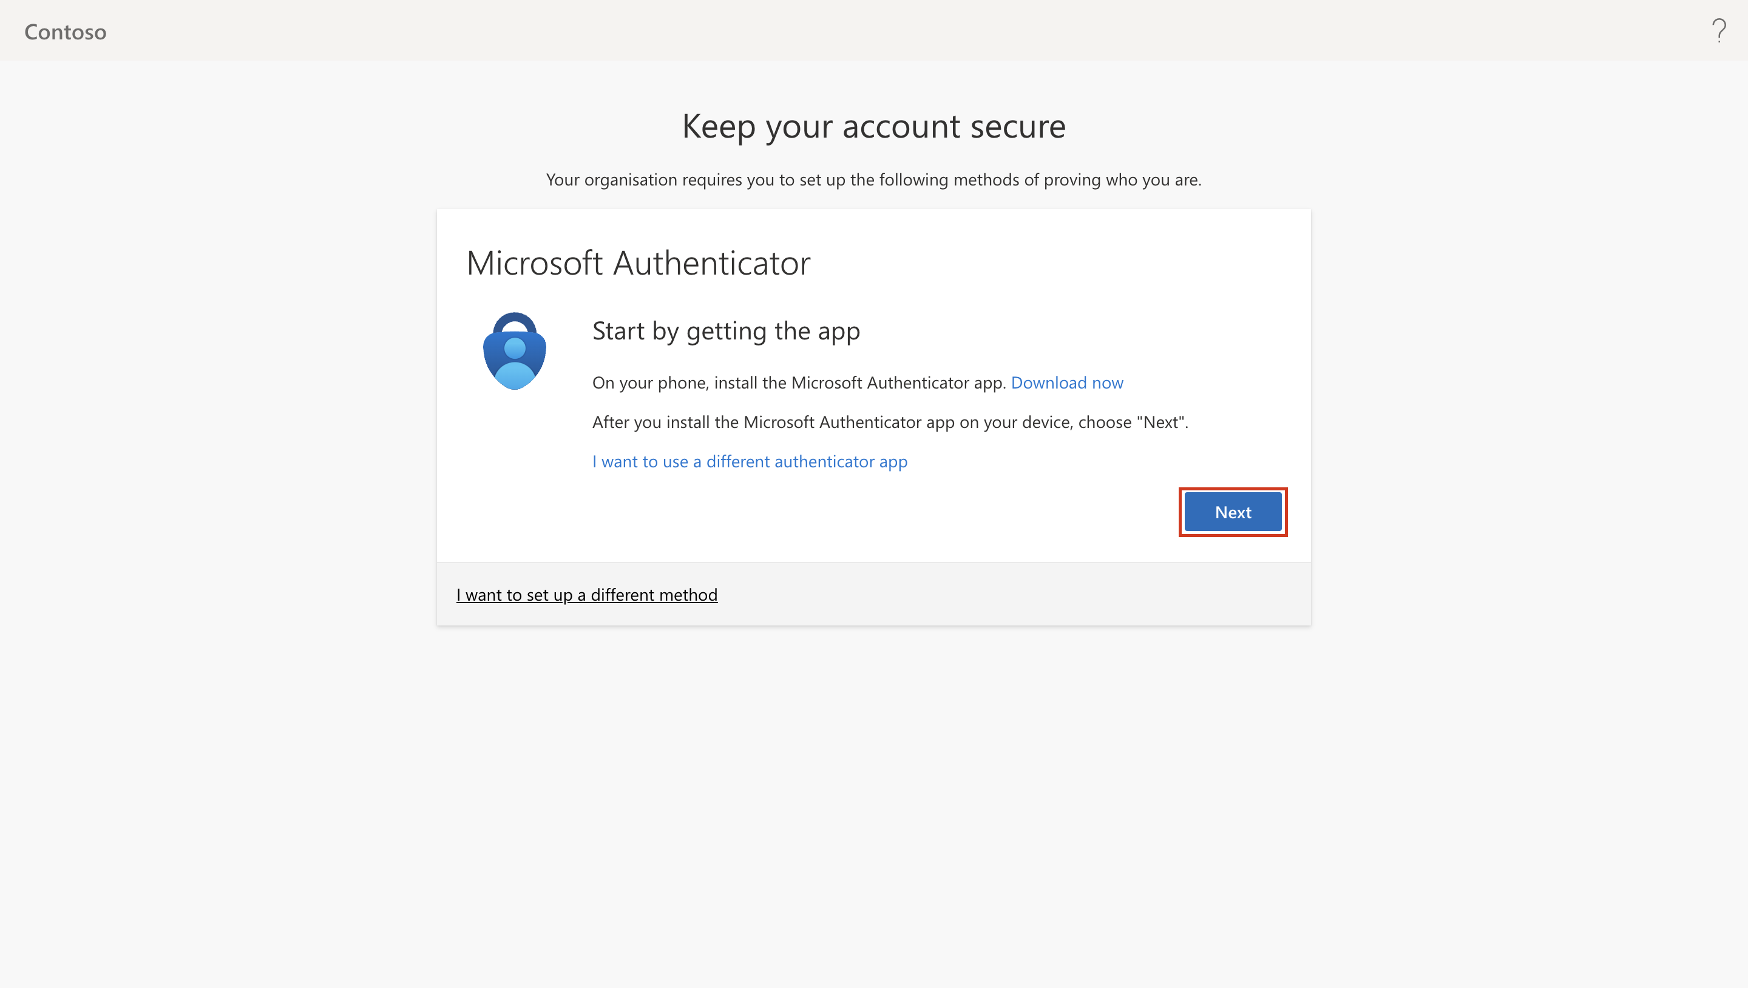

1. On the **Scan the QR code** page, scan the QR image to add the account on your Microsoft Authenticator App on your phone.

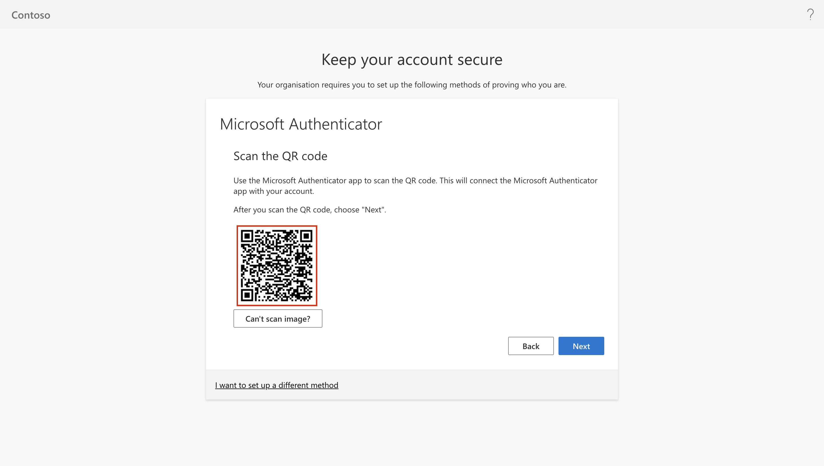

1. Now, select **Next**.

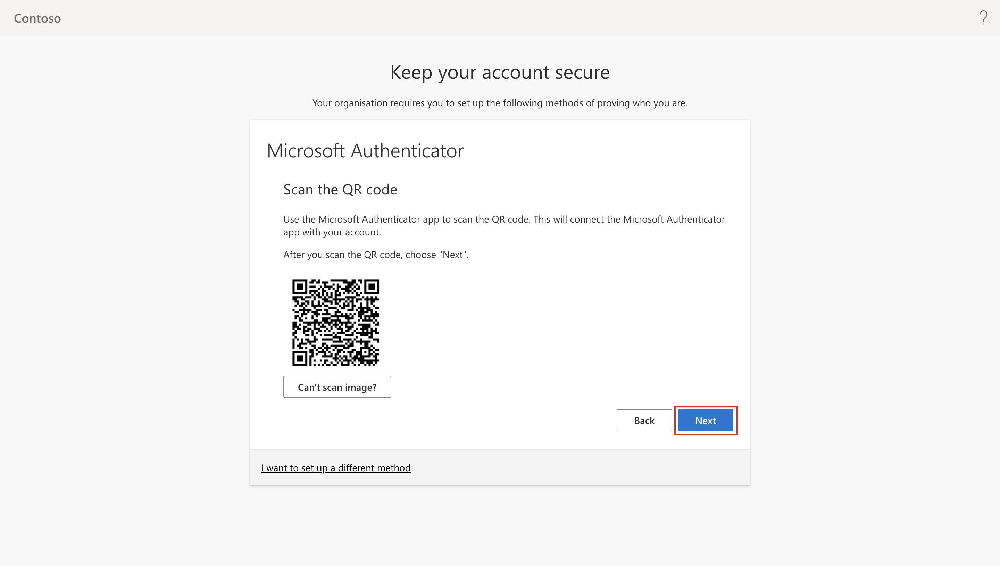

1. When prompted, approve the notification on your phone. Once you see that the notification is approved, select **Next**.

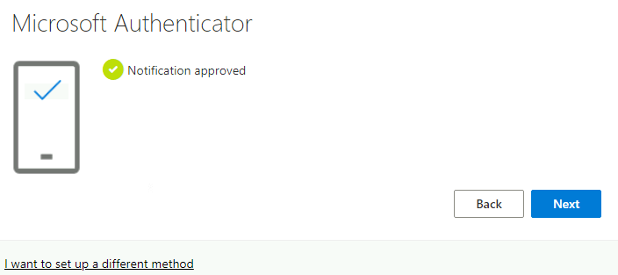

1. Click on **Done**

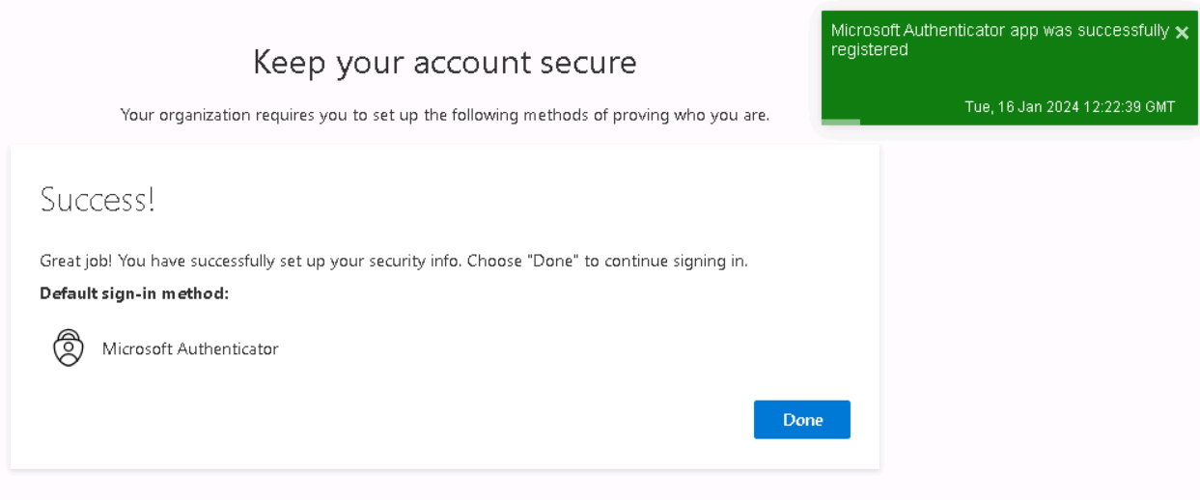

1. You should be logged in to the **My Apps Portal**

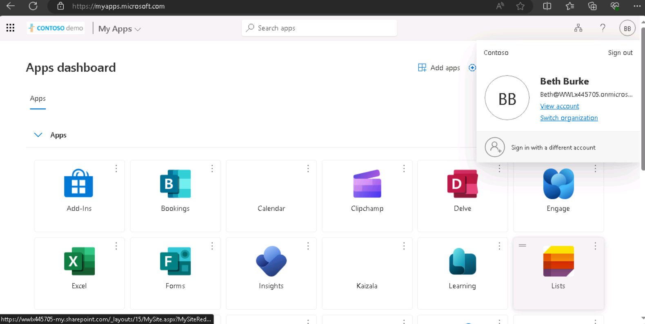

1. You have completed this task, please proceed ahead with the next task.

## Exercise 5 – Enabling Conditional Access for the Research Group

Conditional Access policies at their simplest are if-then statements, if a user wants to access a resource, then they must complete an action.

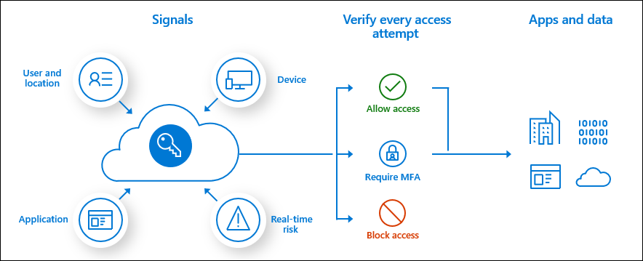

We will set a Conditional Access policy to require MFA for Research Group only when the Access **Microsoft Forms**

1. Open the Edge browser and login to the **Microsoft Entra admin center +++https://entra.microsoft.com+++**.
2. In the **Microsoft Entra admin center**, expand **Protection** and select **Conditional Access**. Click on **Create new policy**.

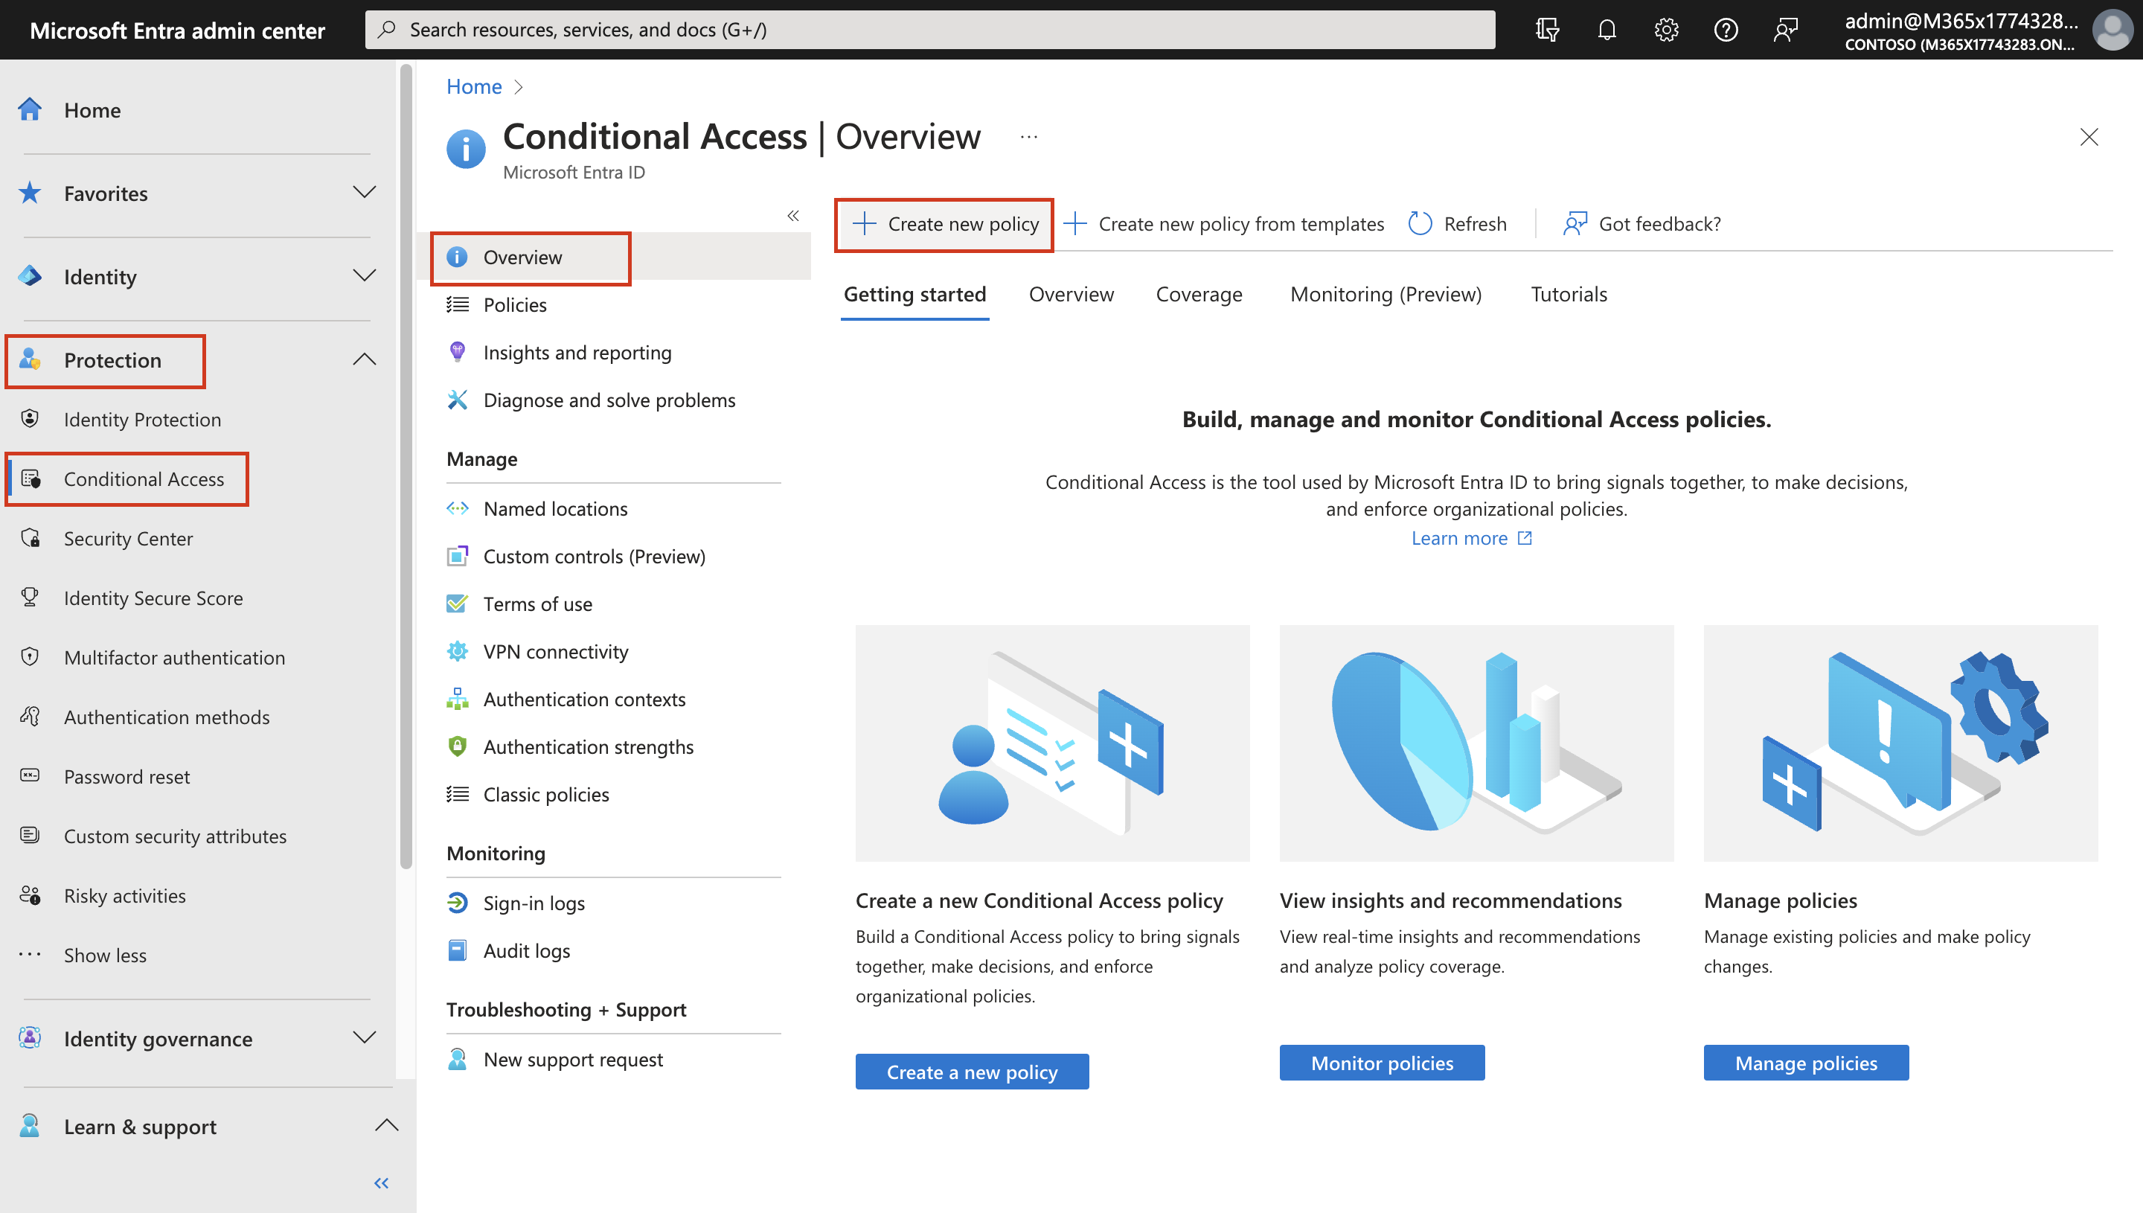

1. On the **New Conditional Access Policy** page, provide the below details
   * Name – **+++CA for Microsoft Forms+++**
   * Under **Users**, select **Specific users included**. Then under **Include**, choose **Select users and groups**. Select the check box near **Users and groups**. Then under **Select**,choose **0 users and groups selected**.

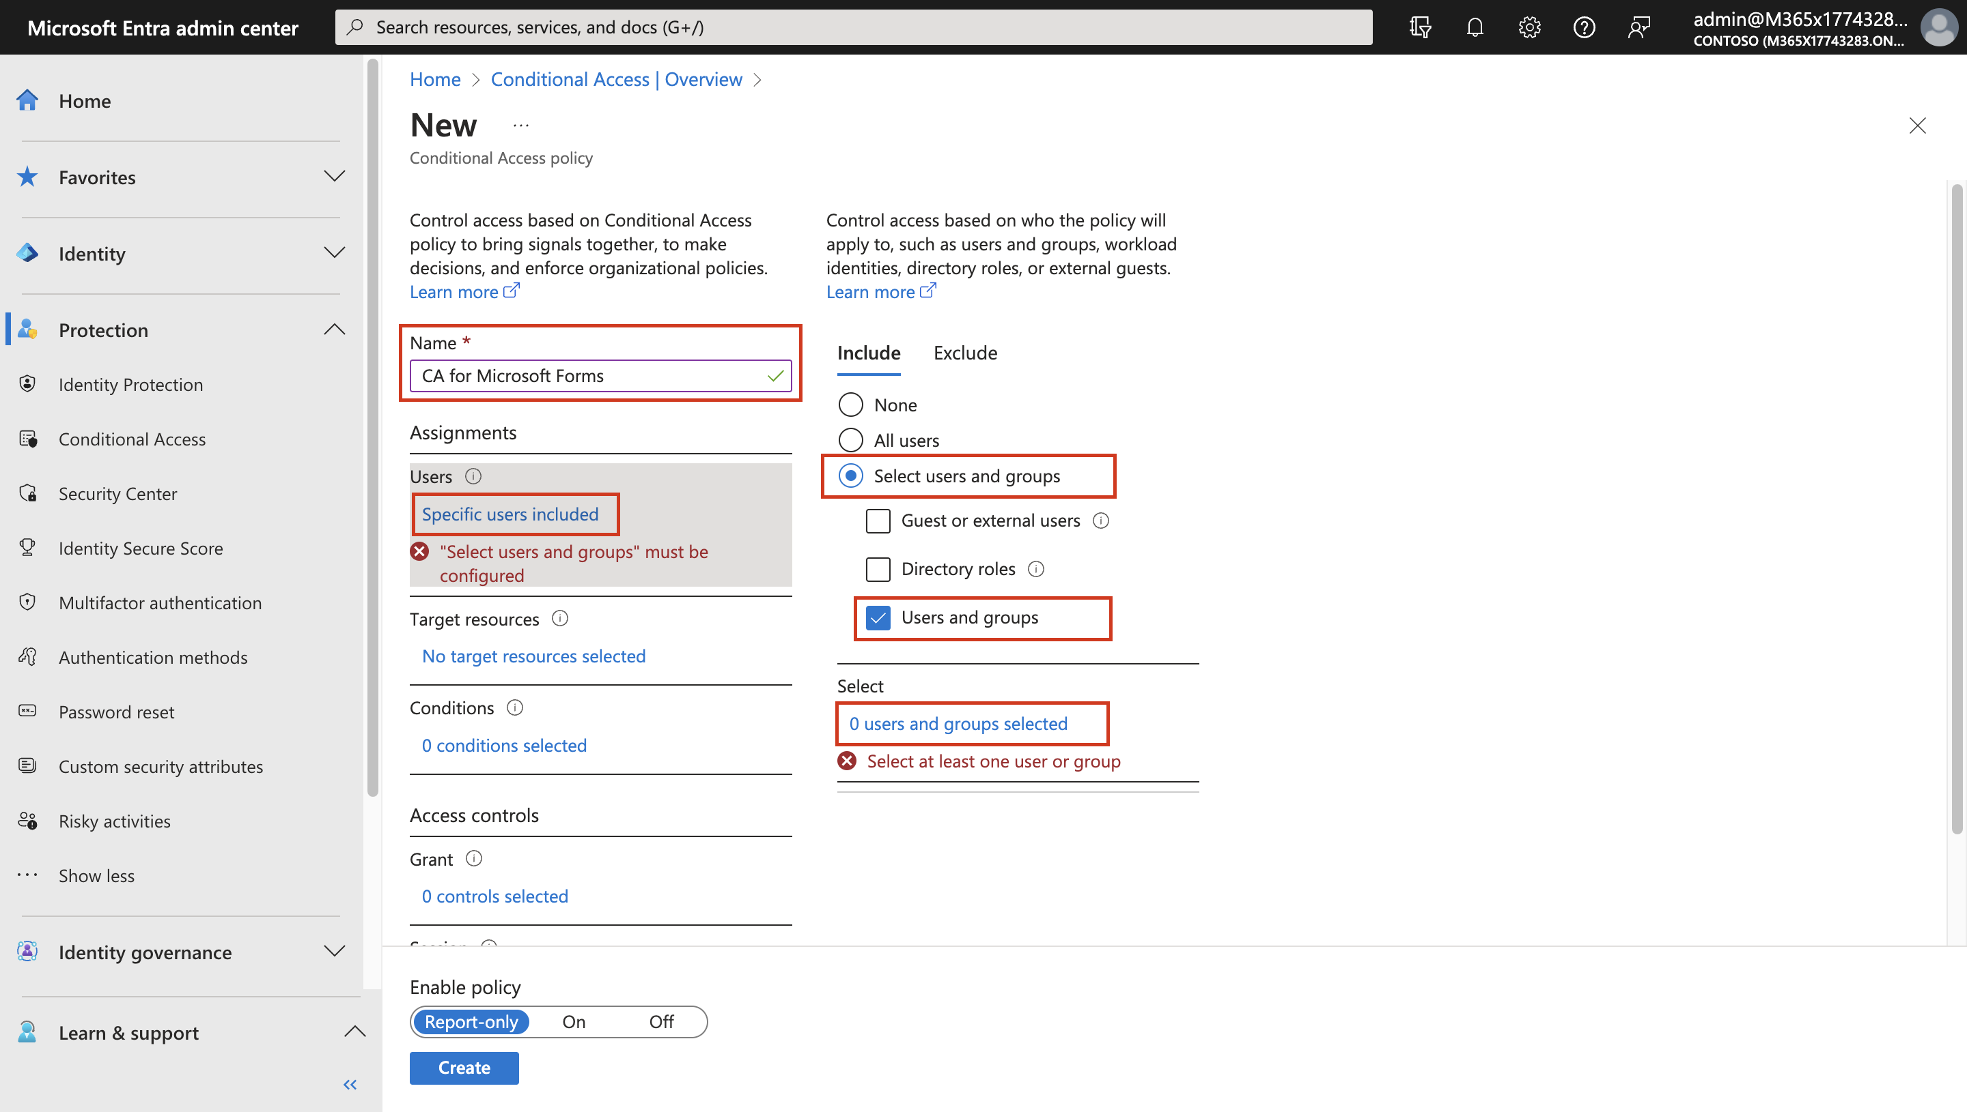

* + Scroll down on the **Select users and groups** page, select **Research101**. Choose **Select**.

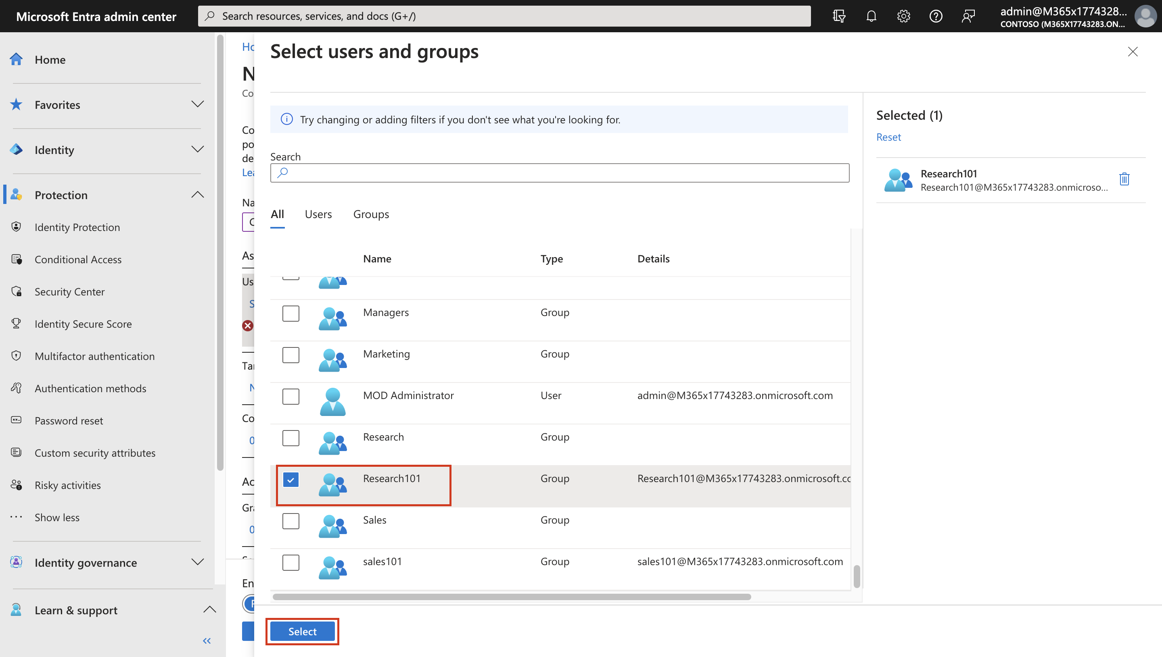

* + Under **Target Resources**, select **No target resources selected**. Then under **Include**, choose **Select apps**. Under select, choose **None**. In the side pane, search for and select **Microsoft Forms** by selecting the check box near the app. Then choose **Select**.

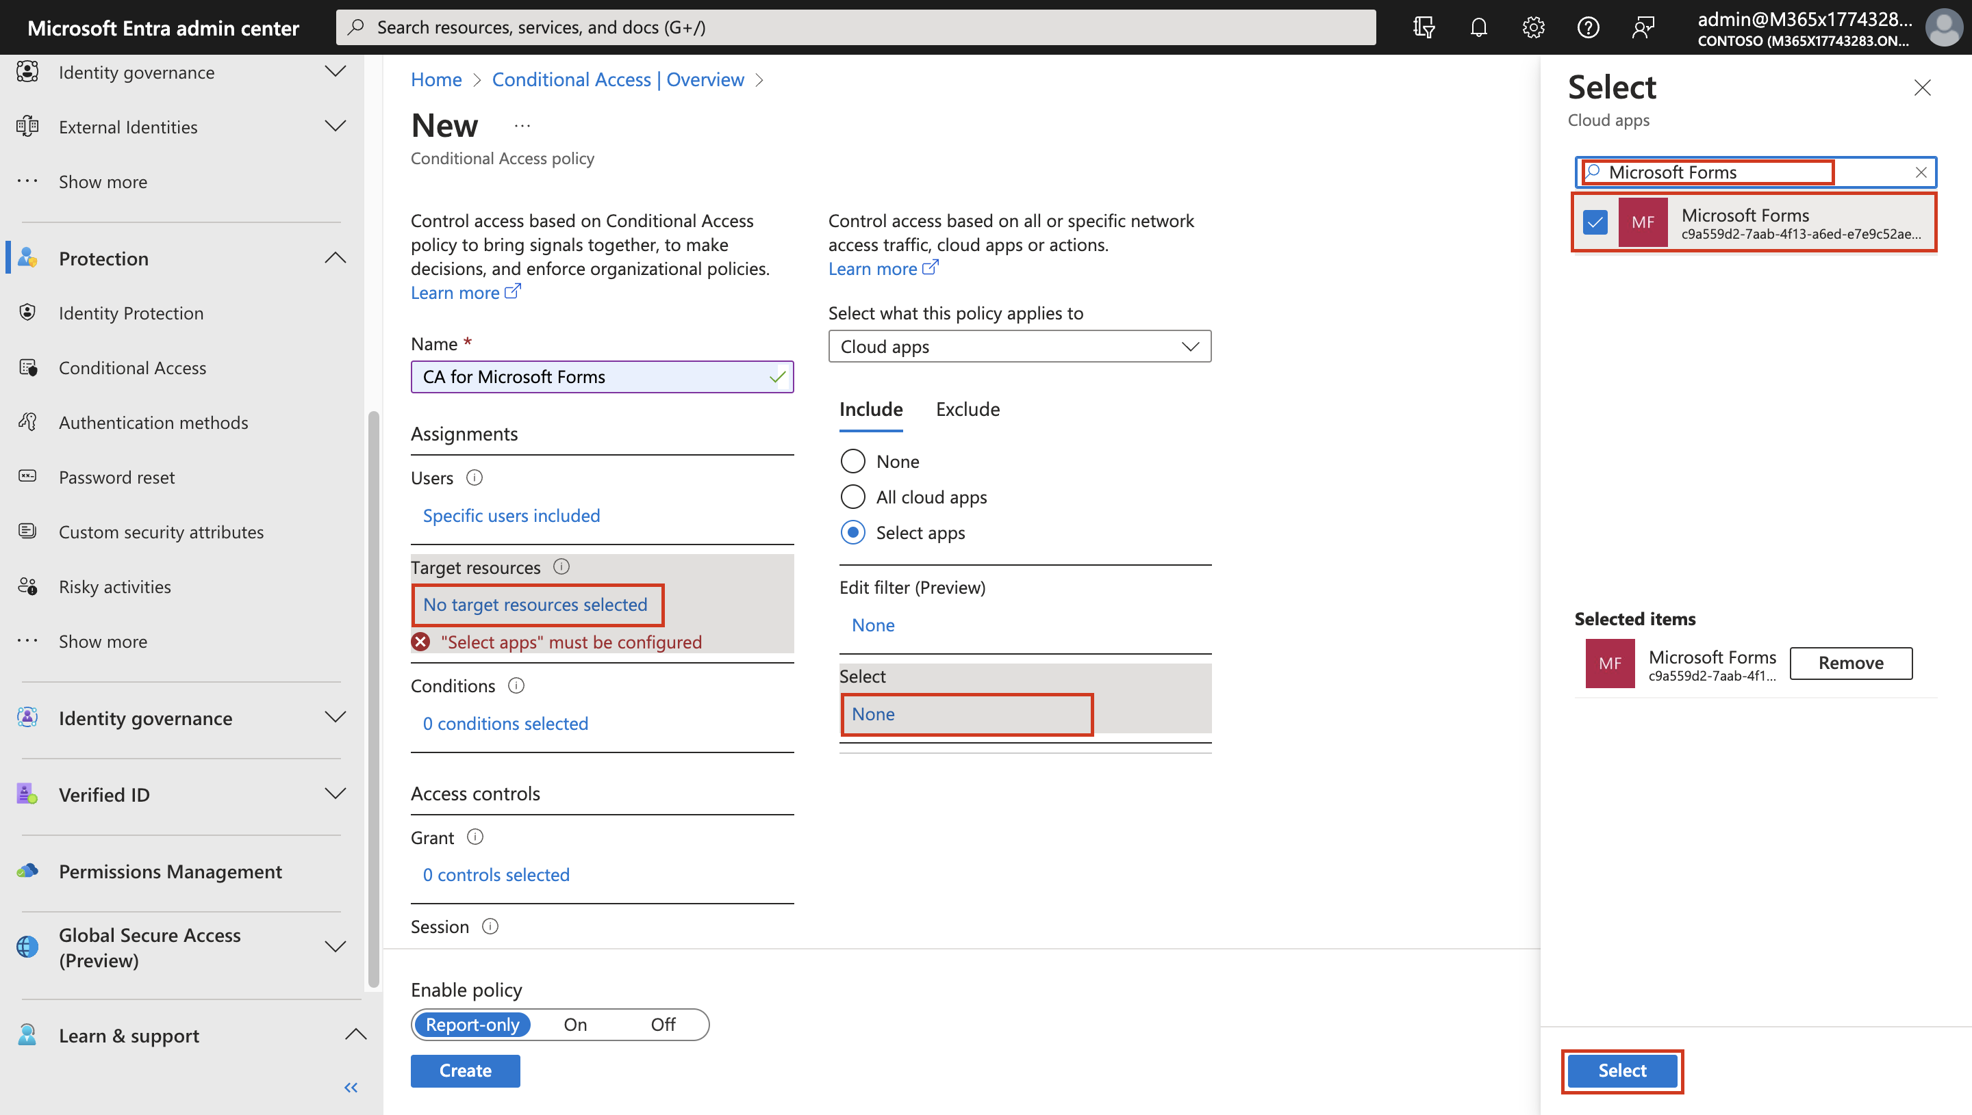

* + Similarly select **Access Controls** > **Grant** > **0 controls selected** > **Grant access** > **Require multi-factor authentication** > **Select**.

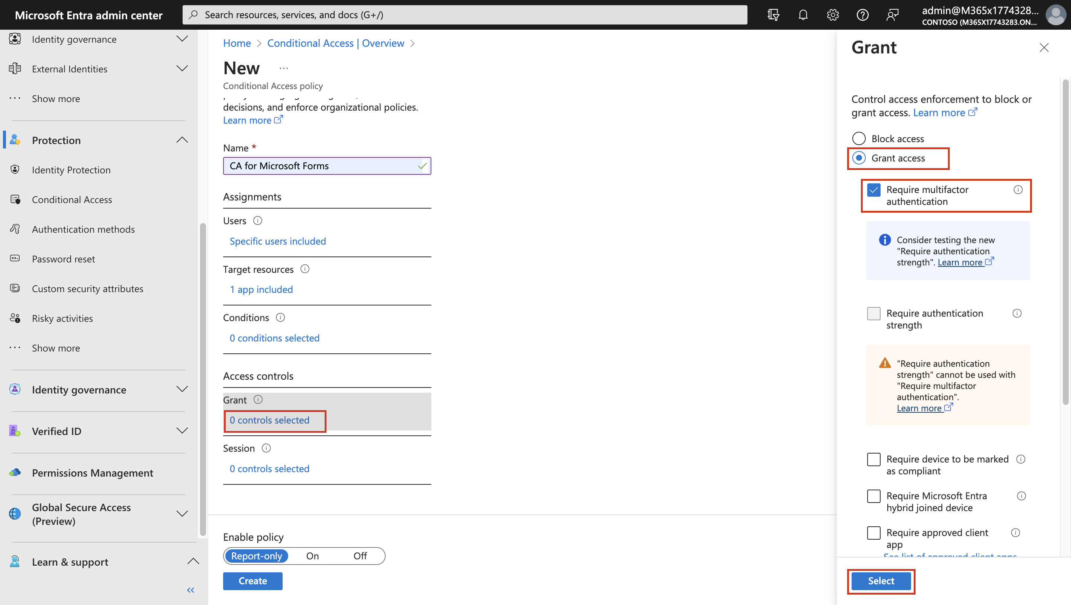

* + Enable policy – **Report-only**
  + Click on **Create**

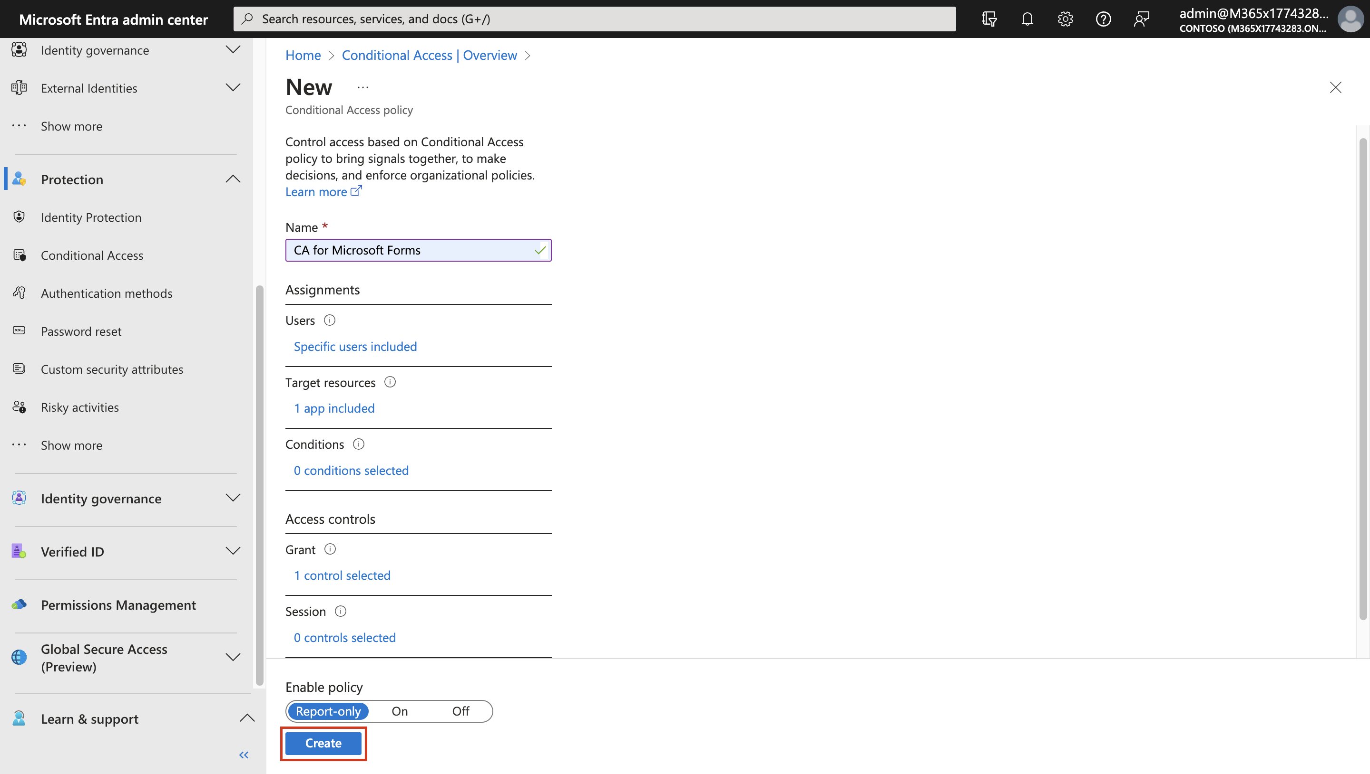

1. You should get the notification as shown in below image.

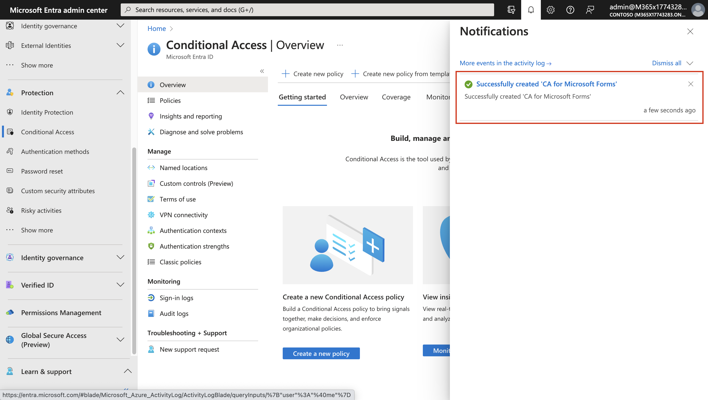

**NOTE** - Report-only mode is a new Conditional Access policy state that allows administrators to evaluate the impact of Conditional Access policies before enabling them in their environment. With the release of report-only mode:

* Conditional Access policies can be enabled in report-only mode.
* During sign-in, policies in report-only mode are evaluated but not enforced.
* Results are logged in the Conditional Access and Report-only tabs of the Sign-in log details.
* Customers with an Azure Monitor subscription can monitor the impact of their Conditional Access policies using the Conditional Access insights workbook.​

1. Now open a browser in InPrivate/incognito mode and login to **MyApps portal** – **+++https://myapps.microsoft.com+++**.
2. Login using **Logan Boyle’s** credentials you will be signed in without any additional information required prompt

* Username – **+++Logan@+++** paste the **Tenant name** from the Home tab.
* Password – **+++Pa55w.rd+++**

1. Click on Forms to access **Microsoft Forms**.

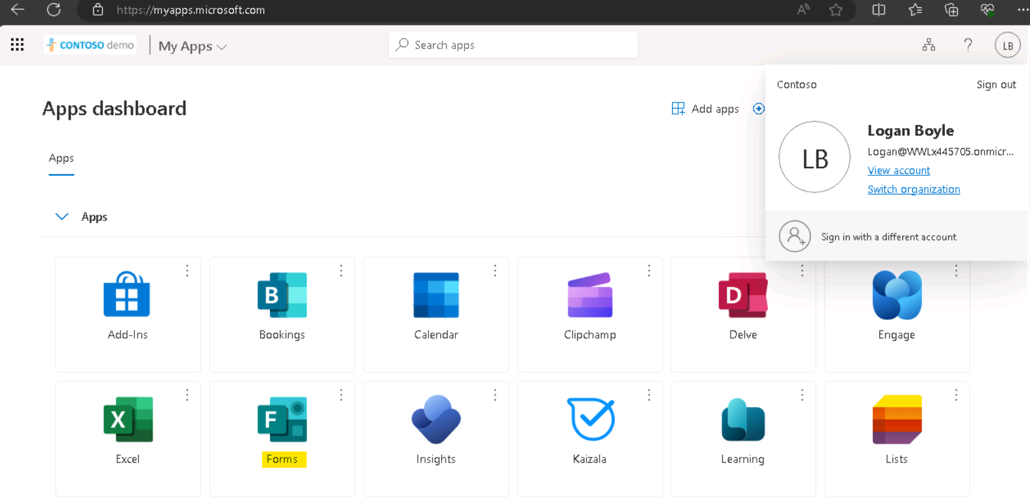

1. Select **Create new**.

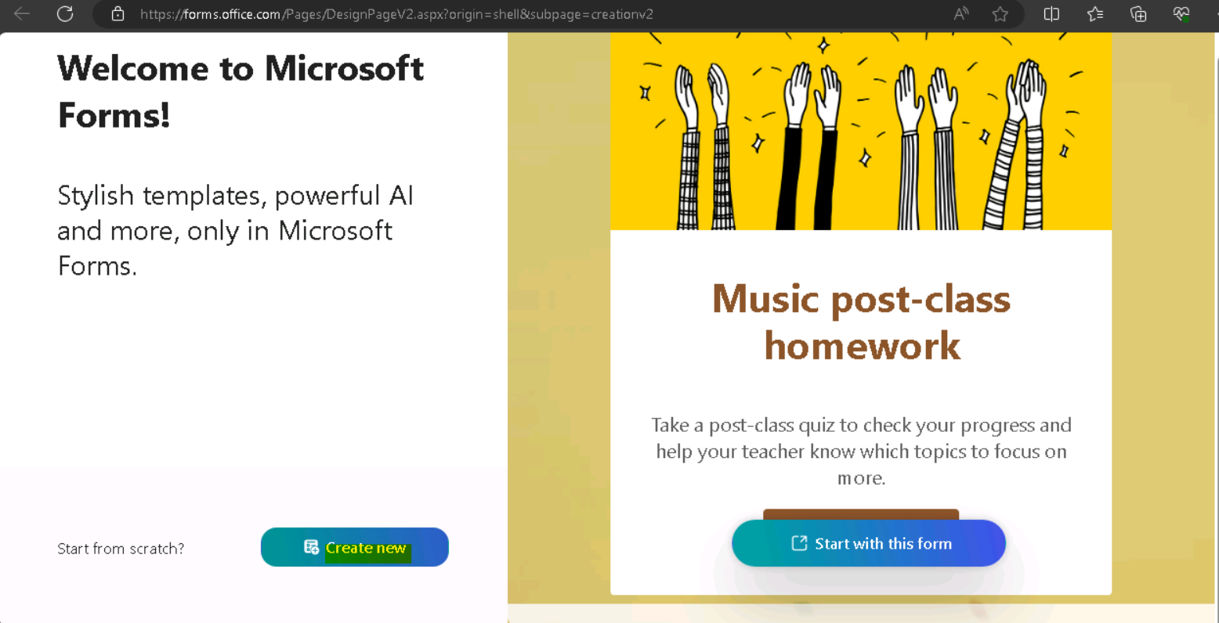

1. Switch back to the **Microsoft Entra admin center** and set the Conditional access policy to **On** and **Save** it.

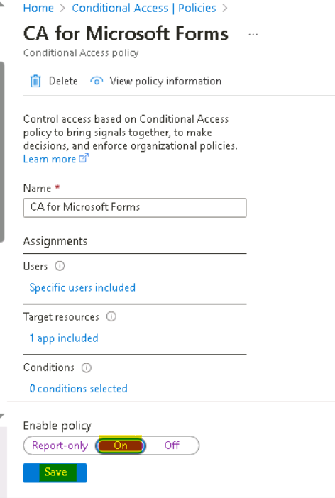

1. Now log off on the InPrivate tab and login to **MyApps portal** – **+++https://myapps.microsoft.com+++**.
2. Login using **Logan Boyle’s** credentials you will be signed in without any additional information required prompt

* Username – **+++Logan@+++** paste the **Tenant name** from the Home tab.
* Password – **+++Pa55w.rd+++**

1. Click on Forms to access **Microsoft Forms**.



1. You will notice that the Conditional Access policy requires you to perform MFA in order to access Forms.

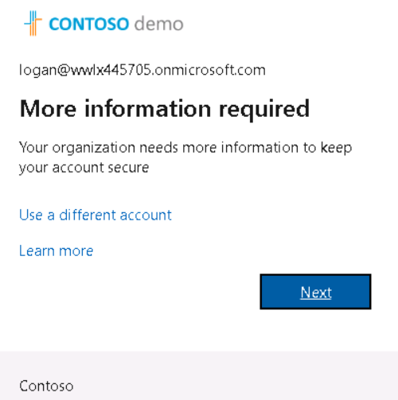

1. Click on **Next** and complete the MFA process to gain access to Forms.
2. You would be required to go through the Microsoft Authenticator process, once completed you will be logged in Microsoft Forms successfully as shown in below images



1. You should be able to login successfully

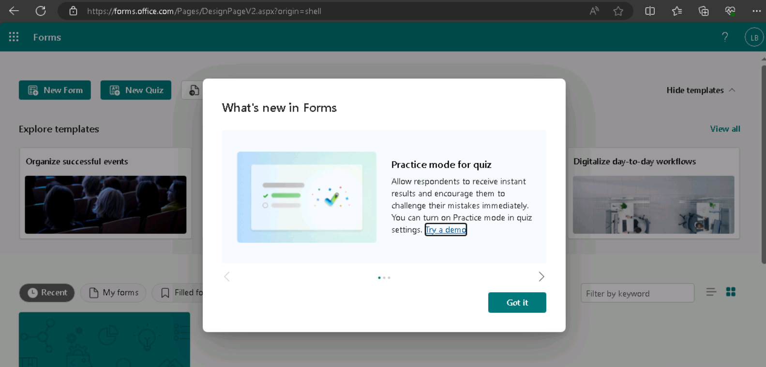

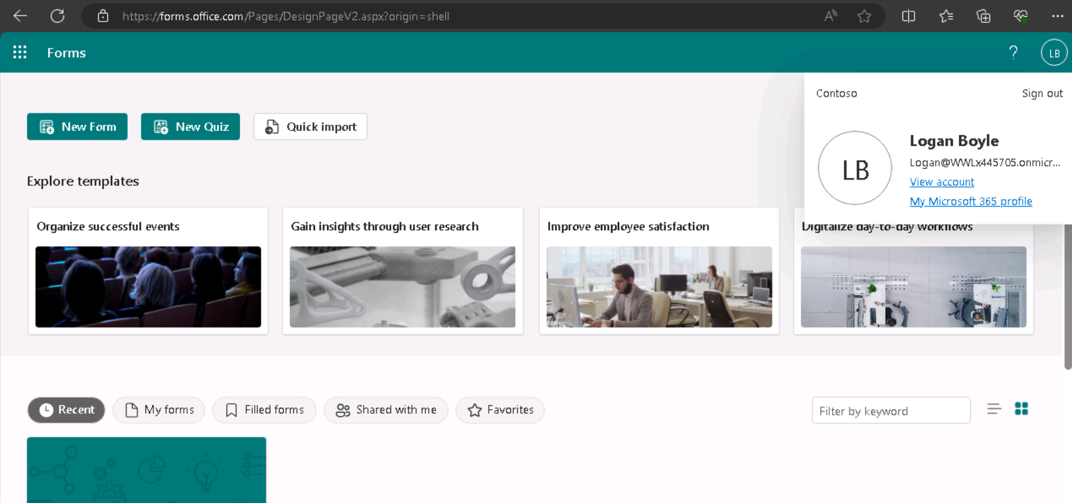

## Summary:

In this lab we assigned the required licenses and created the required records using the provided public domain. We enabled MFA for our users and assigned a basic conditional access policy to a group of users in our organization.